Geothermal Technology at the Salton Sea
Geothermal power is generated by using heat from aquifers heated by molten rock from the core of the earth. Three general processes are in use, dry steam, flash steam, and binary. The Geysers field in California is the only dry steam operation in the U.S. The Imperial Valley has both flash steam and binary plants. Binary plants operate on low temperature resources typically less than 300°F. Flash steam plants use a higher temperature liquid resource that spontaneously flashes into steam at atmospheric pressure.

The geothermal aquifer at the Salton Sea is a high temperature resource typically on the order of 500°F several thousand feet underground. The Salton Sea resource is a saturated brine that comes up a wellbore under natural high pressure. All of the plants exploiting the Salton Sea geothermal resource are of the steam flash type. CalEnergy Operating Company is by far the largest geothermal plant operator at the Salton Sea with 327 MW of generation combined from ten plants. The steam flash process employed by CalEnergy is illustrated in Figure 4. The underground aquifer (1) is heated by magma that rose close to the earth’s surface due to multiple local faults. About 20% of the brine is flashed to steam (2). The steam drives a turbine and generator (3). The remaining 80% or more of the brine (4) is cleared of solids and pumped back down into the aquifer to be reheated and reused.

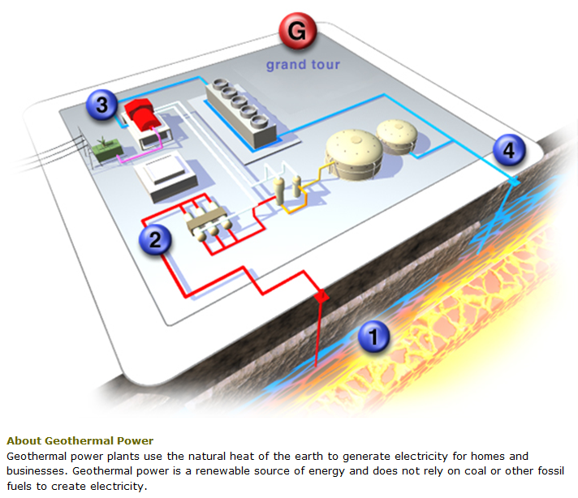
Figure 4. Overview of steam flash plants as operated by CalEnergy (from CalEnergy website)

A more detailed diagram of the triple flash process employed by CalEnergy is shown in Figure 5. Geothermal brine at up to 450 Pounds per Square Inch Gauge (PSIG) and up to 500°F is directed from the production wells to a High Pressure Separator where high pressure steam is flashed from the brine at about 330 PSIG. The high pressure steam goes through a regulating valve to a steam turbine. The geothermal brine, now a little cooler and more concentrated after releasing some water as steam, goes to the Standard Pressure Crystallizer where additional steam is flashed at about 50 PSIG and directed to a turbine. The brine is seeded with some slurry to absorb precipitating salts as the brine concentrates and sent to the Low Pressure Crystallizer where a third flash takes steam at about 20 PSIG and directs it to a turbine. The brine after the third flash goes to a Flash Tank where a final flash at atmospheric pressure is vented to the atmosphere. This final flash is the source of non-commercial steam at about 212°F available for a thermal desalination process. The brine goes from the Flash Tank to a Primary and Secondary Clarifier where silica and precipitated solids are separated out before the brine is injected underground at about 225°F, typically to the periphery of the geothermal field.
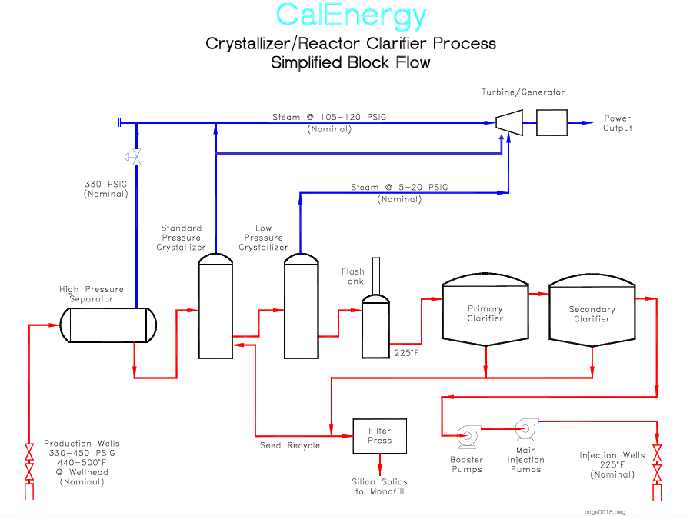
Figure 5. Triple flash brine and steam process as employed by CalEnergy (from CalEnergy public talk)

The Salton Sea Known Geothermal Resource Area (KGRA), shown by the black boundary in Figure 6, is one of the most productive in California. Several studies have provided a wide range of estimates for the extent of both the local and statewide resource by various methods (Gawell, 2006):

- USGS Circular 790 1978, Salton Sea area: 3,400 MW, California:13,716 MW
- Petty 1992 Low, Salton Sea area: 500 MW, California: 5,801 MW
- Petty 1992 High, Salton Sea area: 3,000 MW, California: 24,750 MW
- DOE Data 2005, Salton Sea area: 1,500 MW, California: 12,170 MW
- EIA-AEO 2005 Data, Salton Sea area: 407 MW, California: 9717 MW
- GeothermEx-CEC 2004, Salton Sea area: 1,400 MW, California: 3,186.2 MW
- WGA 2006 Combined, Salton Sea area: 2,860 MW, California: 7,078 MW
- CalEnergy 2009: Salton Sea area: 2,300 MW, California: 3,465 MW (CalEnergy Operating Corporation, 2009)

Of these studies, the GeothermEx study “New Geothermal Site Identification and Qualification” prepared by GeothermEx, Inc. for the CEC in 2004 comes the closest to defining a ‘Proven Reserve’ (Gawell, 2006, pg. 13). The Salton Sea resource is currently tapped by 10 power plants operated by Cal Energy Operating Company with a combined net capacity of 327 MW. A new 49 MW plant owned by Hudson Ranch Power I, LLC went into operation in 2012. Wells now being drilled for a second plant. The total generation is a fraction of the production capacity of the proven Salton Sea KGRA.

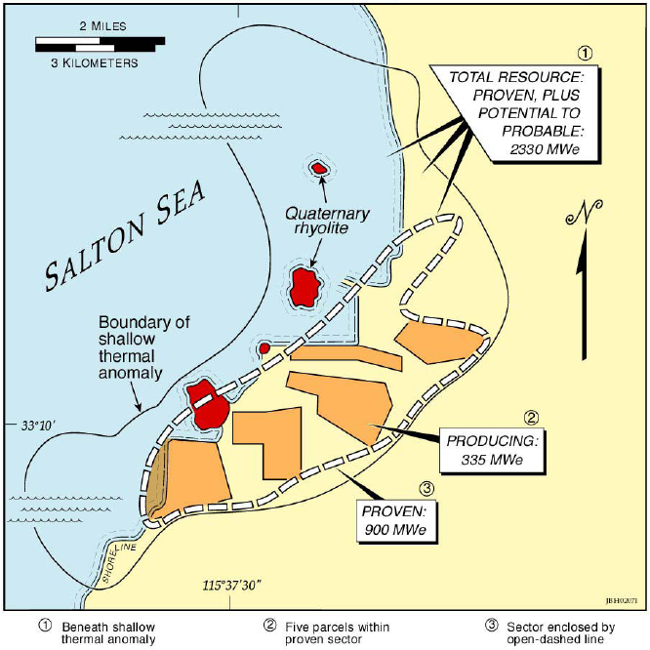
Figure 6. Salton Sea KGRA boundaries from CalEnergy and University of Utah Study

CalEnergy has extended permits on plans to build a new 185 MW plant composed of three smaller plants. The plant was originally permitted as a single plant of more than 300 MW. Steep increases in the cost of corrosion resistant materials such as titanium made it unprofitable to build when the plant was first permitted. In 2002, a document prepared by Steve Baker for the CEC evaluated the request to build Cal Energy Unit 6 (Baker, 2002). The Salton Sea KGRA was defined as encompassing 102,877 acres with only 4,808 acres or 4.7% currently developed for electrical production. CalEnergy had provided an estimate of 680 MW proven reserves, 1,200 MW probable reserves, and 2,300 MW possible reserves in the Salton Sea KGRA. Mr. Baker characterized these estimates as ‘extremely conservative’ based on earlier, much larger estimates by Union Oil. (Baker, 2002, pg. 3). CalEnergy has purchased geothermal leases to develop a prime portion of the Salton Sea KGRA currently under several feet of water just off the southeast shore of the Salton Sea.

