Project Feasibility

Water and Salt Treatment Process Development
Vertical Tube Evaporator (VTE) and Multi-Effect Distillation (MED) are well established technologies in the evaporation of liquids from foods, seawater distillation, and brine concentration. See Appendix A for an in depth discussion of the technology and some background on Sephton Water Technology’s 30 year contribution to the development of it.
Starting with a 2001 proposal by company founder Dr. Hugo Sephton and three colleagues to the Salton Sea Authority and following on a 2004 grant from the U.S. Bureau of Reclamation, Sephton Water Technology has been developing an application of VTE-MED technology to efficiently distill Salton Sea water at a high recovery of 86% using heat from low pressure geothermal steam to drive the process. This distillation process has been developed in the VTE Pilot Plant shown in Figure 15, installed in 2005 and operational since 2006.
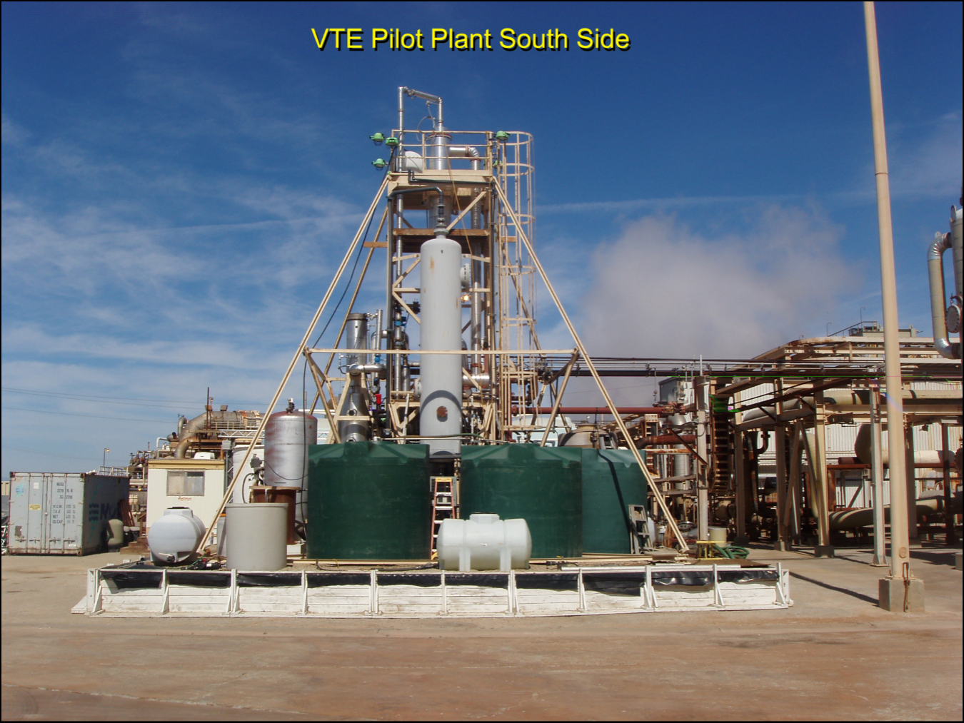
Figure 15. VTE Pilot Plant installed at a CalEnergy Geothermal Plant at the Salton Sea since 2005
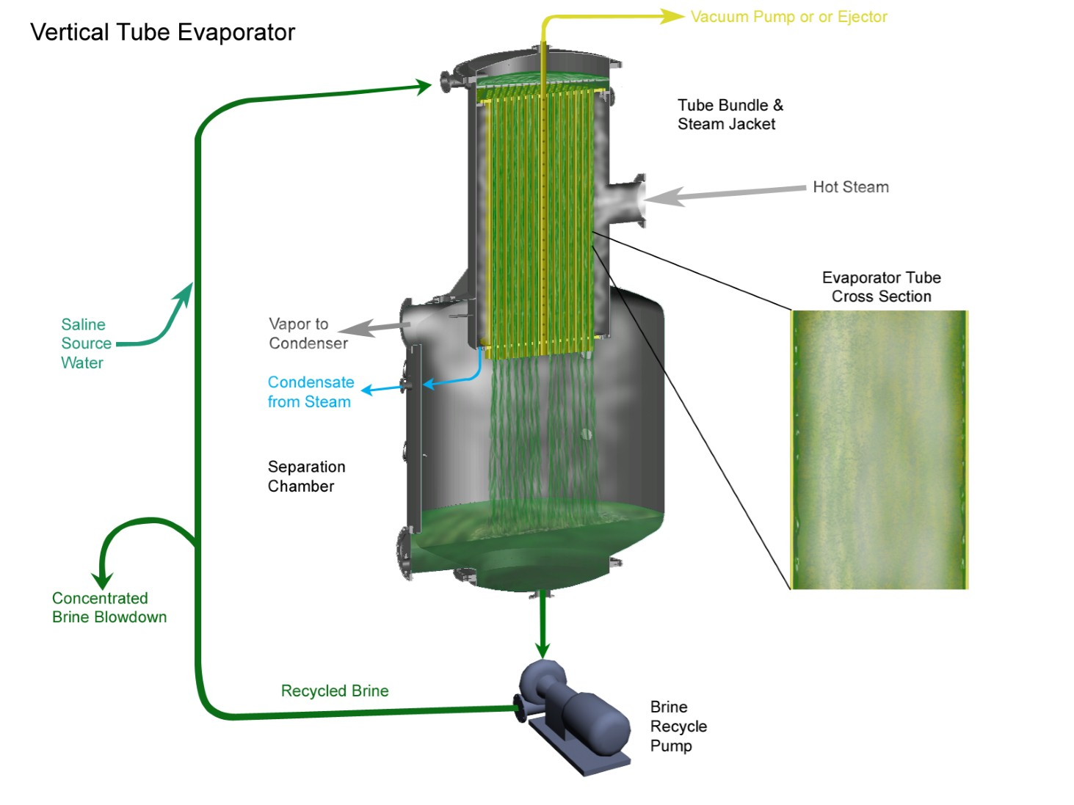
Figure 16. Cutaway view of a single effect VTE distillation process (down-flow mode)
The VTE geothermal distillation process developed since 2006 is illustrated in Figure 16. Seawater is circulated in the evaporator under vacuum, flowing as a film down the inside surfaces of evaporator tubes while geothermal steam condenses on the outside heating the seawater to vaporize inside the tubes. The vapor separates from the seawater as it cascades out of the evaporator tubes into the large separation chamber where it is drawn off by vacuum and condensed in a second heat exchanger. The process uses a then patented scale control method called Dispersed Seeded Slurry Evaporation (DSSE) (U.S. Pat. No. 5,156,706) to prevent the scale forming ions abundant in Salton Sea water from adhering to evaporator tubes and equipment surfaces. The DSSE method introduces a slurry of tiny suspended particles into the seawater to create a nucleus for precipitation of scale forming ions in the water, not on the equipment surfaces. The dispersant is an anionic surfactant (used in liquid dish soap) that coats the equipment surfaces with a monomolecular layer giving a negative charge at the liquid surface. Scale particles are blocked from adhering to metal surfaces and the surfactant forms micelles around the scale particles, that same way soap suspends dirt particles in water.
Because this is an inland site with no option to dump waste brine into the ocean, the intent of the process developed is to recover as much distillate from the hyper-saline Salton Sea water as possible (high recovery rate) while minimizing the volume of the remaining brine and converting it to something useful. The objectives of the testing were:
- Use heat from geothermal steam to distill Salton Sea water.
- Maximize the recovery of distillate from Salton Sea water.
- Minimize the volume of the remaining brine and convert it to a useful product.
- Control mineral scaling using the DSSE method, or other methods
Early testing successfully used heat from geothermal steam to distill Salton Sea water with a high recovery of 86% distillate, and a low volume of remaining brine, achieved by pushing the recirculating brine close to the saturation point as shown in Figure 17.
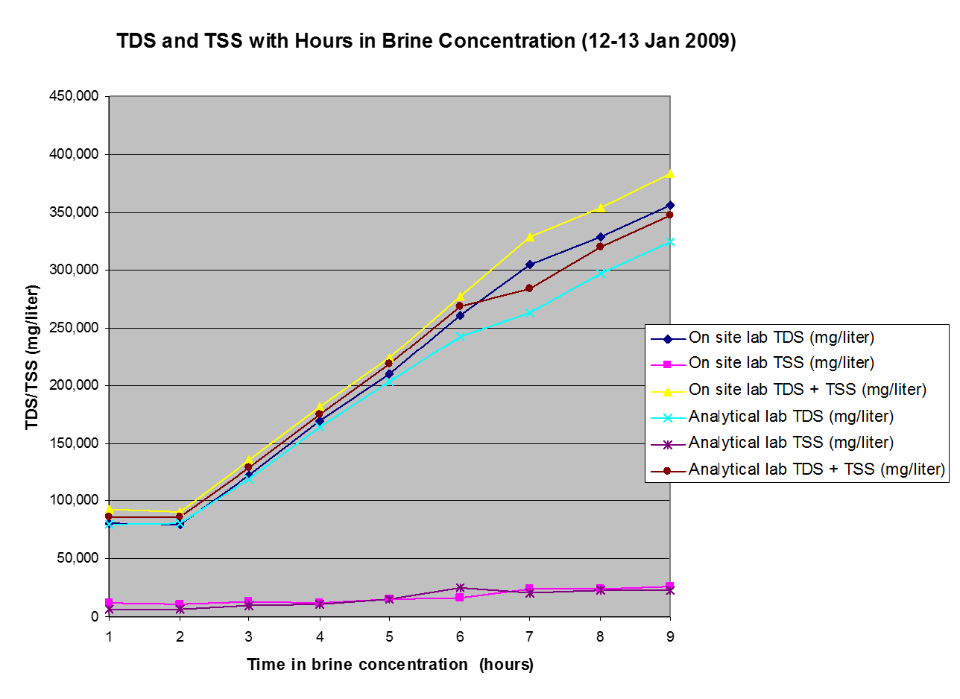
Figure 17. Salton Sea brine concentration with 86% distillate recovery and final brine near saturation
Chemical analysis of the ions in the brine concentrate (Figure 18) showed the concentration of the dominant ions, sodium and chloride rising with overall total suspended solids during Salton Sea brine concentration. Magnesium concentration rises steadily from a lower starting point, but sulfate concentration drops and stays level after the saturation point of calcium sulfate is exceeded. With a concentration too low to see in Figure 18, the calcium content of the Salton Sea water drops by 90%, precipitating as calcium sulfate in the course of brine concentration.
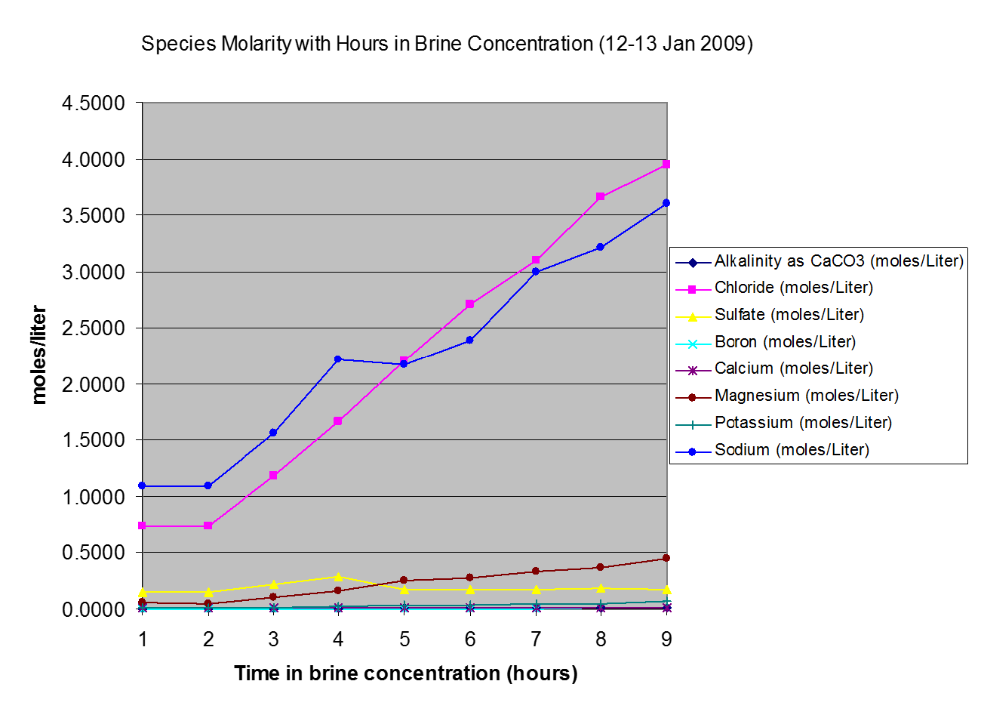
Figure 18. Analysis of ions during Salton Sea brine concentration with final brine near NaCl saturation
The quality of the distilled water recovered from Salton Sea source water is very high with only trace amounts of sodium, chloride, and sulfate detected in analysis by a State certified lab. The purification exceeds 10,000:1 as shown in Figure 19.
The thermal efficiency of the distillation process is measured by two values: the Heat Transfer Coefficient and the Performance Ratio. The heat transfer coefficient is derived from the rate at which heat from the geothermal steam crosses the evaporator tube wall to vaporize seawater inside. Higher values mean lower capital costs as less evaporator tube area is needed for a given distillation capacity. The value is temperature dependent, rising with higher operating temperatures, and will drop significantly if scale forms on the evaporator tubes or at very high brine concentration. Figure 20 shows the measured heat transfer coefficient during brine concentration to high levels in VTE 1. That evaporator has smooth wall titanium tubes which are not highly efficient compared to copper alloys and a fluted tube wall. Figure 21 shows a test run comparing the heat transfer coefficients measured in VTE 2 and VTE 1 over a range of five test conditions simulating the temperatures, pressures, and brine chemistry expected in a small commercial 15 Effect VTE system. VTE 2 has about four times better thermal efficiency than VTE 1due to its fluted profile copper-nickel evaporator tubes.
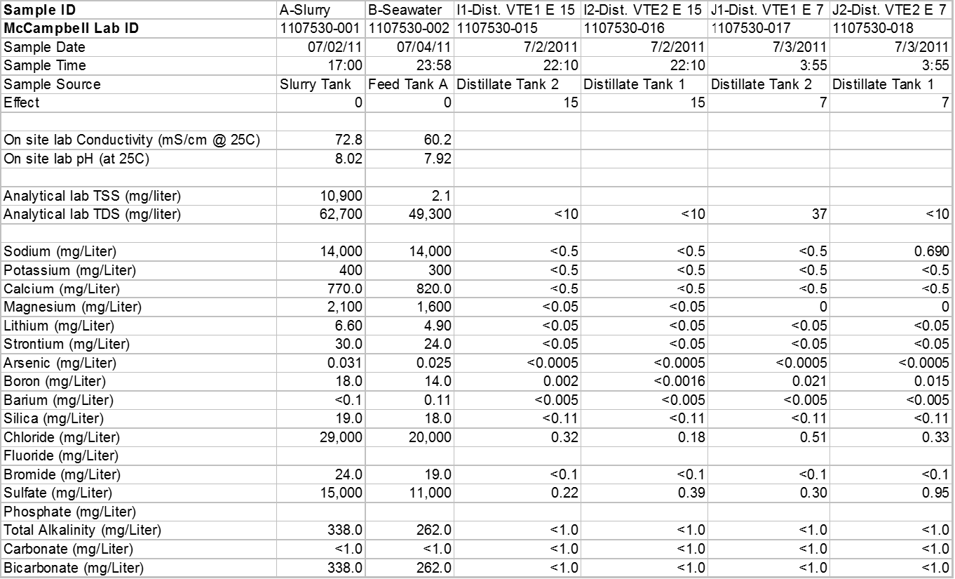
Figure 19. Quality of Water Distilled from the Salton Sea

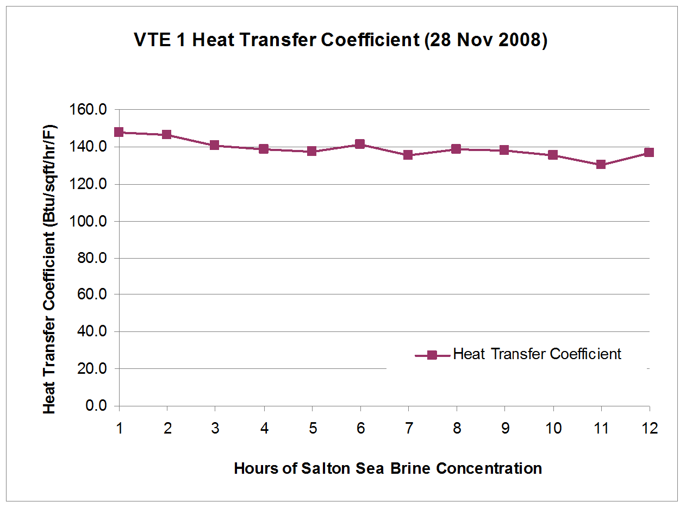
Figure 20. Heat Transfer Coefficient measured in VTE1 during Salton Sea brine concentration
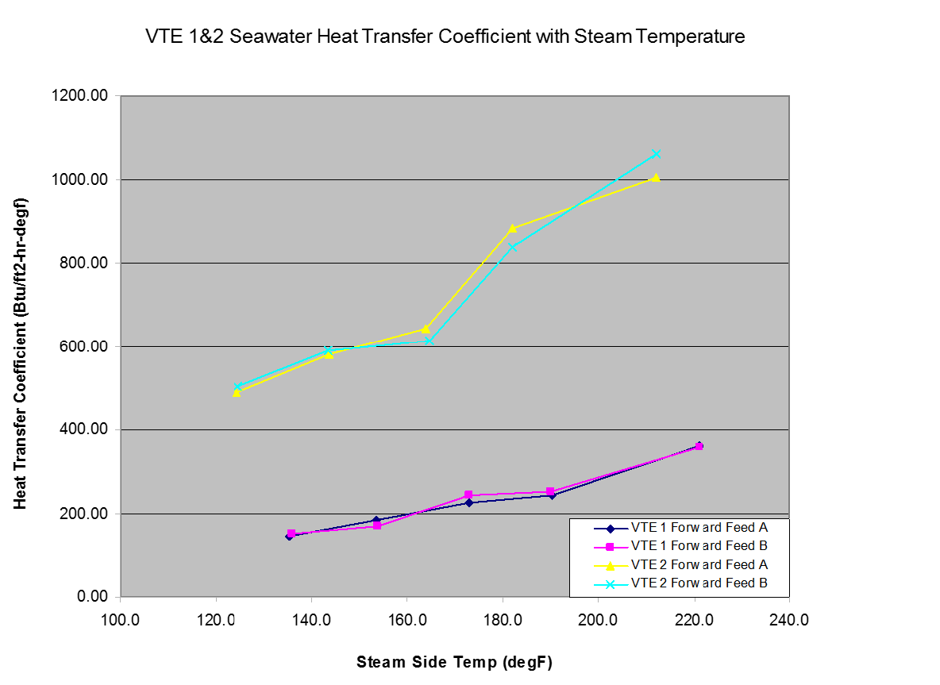
Figure 21. Comparison of Heat Transfer Coefficient between VTE 1 and VTE 2 distilling Salton Sea water
The Performance Ratio measures the pounds of water distilled per 1,000 BTU of thermal energy used. Higher values give more efficient use of thermal energy. The value is very close to the Gained Output Ratio measured as pounds of water distilled per pound of geothermal steam used. Figure 23 shows performance ratio data measured in VTE 2 over a range of five test conditions, (effects 1, 4, 7, 11, and 15) simulating the temperatures, pressures, and brine chemistry expected in a small commercial 15 Effect VTE system. Two values were taken during steady state operation at each effect test condition showing variability caused by small variations in distillate rates and tenth of a degree temperature measurements.
The test data is interpolated in Figure 24 to predict an overall System Performance Ratio for a 15 Effect small commercial VTE system yielding values of 14 pounds of distilled water produced per 1,000 BTU of thermal energy or 14 pounds of distillate per pound of geothermal steam. A commercial VTE system with 25 effects could produce up to 24 pounds of distilled water per pound of geothermal steam. Table 4 shows a calculation of the predicted performance for a 30 MGD 25 Effect VTE-MED Plant using large VTE-MED plant calculation tools developed by Ferris C. Standiford with W.L.Badger Associates. Further testing with the VTE Demonstration Plant will supply data to check these calculations with geothermal steam and Salton Sea water.
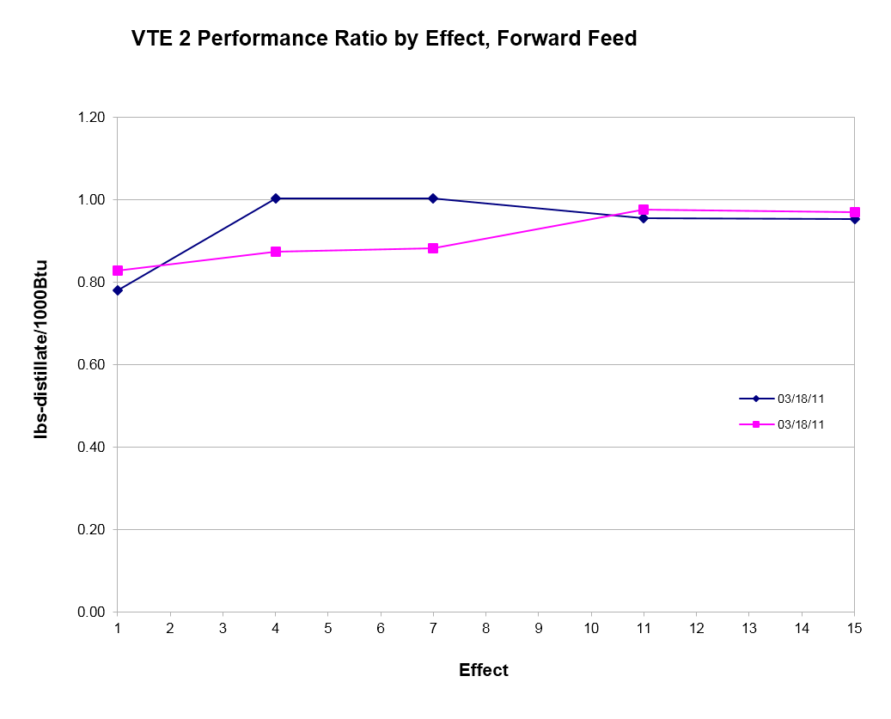
Figure 22. VTE 2 Performance Ratio measured at effect 1, 4, 7, 11, and 15 operating conditions

Figure 23. Performance Ratio interpolated from 5 Effect conditions matching 15 Effect Commercial VTE
Table 4. Design Data for 30 MGD 25 Effect VTE-MED Plants

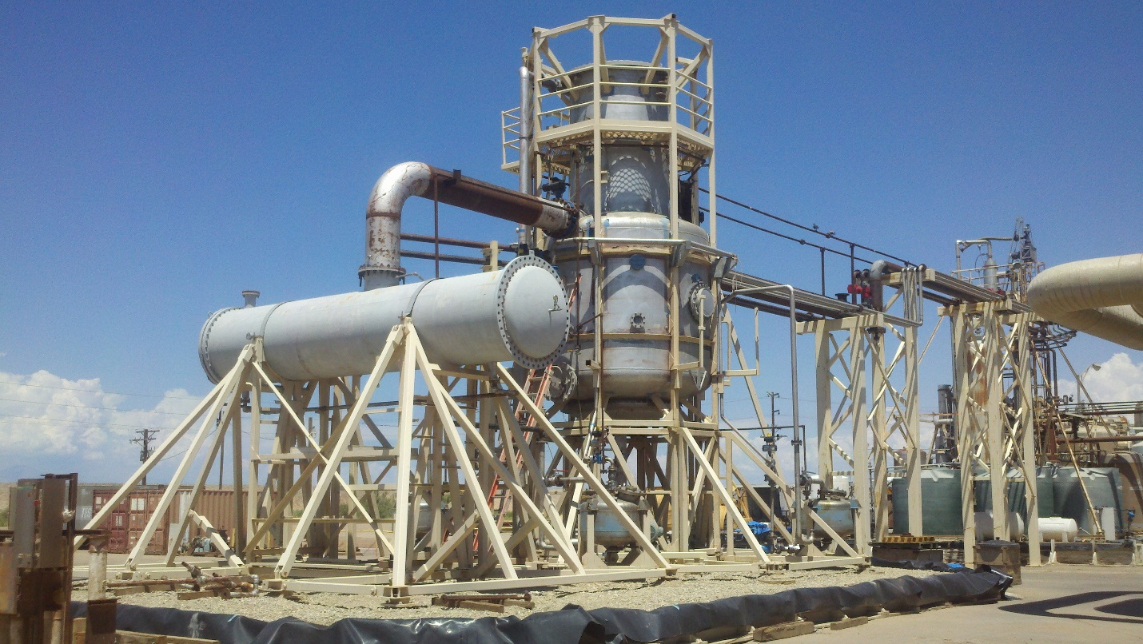
Figure 24. VTE Demonstration Plant under construction with VTE Pilot Plant in the background right.
A larger VTE Demonstration Plant is in the final stages of construction at the CalEnergy geothermal plant as seen in Figure 16. The VTE Demonstration Plant has evaporator tubes of the same size, type, and configuration as the designs specified in this Project. It will be used to develop design quality thermal efficiency and operating data to verify the VTE-MED design parameters used for the 30 MGD 25 Effect VTE-MED Plant design shown in Table 4.
Figure 25. Salton Sea Brine Management Process developed in 2009-2010
The process used for the separation of sodium chloride from biological materials, chemical compounds, and other ions in Salton Sea water was developed by a collaborative effort at the VTE Pilot Plant in 2009-2010 between Sephton Water Technology, Dr. William Bourcier, Larry Lein, and Dick Simonis with grant funding from the Bureau of Reclamation. The objective was to beneficially dispose of concentrated Salton Sea brine by co-injection with the 80% of geothermal that is recycled to the geothermal aquifer. The process developed is illustrated in Figure 25. While the process development was successful, there was no immediate need for additional injection brine as the Salton Sea geothermal aquifer has not depleted. The background and benefit of this testing is more completely described in Appendix B. These tests yielded a clear 99% pure sodium chloride brine from Salton Sea water that was successfully concentrated in the VTE Pilot Plant near saturation with 92% recovery of the water as distillate. The mixed salt reject brine from the process developed was successfully concentrated close to saturation in the VTE Pilot Plant with 75% recovery of the water in the brine as distillate. The serendipitous benefit of these tests was conversion of Salton Sea water to 99% pure sodium chloride brine concentrate as shown in the lab analysis in Figure 26.
Figure 26. Lab Analysis of Salton Sea water purified to 99% sodium chloride and concentrated in VTE
After draining from the VTE system, the purified and concentrated sodium chloride brine from the 2010 pilot testing was later sun dried and sent to a second analytical lab. X-ray diffraction analysis showed the material to be 99.3% halite (crystallized sodium chloride), 0.4% sylvite (crystallized potassium chloride), and 0.3% quartz crystals. The X-ray diffraction lab results are in Appendix D1 while Appendix D2 has mass spectrometry analysis of the same sample showing it to be 99.2% sodium and chloride.
The process of producing Solar Salt from seawater with evaporation ponds has been known and practiced for over a thousand of years. Standard methods will be employed, except that purified sodium chloride brine will be delivered to the Solar Evaporation Ponds at near saturation, accelerating the time and reducing the number of sequential evaporation ponds needed to crystallize and dry the salt. Salt refining by vacuum pan evaporation and other methods from Solar Salt or brine mining is well established and practiced worldwide. After reviewing the best options from standard industry practices, a common and reliable salt refining method will be chosen for the 99% pure concentrated sodium chloride brine feedstock the will be available.
Salinity Gradient Solar Ponds have been developed over decades by many researchers and commercially implemented at the Dead Sea in Israel with a 5 MW demonstration plant driven by a heat from a large solar pond. Sephton Water Technology collaborated with the California Department of Water Resources in 1989 to demonstrate a VTE unit running on solar heat from a ½ acre Salinity Gradient Solar Pond at Los Banos, California. Please see Appendix C for more information on the technology and history of Salinity Gradient Solar Ponds.

Water and Salt Treatment Process Proposed for this Project
The water and salt treatment process is illustrated in Figure 27. Salton Sea water will be screened to exclude fish and debris at the intake, sand filtered to remove algae and large particles, and filtered to remove small particles down to 100 microns. Ultra-filtration (UF) will be employed to remove bacteria and all suspended solids down to 0.1 micron. The UF step will be run between 50% and 90% recovery depending on the amount of particulates in the water. Clear, de-carbonated, Salton Sea water will be dosed with a commercial anti-scalant, then fed to Nano-filtration membranes (NF) known to reject more than 99.8% of sulfate and magnesium. Two passes of NF at 80% recovery will reduce all ions but sodium and chloride to very low concentrations.
Permeate from the 2 passes of Nano-Filtration will be brine with a TDS slightly over half that of the Salton Sea source water with 99% or more of the dry weight consisting of sodium chloride. This will be concentrated in a VTE-MED Plant to the saturation point of sodium chloride, while recovering 92% of the water as distillate.
The saturated sodium chloride brine will then be either further evaporated and crystallized to 99.9% pure sodium chloride in a Vacuum Salt Refining Plant, or the brine can be sun dried in a Solar Evaporation Pond to yield commercial grade Solar Salt at 99% purity.
Reject from the 2 passes of Nano-Filtration will be brine with a TDS about 12% higher than the Salton Sea source water with a mix of salts including elevated concentrations of sulfate and magnesium compared to the Salton Sea. The NF reject will also be concentrated in a VTE/MED process, but only to 75% recovery of water because elevated sulfate and calcium will risk gypsum scaling, and substantial precipitation of suspended solids will occur above a 4:1 concentration factor. Scale will be controlled in the NF reject concentration process by the DSSE method that has been effective in evaporating Salton Sea brine to high concentration in testing done at the Salton Sea over the last several years. After removing the suspended solids, the concentrated NF reject brine should be well suited for use in the bottom layer of a salinity gradient solar pond to directly collect and store solar heat for use as needed generating electricity or driving a thermal desalination process. About 75% of the water in the NF reject will be recovered as distilled water and the rest will go to the salinity gradient solar ponds as low evaporation loss playa coverage.
Figure 27. Salton Sea Water and Salt Treatment Process
The process illustrated in Figure 27 shows solar heat in a salinity gradient solar pond being used to drive the MED concentration of NF reject. This is logical as the brine product would be used to fill new solar ponds with saturated brine. However in the early process implementation, before many salinity gradient solar ponds are built, this process will use heat from geothermal steam and be run in the five lower temperature effects of a 25 effect 30 MGD VTE-MED Plant module.
The key energy inputs to the process in Figure 27 are sunshine, collected and stored as heat in the bottom of a salinity gradient solar pond, electricity to run pumps and controls, and heat from low pressure (LP) geothermal steam. Several geothermal plants near the southeast shore of the Salton Sea flash spent geothermal brine to steam at slightly over atmospheric pressure (referred to as AFT steam) before injecting the brine back into the geothermal aquifer. This resource has not been exploited because power generation from very low (atmospheric) pressure steam would not be economic. Starting at about 212°F, this AFT steam is in a useful temperature range to drive up to 25 MED effects. The available quantity of this discarded steam resource is not sufficient to fully supply one 30 MGD VTE-MED unit so both LP and AFT steam will have to be purchased from current or future geothermal plants at the Salton Sea.

Constructability of Water and Salt Treatment Facilities
Five types of water and salt treatment facilities are planned, some will use well established methods for design and construction, while some will have unique features.
- Salt Separation Plants: Will use standard, highly modular, NF/RO plant construction techniques now well established in the industry. Many vendors of parts and skilled contractors are available, particularly in the San Diego area, an industry center.
- Seawater Distillation Plants: While VTE technology has a long history, there are not many experienced suppliers. The plants will have unique design features. Heat exchanger tube bundles can be built by existing manufacturers and shipped in. The plants must be locally assembled and welded in large modular units.
- Solar Salt Evaporation Ponds: Simple earthworks construction using long established evaporation pond designs will work. Salton Sea playa soils may present some challenges, but the berms will be low (4ft) with very little hydrostatic pressure.
- Vacuum Pan Salt Refining Plants: Standard plant design and construction techniques will be used. Rail spurs and loading facilities will probably be needed to connect salt transport to the existing rail line about 10 miles away.
- Salinity Gradient Solar Ponds: The technology has a long history, but only several constructed ponds (including one near Yuma). The earthworks are simple, but. Salton Sea playa soils may present challenges. Some new technology and materials may be used.

VTE-MED Construction
The 30 MGD 25 Effect VTE-MED Plants will be based partly on design principles developed for a 75 MGD 30 Effect vertically stacked VTE-MED plant designed for the Metropolitan Water District of Southern California (MWD) in the mid 1990’s. This design was successfully pilot tested for desalination of seawater in Huntington Beach, but was never built because Imperial Valley water transfers were cheaper. Due to the high seismic risk in the Salton Sea region, the lower profile vertical stack design shown in Figure 28 will be used with five effect stacks per 75 foot high steel vessel compared to 30 Effects stacked in a single 300 foot high concrete cylinder used in the MWD design. Five 75 foot high vacuum vessels will be welded in place, side by side, with steam and water piping connections between them. Corrosion resistant stainless steel sheeting will be welded to the inside of the steel vacuum vessels and to the decking between the five effect stacks. Evaporator tube bundles will be factory manufactured by heat exchanger suppliers to a 12ft maximum diameter for truck transport to the plant site. The tube bundles will be lowered into pace with a crane and capped with hemispherical heads bolted in place. Piping will be welded on site connecting steam and water to the vessels, with pumps shipped in and installed to the piping. Plastic HDPE pipe will be run to the Salton Sea to deliver seawater to the plant, and brine to solar ponds, with provision to relocate the intake as the Sea recedes. Plastic piping will connect the VTE-MED Plant to the adjacent Salt Separation and Vacuum Pan Salt Refining Plants.
Figure 28. Stacked Multi-Effect / Stacked Single Effect VTE designs from U.S. Patent #6,309,513

Salinity Gradient Solar Pond Construction
Salinity Gradient Solar Ponds have been built sporadically over several decades using a variety of construction techniques. Most have used sloped earthen berms or excavations lined with high temperature plastic sheeting. One recent large 60 acre single pond construction on Wellton-Mohawk Irrigation and Drain District land near Yuma, Arizona is shown in Figure 29. This solar pond has a multi-layered compacted clay base. Standard earth moving equipment with a small crew were sufficient to construct this pond on a very low privately funded budget.
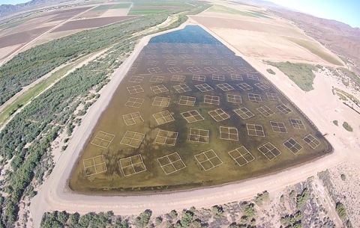
Figure 29. 60 acre Salinity Gradient Solar Pond constructed near Yuma, AZ
A grant funded pilot test to determine the feasibility of constructing Salinity Gradient Solar Ponds on the Salton Sea playa is still in the design and permitting phase after four years of delays. That pilot project is managed by IID in collaboration with Sephton Water Technology and with steam and land resources provided by CalEnergy Operating Company. A conceptual drawing of the small pilot project is shown in Figure 30. The newly exposed Salton Sea playa site for that pilot project is shown in Figure 31.
This pilot project will construct a small ¼ acre Salinity Gradient Solar Pond and an adjacent ¼ acre marine habitat pond from compacted earthen berms filled from nearby quarry materials. The solar pond will be lined with high temperature plastic to contain the mixed salt brine against seepage, for both environmental and economic reasons. In addition to examining construction and operational issues, this pilot test will identify whether or not there are any environmental problems with wildlife habitat closely co-existing with Salinity Gradient Solar Ponds.

Environmental Issues of Water and Salt Treatment Facilities
The environmental issues raised from constructing the facilities located next to the geothermal plants will be similar to those of the geothermal plants themselves, with extensive environmental documentation and permitting required. The power source will be 100% renewable geothermal and solar, so greenhouse gas and air pollution issues should be limited to construction equipment and salt transport by rail or road. Since thousands of tons of salt will produced, the transportation air impact may be significant, mitigated by the benefit to Salton Sea restoration and aquatic habitat and by dust suppression. The impact on dust will be a net positive with construction dust more than offset by long term playa dust suppression. There will be no discharge of wastewater from the facilities outside of human waste from plant and construction crews.
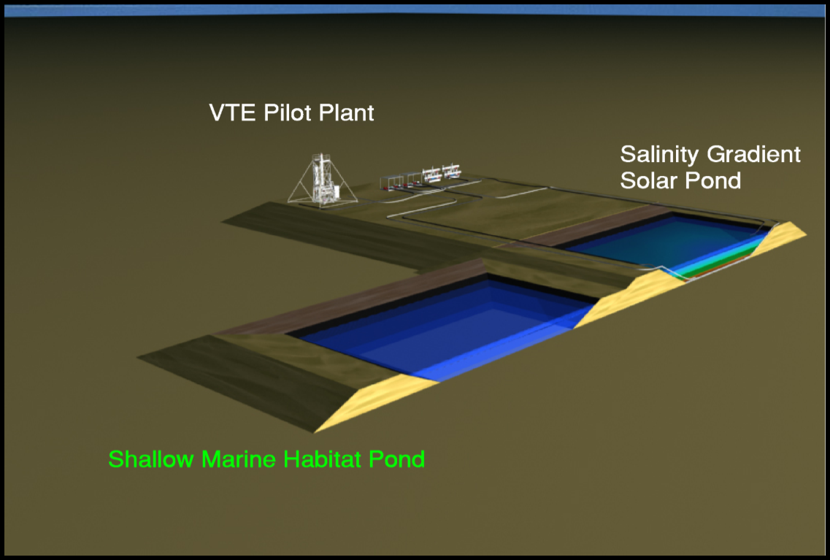
Figure 30. Conceptual Drawing of ¼ acre IID/Sephton Salinity Gradient Solar Pond Pilot
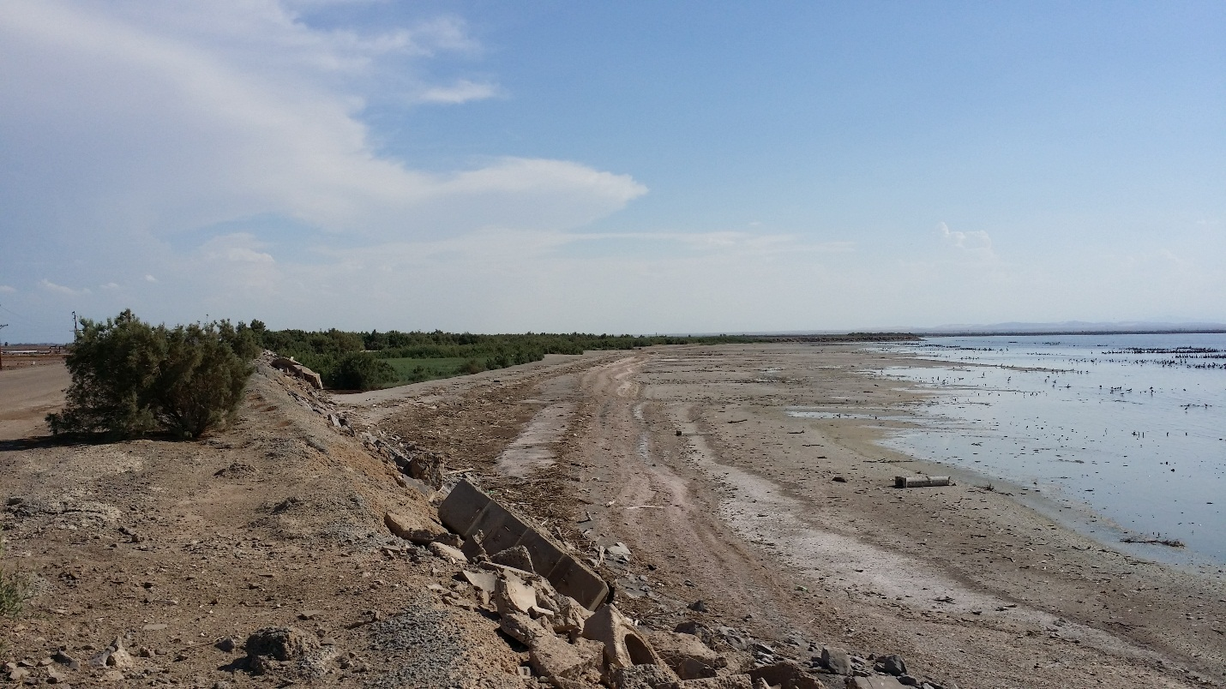
Figure 31. Site for ¼ acre IID/Sephton Salinity Gradient Solar Pond Pilot on new Salton Sea playa
Visual impacts will be mitigated by placement of the water and salt treatment plants adjacent to geothermal plants, however there will be an increase in the number of industrial structures on the landscape. The area on the south shore of the Salton Sea is mostly agricultural and industrial with no private residences in the immediate area. Some of the construction may be near a Federal Wildlife Refuge, but no direct intrusion on that land is expected.

