Harnessing Geothermal Energy with the Self Contained In-Ground Geothermal Generator and Self Contained In-Ground Geothermal Heat Exchanger

Nikola N. Lakic

78-365 Hwy 111, #402, La Quinta, California, 92253

[nlakic@GeothermalWorldwide.com](mailto:nlakic@GeothermalWorldwide.com)

**Keywords:** geothermal energy, electricity, desalinization, clean environment, Geothermal Power, Electricity, Importing Seawater, In-Line-Pump, In-Line-Generator, Renewable Energy, Heat Exchanger, Desalinization, Potable Water, Lithium, Environment, Wildlife Sanctuary, Tourism.

# Abstract

There is an infinite source of energy under our feet, whether it is a few miles underground or on the ground surface in locations such as Hawaii. The question was, until now, how to harness it expediently and efficiently? The presented methodology capitalizes on our planet’s natural internal heat. The essence of the Scientific Geothermal Technology is transferring heat from heat sources to the power units with completely closed-loop systems. The Self Contained In-Ground Geothermal Generator (SCI-GGG) system uses several completely closed-loop systems and generates electricity down at the heat source and transmits it up to the ground level by using electrical cables. The SCI-GGG apparatus consists of a boiler; a turbine; a converter; a generator; a condenser distributor; and a condenser that is arranged to function in confined spaces such as in a wellbore. The SCI-GGGG absorbs heat from the heat source (hot rocks, lava, geothermal reservoir, geysers, etc.) and generates electricity at the heat source which is then transmitted by cable up to the ground surface to electrical grids for use in houses and industry. In the process of cooling the engine compartments with a separate closed-loop system which is the Self Contained In-Ground Heat Exchanger (SCI-GHE system) additional electricity is generated on the ground surface.

The Self Contained In-Ground Heat Exchanger (SCI-GHE) system is an integral part of the SCI-GGG system and can function independently. The system consists of a closed-loop thermally insulated line with 2 coiled pipes (heat exchangers) with at least one “In-Line-Pump”. The first heat exchanger is lowered at the heat source and the second heat exchanger is coupled into the evaporator of a binary power unit on the ground surface which produces electricity by using the Organic Rankine Cycle (ORC).

# 1. Introduction

## 1.1 Note:

Presented paper with the title “Harnessing Geothermal Energy with the Self Contained In-Ground Geothermal Generator and Self Contained In-Ground Geothermal Heat Exchanger” is a segment of the comprehensive design for the long-term solution for the restoration of the Salton Sea (Lake in California). The solution for the restoration of the Salton Sea includes an architectural element that harmoniously implements several breakthrough technologies into a self-sustaining organism. There are five phases (segments) of the project including harnessing solar and hydro energy which are excluded for this occasion as not relevant to the geothermal issue. Each of the phases (segments) is essential for the final result of the project. Either of two presented systems “Harnessing Geothermal Energy with the Self Contained In-Ground Geothermal Generator” and “Self-Contained In-Ground Geothermal Heat Exchanger” is a fundamental segment of the comprehensive design on which the function of other segments depends.

For this occasion, the paper “Harnessing Geothermal Energy with the Self Contained In-Ground Geothermal Generator and Self Contained In-Ground Geothermal Heat Exchanger” is marked as a (Segment II). For a complete understanding of this segment, it is necessary to review the other two integral parts of the comprehensive design with titles “Harnessing Energy and Water in the Salton Sea” as a (Segment I), and “System for Drilling Deeper and Wider Wellbores” as a (Segment III).

## *1.2 Overview of the contemporary geothermal power plants:*

Contemporary geothermal power plants are limited to geothermal reservoirs. The production wells need to be drilled into the geothermal reservoirs to bring hot water to the power plant on the ground surface. Then, after removing silica steam is used to spin turbines creating mechanical energy. The shaft from the turbines to the generator converts mechanical energy into electrical energy. The used geothermal fluid is then returned down through injection well into the reservoir to be reheated, to maintain pressure, and to sustain the reservoir. Contemporary geothermal power plants are limited to the location with a geothermal reservoir. The experimental Enhanced Geothermal Systems (EGS) needs the formation of the geothermal reservoir – at least 1 cubic kilometer – which is a serious limitation. There is an infinite source of energy under our feet, whether it is a few miles underground or on the ground surface in locations such as Hawaii. The question was, until now, how to harness it expediently and efficiently?

***1.3 Summary of the Self-Contained In-Ground Geothermal Generator (SCI-GGG):***

The "Self-Contained In-Ground Geothermal Generator" (SCI-GGG) system for harnessing geothermal energy (hot rocks, hydrothermal reservoir) to produce electricity consists of:

1. Lowering the (SCI-GGG) apparatus into a pre-drilled well bore deep to the source of heat.
2. Absorbing heat from the source of heat and generating electricity at the source of heat and transmitting electricity to the ground surface by using electric cable.
3. In the process of cooling engine compartments with separate closed-loop system additional electricity is generated on the ground surface with the binary power unit by using the Organic Rankine Cycle (ORC).

The "Self-Contained In-Ground Geothermal Generator" (SCI-GGG) system consists of several main compartments: a boiler compartment; a turbines compartment; a generator compartment; a condenser distributor compartment; and a condenser compartment that is arranged so to function in limited space such as a wellbore (See Fig. 1).

The boiler is exposed to the heat of hot rocks while the rest of the apparatus is thermally insulated from the heat and is additionally cooled with a second closed-loop system. The second closed-loop system is engaged with the third closed-loop system on the ground surface, which is the Binary Power Unit, and can function separately as an independent apparatus – explained further as the "Self-Contained In-Ground Heat Exchanger" (SCI-GHE) system. If needed, the Organic Rankine Cycle (ORC) is applicable here. The condenser compartment is formed between two cylindrical walls which surround the turbines, generator, and condenser distributor compartment, and is cooled by circulating water through the condenser with a second closed-loop system. Heated water is brought up on the ground surface to a heat exchanger which is engaged with a third closed-loop system which is the Binary Power Unit (See Fig. 2). By lowering the SCI-GGG apparatus in a predrilled wellbore to the hot rocks, or hydrothermal reservoir, electricity is generated below the ground and transmitted up to the ground surface by an electric cable and subsequently through an electric grid to the houses and industry.

One power plant consists of a few dozen wellbores with SCI-GGG apparatuses; a cooling system exchanging heat on the ground surface using a multi-phase cooling system and binary production units which also produces additional electricity; and a control center (See Fig. 5). The production capacity of the power plants depends on the number of the wellbores, and diameter and the length of the apparatus, and of course, the temperature of the hot rocks. Deeper we drill the higher temperature of the rock formation we can reach. The (SCI-GGG) system uses several completely closed-loop systems and eliminates the issues of pumping geothermal fluid on the ground surface, filtration, separation, equipment corrosion, scaling, and groundwater pollution, etc., and at no time is there any contact with the environment by the working fluid or the heat exchange fluid, therefore, it doesn’t pollute the environment.

Although the main purpose of the (SCI-GGG) system is to use limitless dry hot rocks for the production of electricity, the (SCI-GGG) system is not limited to dry hot rocks - it can be lowered into the existing hydrothermal reservoir or can be suspended with cable over lava flow (lava tube) in locations such as Hawaii.

Here is introduced a radical change in how geothermal energy can be harnessed more efficiently. This system is not limited to a hydrothermal reservoir. Instead of having an injection well and production well and formation of fractured rocks between them (nest) and need of, at least one cubic kilometer, of water as is the case in the EGS, which is extremely difficult to find these days, and a single power unit - the presented system introduces a “Vertical approach” – multi wellbores – completely closed-loop system – and multi (smaller) power units using piston system instead of turbines although turbines can be used too. With a new drilling methodology, presented in Segment III(V), that can be achieved because now we can search for and reach a permanent source of energy and not be excessively dependent on the geothermal reservoirs as is the case in the conventional system for harnessing geothermal energy.

***1.4 Summary of the Self-Contained Geothermal Heat Exchanger (SCI-GHE):***

The "Self-Contained In-Ground Heat Exchanger" (SCI-GHE) system is an integral part of the "Self-Contained In-Ground Geothermal Generator" (SCI-GGG) system and can operate independently. The SCI-GHE system is less powerful than the SCI-GGG system because generates electricity only on the ground surface but is easier to build and maintain. The "Self-Contained In-Ground Heat Exchanger" (SCI-GHE) system consists of a closed-loop thermally insulated line with two heat exchangers (the first heat exchanger and a second heat exchanger - coiled pipes) and at least one In-Line-Pumps (See FIGs. 3,4 and 7). The first heat exchanger is lowered at the source of heat and the second heat exchanger is coupled into the evaporator of a binary power unit on the ground surface which produces electricity.

The SCI-GHE system can be used in many applications with minor modifications. In the presented application which is relevant to the restoration of the Salton Sea the boiler is filled with salty water from the bottom of the Lake to the level “H” (See Fig. 7). The water in the boiler is heated with a second heat exchanger. The generated steam feeds the “piston power unit” which generates electricity (See Fig. 7-10). Electricity is then transmitted through an electric grid. Exhausted steam enters the condenser where potable water is generated as a free byproduct. Remaining water from the boiler now level “L” is injected into the wellbore to improve the conduction of the heat from surrounding hot rocks to the first heat exchanger. After a certain period, the wellbore will be filled with brine from the boiler and periodically pumped up trough excavation line to the mineral extraction facility to be used as a source for extraction of lithium. Different methods for extraction of lithium can be used including ion-imprinted polymers.

One of many Power Plants consists of 24 wellbores drilled in a circle of radius of about 500 meters. Each wellbore has the “Self-Contained In-Ground Heat Exchanger" (SCI-GHE) system. The power plant has four identical modular quarters each having a mineral extraction facility (See FIGs. 5 and 6).

The presented the "Self-Contained In-Ground Heat Exchanger" (SCI-GHE) system is designed for a location where there is a substantial heat source and where heat flux is not an issue. For locations where heat flux is an issue, the SCI-GHE system can be modified to incorporate an in-line pump for steering hot fluid around the first heat exchanger and/or can be modified to incorporate a motorized drill-head to drill and move the whole drilling/heat exchange apparatus deeper in search for hotter temperatures (See Fig. 7). That system is presented in more detail in segment III (V) – the System for Drilling Deeper and Wider Wellbores

With presented technology now we can tap to limitless geothermal energy with less limitations.

**ADDENDUM**

(The section “2” below is added later after submission of paper)

**2.** Preliminary Cost Estimate and Revenue for the Proposed Power Plant:

The Proposed Geothermal Power Plant(s) - the “Scientific Geothermal Technology” consists of 24 well-bores and with many projected power plants (in 100s) drilling is most expensive and most important part, therefore we need to implement a new system for drilling faster, deeper and wider wellbores.

***2.1*** *Preliminary Cost Estimate for the Proposed Power Plant:*

The cost for 60” diameter wellbore 8,000 feet deep might cost about $16,000,000.

24 wellbore x $4M = **$384,000,000**.

Binary Power Unit of 4 MW might cost about $100,000;

(Binary Power Unit of 4 MW is modest assumption.)

24 Binary Power Unit x $100,000 = $2,400,000;

The Control Center might cost about $4,600,000;

The Mineral Extraction Facility might cost about $10,000,000;

The potable water Pond might cost about $5,000,000;

Piping system might cost about $2,000,000;

A new Derrick might cost about $10,000,000;

One Geothermal Power Plant might cost about **$418,000,000.**

Three (3) Power Plant including final development of the drilling system might cost about **$1,254,000,000**.

The new drilling system is more expensive at this earlier stage because of development cost, but in the long term, it would be better and less expensive solution.

Several initiating power plants on several sectors around the Salton Sea would be able to provide finance for subsequent power plants.

An analogy of this new drilling system in comparison to conventional drilling systems could be made - as comparison between new digital TV system and analog TV system that we switch from 15 years ago.

More power plants are built with the initial budget the faster we will proceed with subsequent power plants and the whole project, which final result will be more clean energy and more potable water.

It is realistic to conclude that Phases I – IV, would cost around $15 billion dollars, (preferably less) with the final result of “really” saving the Salton Sea and providing conditions for tourism, clean energy, potable water, and prosperous economy.

2.2.1 Preliminary Estimate of Production Capacity of one Geothermal Power Plant:

Proposed Geothermal Power Plant(s) the “Scientific Geothermal Technology” consist of 24 well-bores and 24 Binary Power Units. Rough estimate for production capacity of one Power Unit is about 4 Mwh.

24 “Binary Power Units” x 4 MW = 96 MWh; ~ 100 MWh;

2.2.2 Preliminary Estimate of Revenue of one Geothermal Power Plant:

Assumed price of $60 per MWh;

$60 x 96 MWh = $5,760 per hour;

$5,760 x 24h = $138,240 per day;

$138,240 x 365 days = $50,457,600 per year;

**3.** Preliminary **Estimate for Extraction of Lithium from water of the Salton Sea:**

**Salton Sea Facts:**

Surface: 350 square miles (910 km²).

Inflow: < 1,200,000 acre-feet (1.5km³).

Depth: 43 feet (13 m).

Volume: 6,000,000 acre-feet (74 km³).

Salinity: 56 grams per liter.

[Pacific Ocean is: 35 gm /L].

Salt concentration has been increasing per year 3%.

About 4,000,000 Tons of salt are deposited in the Valley (Salton Sea) each year with irrigation water.

1,000,000 acre-feet = 1,233,481,837.54 Kiloliters (Kl).

1,233,481,837.54 Kiloliters (Kl) = 1,213,746,128 Tons.

1,213,746,128 Tons ÷5,000,000 = 242.75 Tons of Lithium.

Import of 1,000,000 acre-feet of seawater from Route #1 (Gulf of California - San Felipe) brings about **242.75 Tons of Lithium per year.**

Import of 2,000,000 acre-feet of seawater from Route # 2 (Pacific Ocean - Long Beach brings about **485 Tons of Lithium per year.**

Import of 242.75 Tons of Lithium from Route #1 (+) 485 Tons of Lithium from Route #2 - it sums up to **727.75 Tons** of Lithium per year.

Since the water of the Salton Sea is about 50% saltier than the water from the Ocean it is realistic to expect that about **1000** **Tons of Lithium per year** can be extracted from the Salton Sea.

Economical lithium-source brine (lithium chloride) normally contains anywhere from a few hundred parts per million of lithium to upward of 7,000 ppm.

Sea water is a very poor source for the extraction of Lithium because the lithium concentration of sea water is about 0.2 parts per million (e.g., recovery of 1 ton of lithium requires treating 5 million tons of water).

Increasing concentration of brine by inducing evaporation inside the “Mineral Extraction Building” which function as a “Green House” and in process condensing vapor as water – a free byproduct. By repeating the process of adding salty brine into “evaporation tray” and inducing evaporation – it increases concentration of brine in the “evaporation try”. This process does not need expensive electric energy. The evaporation is induced by hot pipes positioned underneath the “evaporation try” (See Figs. 11-13).

The price of Lithium per metric ton as of 2019 is: $13,000. Lithium price is expected to rise.

Estimated revenue from extracted lithium from salty water from the Salton Sea:

1000 Tons x$13,000 = $**13,000,000** per year.

**4.SUMMARY:**

The Cost of One Geothermal Power Plant: **$418,000,000.**

The Cost of 3Power Plant: **$1,254,000,000.**

(Estimate of Production Capacity of one (1) Geothermal Power Plant: **100 MW).**

Estimate of Production Capacity of three (3) Geothermal Power Plant: **300 MW**.

(Preliminary Estimate for Revenue of one (1) Geothermal Power Plant: **$50,457,600** per year)**.**

Preliminary Estimate for Revenue of three (3) Geothermal Power Plant: **$151,372,800** per year**.**

Estimate for Extraction of Lithium from the water of the Salton Sea:$**13,000,000** per year

# 5. DISCLOSURE - (ILLUSTRATIONS) - the Self Contained In-Ground Geothermal Generator and Self Contained In-Ground Geothermal Heat Exchanger (SEGMENT II (IV))

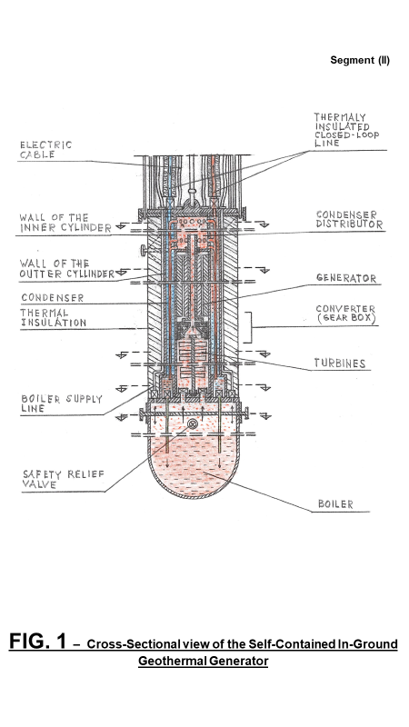

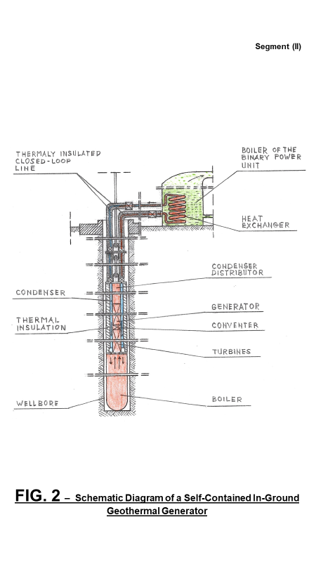

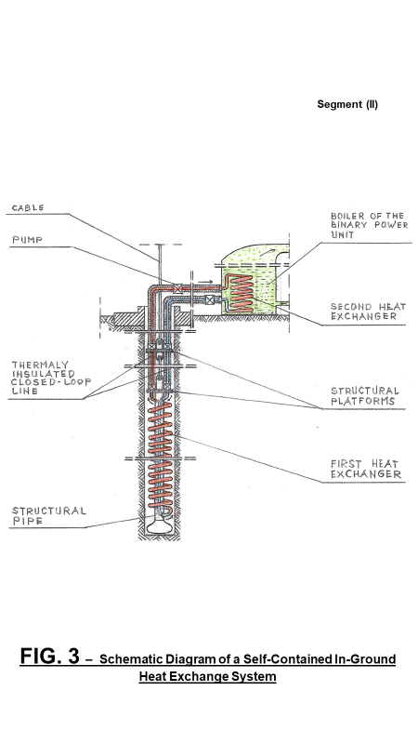

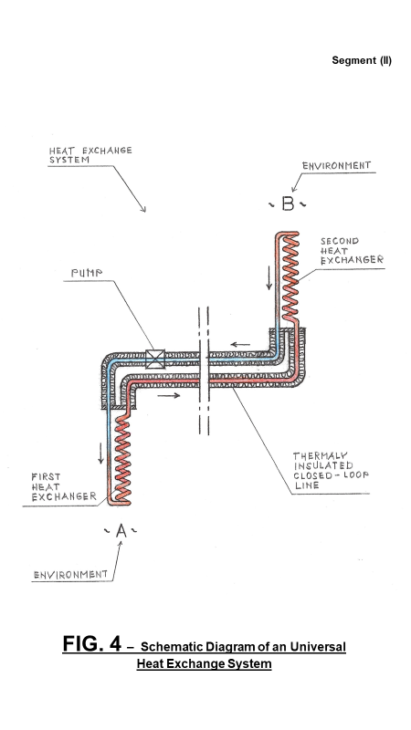

# 

# 

# 

# 

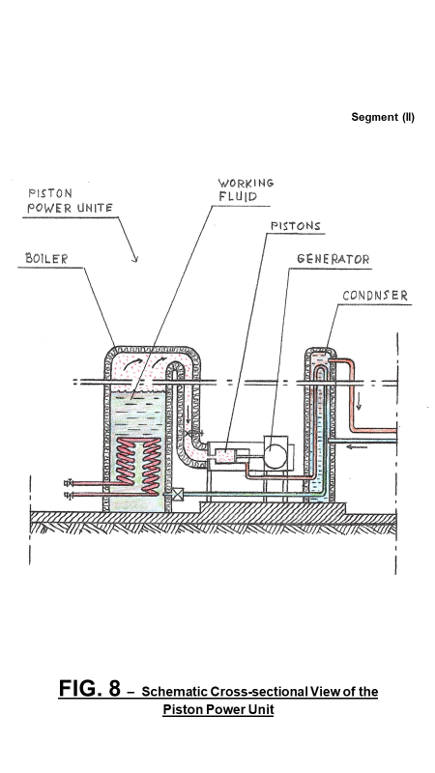

# 

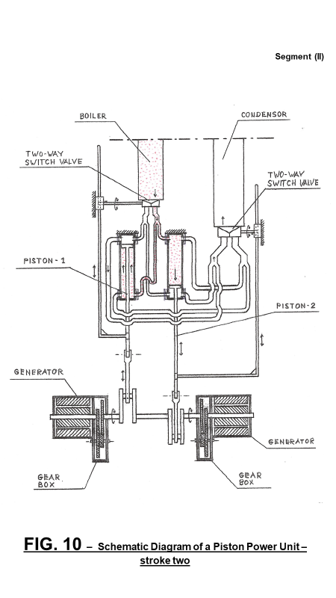

# 

# 

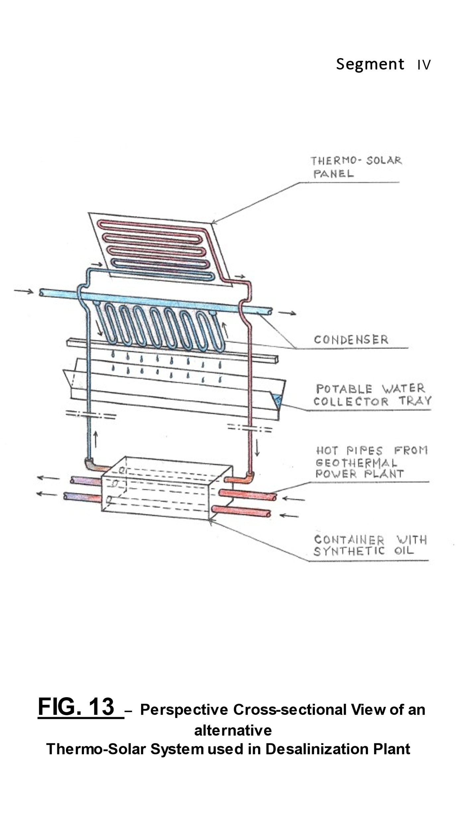

# 3. Conclusion:

The essence of the presented technology - the SCI-GGG system - is using several completely closed-loop systems and generating electricity at the source of heat and transmitting electricity to the ground surface by using an electric cable.

Also, the essence of the presented technology - the SCI-GHE system - is transferring heat from heat sources to the power units with completely closed-loop systems.

Although the presented system is a part of a geothermal power plant designed to incorporate the local condition of the Salton Sea area to generate electricity, to generate potable water, desalinate the Lake, and to generate the brine which can be used for the extraction of lithium - the presented system is not limited to this location (application). With presented technology now we can tap to limitless geothermal energy with less limitations.

**SUMMARY:**

The Cost of One Geothermal Power Plant: **$418,000,000.**

The Cost of 3 **Power Plant**: **$1,254,000,000.**

Energy generated: **300 MW.**

Preliminary Estimate for Revenue of one Geothermal Power Plant: **$50,457,600** per year**.**

Estimate for Extraction of Lithium from the water of the Salton Sea:$**13,000,000** per year

# 4. REFERENCES

U.S. Patent No. 7,849,690; Entitled: “Self-Contained In-Ground Geothermal Generators” (SCI-GGG); Issued on Dec.14, 2010;

U.S. Patent No. 8,281,591; Entitled: “Self-Contained In-Ground Geothermal Generators” (SCI-GGG); Issued on October 9, 2012;

U.S. Patent No. 8,713,940; Entitled: “Self-Contained In-Ground Geothermal Generators”; Issued on May 6, 2014;

U.S. Patent No. 9,206,650; Entitled: “Apparatus for Drilling Faster and Wider Wellbore; Issued on December 8, 2015;

U.S. Patent No. 9,978,466; Entitled: “Self-Contained In-Ground Geothermal Generator and Heat Exchanger with In-Line Pump; Issued on May 22, 2018;

U.S. Patent No. 9,982,513; Entitled: “Apparatus for Drilling Faster and Wider Wellbore with Casing; Issued on: May 29, 2018;

U.S. Patent No. 9,995,286; Entitled: “Self-Contained In-Ground Geothermal Generator and Heat Exchanger with In-Line Pump and Several Alternative Applications; Issued on: June 12, 2018;

U.S. Patent No. 11,098,926; Entitled: “Self-Contained In-Ground Geothermal Generator and Heat Exchanger with In-Line Pump used in Several Alternative Applications including the Restoration of the Salton Sea. Issued on August 24, 2021;

Several patent-pending applications.