Harnessing Energy and Water in the Salton Sea (Segm. III)

(System for Harnessing Solar Energy)

Nikola N. Lakic.

Geothermal Worldwide, Inc.

78-365 Hwy 111, #402, La Quinta, CA 92253

E-mail address: [nlakic@GeothermalWorldwide.com](mailto:nlakic@GeothermalWorldwide.com)

**Keywords**

Geothermal, Environment, Wildlife Sanctuary, importing seawater, Tourism, Renewable Energy, Electricity, Solar Power, Geothermal Power, Heat Exchanger, In-Line-Pump/Generator, Geothermal Self Contained In-Ground Geothermal Generator, Desalinization, Lithium.

# ABSTRACT

The Salton Sea in California is a terminal lake with reduced inflow from the Colorado River as a result of the water transfers related to the Quantification Settlement Agreement (QSA). The Lake is shrinking and exposing the receding shoreline (toxic playa) to the elements and facing incoming environmental disaster.

The presented proposal includes an architectural element that harmoniously incorporates several patented technologies into a self-sustaining organism. It is a long-term solution for the restoration of the Salton Sea.

The presented proposal includes several options based on the same concept: 1) Dividing the Lake into three sections; 2) Importing seawater from the Ocean, and; 3) Harnessing prevalent geothermal and solar energy. In this segment (III), the emphasis is on using the pipeline for importing seawater as a foundation for solar panels assemblies.

The presented system for importing seawater and using the pipeline as a foundation for the solar panels is a fundamental value in determining the feasibility of the phase of importing seawater into the Salton Sea which is the essential phase for harnessing geothermal energy and for the restoration of the Salton Sea.

The pipeline provides a substantial surface that otherwise would need to be selected, leased, or purchased. By using the pipeline as a foundation for solar panels assembly it eliminates expenses for leasing or purchasing a location, therefore, increasing the revenue.

Presented Thermo-Optical Solar system (TOS) consists of a panel and/or dish with several indentations in the shape of parabolas with a reflective coating inside and a transparent cover with lenses. The panel or dish also contains a closed-loop heat exchange system with the first heat exchanger positioned in focal points of parabola and lenses, and a second heat exchanger positioned into the boiler of the binary power unit nearby. The power units consisting of the evaporator with a working fluid, a piston engine with generators, and a condenser.

## 1. Introduction

The solar farms on an industrial scale require a substantial surface of the land for solar panels positioned around power generating facilities. That land needs to be selected, leased, or purchased. The Conventional Photo Voltaic (PV) solar panels are efficient only about 15% -20%.

The pipeline corridor provides a substantial surface of the land that otherwise would need to be selected, leased, or purchased. By using the pipeline as a foundation for solar panels assembly (See FIG. 1) eliminates expenses and increase the revenue. In this proposal is presented a new Thermo-Optical Solar system (TOS) which consists of a panel or dish (See FIG. 1 – 5).

Presented Thermo-Optical Solar system (TOS) consists of a panel and/or dish with several indentations in the shape of parabolas with a reflective coating inside and a transparent cover with lenses. The panel and/or dish also contains a closed-loop heat exchange system (See FIG. 1-4 and 6) with the first heat exchanger positioned in focal points of parabola and lenses, and a second heat exchanger positioned into the boiler of the binary power unit nearby (See FIG. 1). The power units consisting of the evaporator with working fluid, pistons with generators, and a condenser (See Fig. 7-8). There is also a battery pack (See FIG. 1).

The dish has a parabolic indentation with a reflective surface to reflect sunrays into the focus of the parabolic cavity where the first heat exchanger is positioned. This system also uses lenses to focus sunrays in an additional part of the first heat-exchanger positioned in a focal point of the lances. The synthetic oil circulates through the first heat-exchanger positioned into panel and/or dish, which is connected to the second heat exchange positioned into the evaporator of the power unit which generates electricity(See FIG. 6- 8). The power unit consists of a Boiler (evaporator), pistons unit, gearbox, generators, and condenser.

In this presentation, the Thermo-Optical solar system use breeze and cooler temperature of the pipeline for cooling the condensers (See Fig. 1). The presented system for harnessing solar energy used in the process of importing seawater is a necessary part for the restoration of the Salton Sea, CA, although technology is not limited to the Salton Sea project. The presented system can be used in the residential sectors and for desalinization and production of potable water.

The presented “thermo-optical solar system” has not been tested yet, but it is realistic to expect that it can generate multi-fold electricity per unite surface than a photovoltaic system because power density is substantially higher. The size of the panels is similar to the conventional PV panels with slightly higher thickness.

### 1.1 Overview of the Proposal for Harnessing Solar Energy in the Process of Importing Seawater for the Restoration of the Salton Sea.

**ADDENDUM**

In this segment some values are changed from the original papers. Namely, the ratio between Photo Voltaic PV panels and “Thermo-Optical Solar” (TOS) panel here is used only two-fold. In original papers was used five-fold ratio.

The presented “thermo-optical solar system” has not been tested yet, but it is realistic to expect that it can generate multi-fold electricity per unite surface than the photovoltaic system because power density is substantially higher.

Photo Voltaic PV panels on 160 miles (length of pipeline) = 141.137 acres of panels (see section 1.3). ==>

141.137 acres (of panels) x 1.5 MWh (average production of electricity with the PV system) = 211.76 MWh.

Although several-fold ratio would be a more realistic ratio for the (TOS), here is calculated the only two-fold ratio.

=> 211.76 MWh. x 2 **=** 423.52 MWh.

160 miles (length of pipeline) Route #1 can generate **423.52 MWh**.

***1.2 Preliminary Cost Estimate for Energy generated from Thermo-Optical Solar System used in the process of importing Sea Water from the Ocean into the Salton Sea.***

The length of most of the proposed pipeline routes is about 160 miles. Out of 5 here are presented only 2 the most feasible corridors. For easier calculation here is calculated the length of the pipeline to be 1 mile. For any particular distance, final results can be easily calculated.

### 1.3 Preliminary Estimate for Capacity of the Solar Panel Assembly:

There are two solar panels assembly on each segment of the pipeline (see FIG. 1). One solar assembly has two sets of three panels of dimensions about 3.5’ x 5.2’. The length of one segment of the pipeline is about 30 ‘.

1 mile ÷ 30’ = 5,280 feet ÷ 30’ (length of a segment) = 176 pipeline segments.

One set of panels 5.2’ x 3.5’ = 18.2 square feet; => 18.2 square feet x 6 panels = 109.2 square feet. 109.2 square feet x 2 assembly = 218.4 square feet.

218.4 square feet (two assembly) x 176 (segments) = 38,438.4 square feet.

38,438.4 square feet = 0.882332 acres.

One mile of a pipeline can have 0.882332 acres of panels.

0.882332 acres (of panels) x 100 miles (length of pipeline) = 88.2 acres of panels.

(1 acre of solar panels - Photo Voltaic (PV) - produces 1.5 MWh – 1.68 MWh).

88.2 acres (of panels) x 1.5 MWh = 132.34 MWh

0.882332 acres (of panels) x 160 miles (length of pipeline) = 141.137 acres of panels.

141.137 acres (of panels) x 1.5 MWh = **211.76 MWh.**

### 1.4 Preliminary Cost Estimate of the Solar Panel Assembly System assembled on the pipeline system 160 miles distance:

The preliminary cost estimate of one set of the “Thermo-Optical Solar (TOS) panel assembly (see FIG. 1) costs about $ 2,000. The preliminary estimate of two sets of the “Thermo-Optical Solar (TOS) panel assembly assembled on one pipeline segment 30 feet long cost about $4,000 (See FIG. 1 and 2).

176 (pipeline segment per mile) x $4,000 = $704,000; Assuming that every two pipeline segments there are a power unit and a battery.

The preliminary cost estimate of one power unit is $3,000;

The preliminary cost estimate of one battery unit is $3,000;

Let’s call it “power pack” about $6,000.

176 segments ÷ 2 = 88 power pack;

88 power pack x $6,000 = $528,000;

For one mile the cost of 88 power pack is about = **$528,000.**

The cost for one mile of (88 power pack = $528,000) + (352 Thermo-Optical Solar (TOS) panel assembly = $704,000) = **$1,232,000.**

For 160 miles the cost for the Thermo-Optical Solar system is $197,120,000 ~ **$200,000,000**;

For 200 miles the cost for the Thermo-Optical Solar system is $246,400,000 ~ **$500,000,000**;

***1.5 Preliminary Cost Estimate for and Energy generated from*** ***Thermo-Optical Solar System used for pipeline for importing Sea Water from the Ocean into the Salton Sea - Routes #1 & #2.***

1.5.1 Preliminary Cost Estimate for Energy Generated from the Route #1:

160 miles (length of pipeline) Route #1 can generate **423.52 MWh**.

1.5.2 Preliminary Cost Estimate for Revenue Generated from the Route #1:

The Thermo-Optical Solar (TOS) System installed on pipeline Route #1 can generate about **423.52 MWh.** (See Section 1.1).

Revenue generated from the Thermo Optical Solar (TOS) system installed on pipeline Route #1:

**423.52 MWh** x $60 = $25,411 per hour;

$25,411 x 6 hours = $152,467.2 per day;

$152,467.2 x 300 days (sunny days in area per year) = $45,740,160 per year.

**Revenue** generated from the Thermo-Optical Solar (TOS) System installed on pipeline Route #1 would be at least **$45,740,160** per year.

1.5.3 Preliminary Cost Estimate for the Maintenance Expenses for the pipeline - Route #1:

### It is realistic to conclude that the Maintenance Expenses for the Thermo Optical Solar (TOS) system installed on pipeline system for the pipeline - Route #1 is 5% or the revenue generated. Let’s say $2.5 million.

1.5.4 Preliminary Estimate for Energy generated from the solar system on Route #2:

Photo Voltaic PV panels on 200 miles (length of pipeline) = 176.4664 acres of panels ==>.

176.4664 acres (of panels) x 1.5 MWh = 264.6996 MWh.

(1 acre of solar panels produces 1.5 MWh – 1.68 MWh).

Although multi-fold ratio would be a more realistic ratio, here is calculated the only two-fold ratio.

264.7 MWh x 2 fold estimate = 529.4 MWh.

The Thermo-Optical Solar System installed on route #2 pipeline can generate **529.4 MWh.**

529.4 MWh - 275.7 MWh (energy needed for pumping up seawater) = **253.7 MWh.**

Remaining 253.7 MWh can be sold to the grid.

1.5. 5 Preliminary Estimate for Revenue Generated for solar system on Route #2:

529.4 MWh x $60 = $31,764 per hour

$31,764 per hour x 6 hours = 190,584 per day per day.

190,584 per day per day x 300 days = **$57,175,200 per year.**

* $57,175,200 per year - ($29,775,600 transferred for pumping stations)

**Revenue Generated:**  253.7 MWh x $60 = $15,222 per hour.

$15,222 x 6 hours = $91,332 per day per day.

$91,332 per day x 300 days = **$27,399,600 per year.**

1.5.6 Preliminary Cost Estimate for the Maintenance Expenses for the pipeline - Route #2:

### It is realistic to conclude that the Maintenance Expenses for the Thermo Optical Solar (TOS) system installed on pipeline system for the pipeline Route #2 is the same as for Route #1. Let’s say $3 million.

**2.**  ***Overview of the Proposal for Harnessing Solar Energy from the pipeline system for irrigation of the farmland area Northern and Southern from the Salton Sea.***

The south area from the Lake to the border with Mexico, there are three main pipelines (central, western, and eastern) and numerous perpendicular (ribs) pipelines (See segment I, FIGS 3, 4, 5 and 8). The rough estimate of the length of all together pipelines is about 870 miles (40 miles West line + 50 miles Central line + 60 miles eastern line = 150 miles + (24 perpendicular ribs pipelines x 30 miles = 720 miles) => **870 miles**.

Presented “thermo-optical solar system” has not been tested yet, but it is realistic to expect that it can generate multi-fold electricity per unite surface than photovoltaic system because power density is substantially higher.

### 2.1 Preliminary Cost Estimate for Energy Generated from the Thermo-Optical Solar System for the pipeline system for irrigation of the farmland area Southern from the Salton Sea.

For easier calculation here is calculated the length of pipeline of 1 mile. For any distance, the results can be easily calculated by multiplying the value of 1 mile with the specific distance of miles.

There are two solar panels assembly on each segment of the pipeline (see Segment III, FIG. 1). One solar assembly has two sets of three panels of dimensions about 3.5’ x 5.2’. The length of one segment of the pipeline is about 30‘.

1 mile: = 5,280 feet ÷ 30’ (length of a segment) = 176 pipeline segments.

One set of panels 5.2’ x 3.5’ = 18.2 square feet; => 18.2 square feet x 6 panels = 109.2 square feet. 109.2 square feet x 2 assembly = 218.4 square feet.

218.4 square feet (two assembly) x 176 (segments) = 38,438.4 square feet.

38,438.4 square feet = 0.882332 acres.

One mile of pipeline can have 0.882332 acres of panels.

0.882332 acres (of panels) x 100 miles (length of pipeline) = 88.2 acres of solar panels.

(Fact: 1 acre of solar panels PV produces 1.5 MWh – 1.68 MWh).

88.2 acres (of panels) x 1.5 MWh = 132.34 MWh.

0.882332 acres (of panels) x 870 miles (length of pipeline) = 767.43 acres of solar panels (See section 2.6.)

767.43 acres (of solar panels) x 1.5 MWh (average production of electricity with PV system) = 1,151.15 MWh.

Photo Voltaic PV panels on 870 miles (length of pipeline) = 767.43 acres of panels ==>

767.43 acres (of panels) x 1.5 MWh (average production of electricity with PV system) = 1,151.145 MWh.

Although several-fold ratio would be a more realistic ratio for the “Thermo-Optical Solar system”, here is calculated (conservatively) the only two-fold ratio. =>

1,151.145 MWh X 2 = **2,302.29 MWh**.

**2.2.** Preliminary Estimate for Revenue generated from the Thermo Optical Solar (TOS) system installed on pipeline system for irrigation of the farmland Southern area of the Salton Sea:

2,302.29 MWh x $60 = $138,137.4 per hour.

$138,137.4 x 6 hours = $828,824.4 per day.

$828,824.4 x 300 days (sunny days in area per year) = **$248,647,320 per year.**

**Revenue generated** from the Thermo-Optical Solar (TOS) System installed on pipeline system for irrigation for farmland Southern from the Salton Sea would be at least **$248,647,320** per year**.**

NOTE: Here are not calculated solar panels and dishes that can be set up on service roads near the pipelines and electric power lines, but that would double or triple the revenue of the area.

**2.3** Preliminary Estimate for Maintenance Expenses for the Thermo Optical Solar (TOS) system installed on pipeline system for irrigation of the farmland area Southern from the Salton Sea:

### It is realistic to conclude that the Maintenance Expenses for the Thermo Optical Solar (TOS) system installed on pipeline system for irrigation of the farmland Southern area from the Salton Sea will be 5% of revenue or less. Let’s say $12,400,000.

**2.4 *Preliminary Estimate for Energy Generated of the solar system installed on the*** ***pipeline system used for irrigation of the farmland area Northern from the Salton Sea:***

Since the farmland area Northern of the Salton Sea is about half of the farmland area southern of the Salton Sea, the results of the “Harnessing Solar Energy” and **“**Cost Estimate for the Thermo-Optical Solar System” are simply divided on half.

Preliminary estimate for energy generated is 2,302.29 MWh ÷ 2 = **1,151.14 MWh**;

**2.5** Preliminary Estimate for Revenue generated from the Thermo Optical Solar (TOS) system installed on pipeline system for irrigation of the farmland Northern area of the Salton Sea:

### $248,647,320 per year ÷ 2 = $124,323,660 per year.

### 2.6 Preliminary Cost Estimate of the Solar Panel Assembly System assembled on the pipeline system used for irrigation for farmland area South area from the Salton Sea:

The preliminary cost estimate of one set of the “Thermo-Optical Solar (TOS) panel assembly cost about $2,000. Preliminary estimate of two sets of the “Thermo-Optical Solar (TOS) panel assembly assembled on one pipeline segment 30 feet long cost about $4,000 (See Segment III, FIG. 1).

176 (pipeline segment per mile) x $4,000 = $704,000; Assuming that every two pipeline segments there are a power unit and a battery.

Preliminary cost estimate of one power unit is about $3,000.

Preliminary cost estimate of one battery unit is about $3,000.

Let’s call it “power pack” $6,000.

176 segments / 2 = 88 power pack per mile.

88 power pack x $6,000 = $528,000.

The cost for one mile of (88 power pack = $528,000) + (352 Thermo-Optical Solar (TOS) panel assembly = $704,000) = $1,232,000.

For 870 miles the cost is $1,151,010,000 ~ **$1,200,000,000.**

### 2.7 Preliminary Cost Estimate of the Solar Panel Assembly System assembled on the pipeline system used for irrigation for farmland area Northern from the Salton Sea:

### For 430 miles the cost is $575,505,000 ~ $580,000,000.

**2.8** Preliminary Estimate for Revenue generated from the Thermo Optical Solar (TOS) system installed on pipeline system for irrigation of the farmland Northern area of the Salton Sea:

### The acreage of the farmland Northern from the Salton Sea is about ½ of the acreage of the farmland Southern area of the Salton Sea.

For easier calculation here is divided values (Energy Generated and Expenses) from Northern section of the Salton Sea.

### So, the “Thermo-Optical Solar system” for the pipeline system used for irrigation of the farmland Northern area from the Salton Sea is

2,302.29 MWh ÷ 2 **= 1,151.145 MWh.**

NOTE: Here are not calculated solar panels and dishes that can be set up on service roads near the pipelines and electric power lines, but that would double or triple the revenue of the area.

**2.9** Preliminary Estimate for Maintenance Expenses for the Thermo Optical Solar (TOS) system installed on pipeline system for irrigation of the farmland area Northern from the Salton Sea:

### It is realistic to conclude that the Maintenance Expenses for the Thermo Optical Solar (TOS) system installed on pipeline system for irrigation of the farmland Southern area from the Salton Sea will be 5% of revenue or less. Let’s say $6,200,000.

## 3. SUMMARY:

The Cost of TOC system for Route #1 (160 miles): ~ **$200,000,000**.

Maintenance of the TOS on Route #1: $2.5000,000.

The Cost of TOC system for Route #2 (200 miles): ~ **$250,000,000**.

Maintenance of the TOS on Route #2: $3.5000,000.

The Cost of the TOC system for South of Salton Sea (870 miles): ~ **$1,200,000,000.**

Maintenance of the TOS system of the South of Salton Sea (870 miles): **$12.400,000.**

The Cost of TOC system for Northern of Salton Sea (430 miles): **~ $580,000,000.**

Maintenance of the TOS system of the Northern of Salton Sea (430 miles): **$6,200,000.**

* **$2,254,600,000**

Energy Generated with TOS on Route #1: **423,52 MWh.**

Energy Generated with TOS on Route #2: 529 MWh – (275.7 MWh) = **253.7 MWh.**

Energy Generated with TOS on Southern of Salton Sea (870 miles): **2,302.29 MWh.**

Energy Generated with TOS on Northern of Salton Sea (430 miles): 1**,151.14 MWh.**

* **4,405.95 MWh – 275.7 MWh = 4,130.25 MWh.**

Revenue Generated TOC system for Route #1 (160 miles): **$45,740,160** per year.

Revenue Generated TOC system for Route #2 (200 miles): **$27,399,600 per year.** ($57,175,200 per year - ($29,775,600 transferred for pumping stations)

Revenue from the TOS on area Southern of Salton Sea (870 miles): **$248,647,320 per year**.

Revenue from the TOS on area Northern of Salton Sea (430 miles): **$124,323,660 per year**.

* **$475,886,340** – ($29,775,600) = **$446,110,740**.

NOTE: Here are not calculated solar panels and dishes that can be set up on service roads near the pipelines and electric power lines, but that would double or triple the revenue of the area.

**4. Illustrations of the Segment (III) - Importing Seawater for the Restoration of the Salton Sea.**

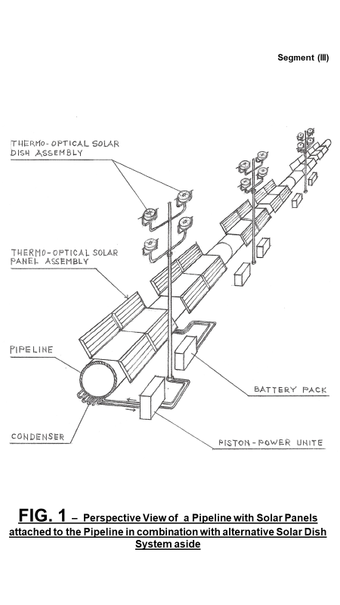

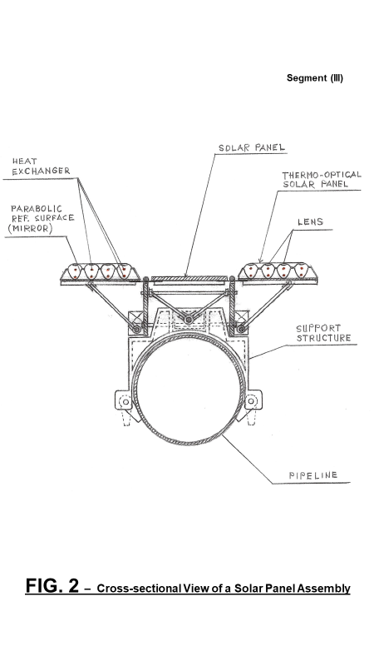

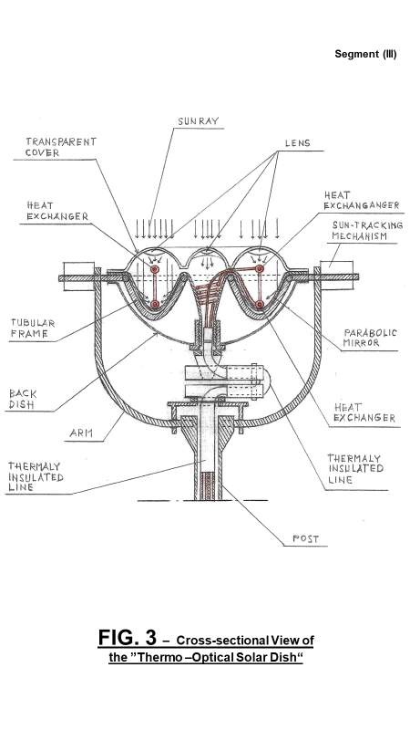

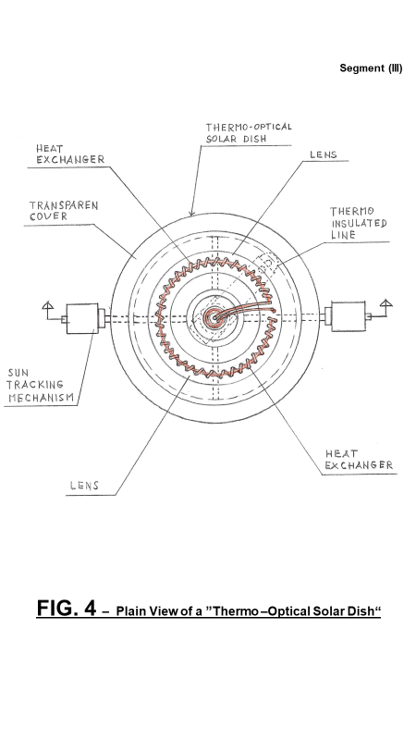

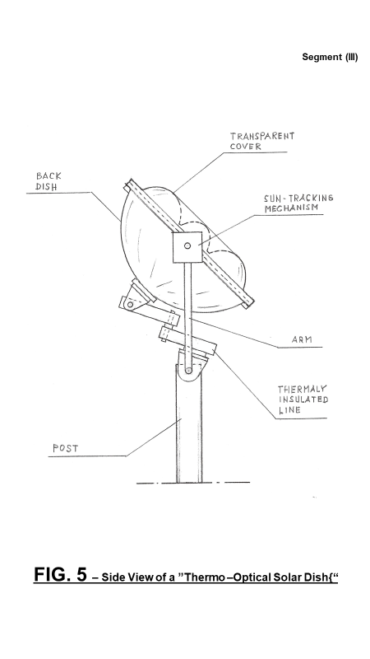

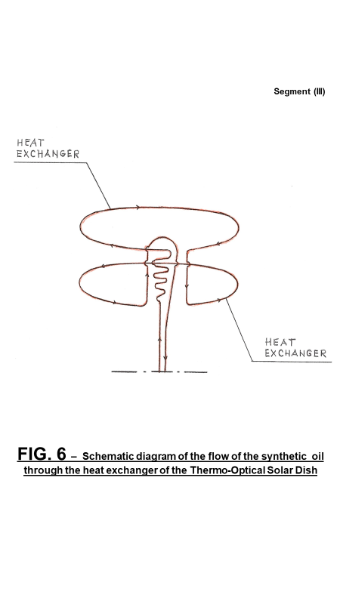

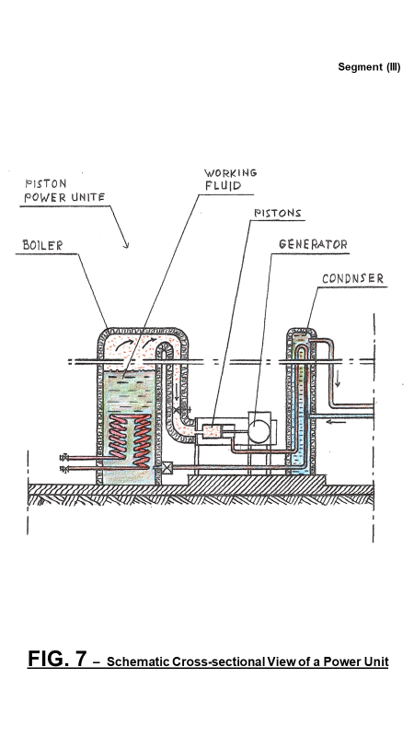

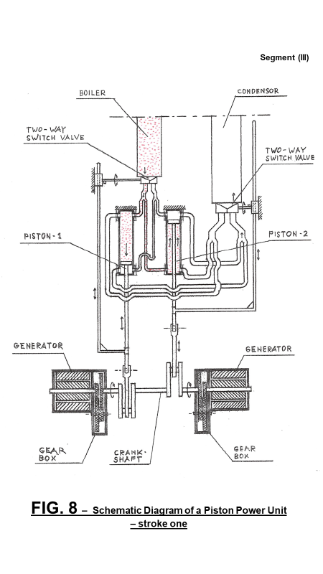

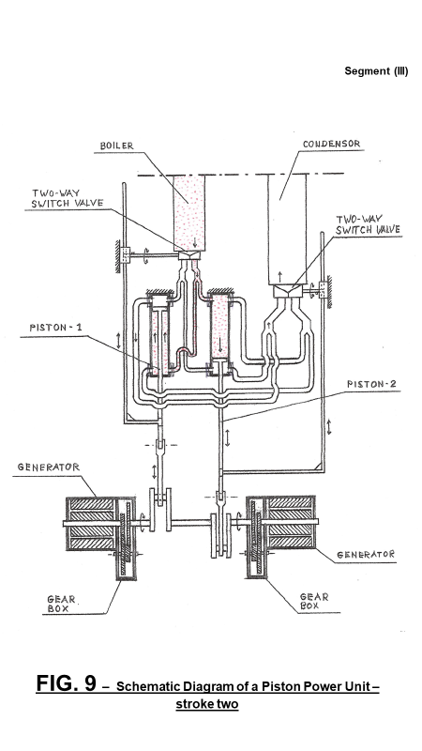

## 3. Conclusion:

Harnessing solar energy in combination with the pipeline system for importing seawater makes a phase of importing seawater self-sustainable and profitable. Importing seawater is a fundamental phase of this comprehensive project on which other phases depend and is an essential element in providing the necessary water for harnessing geothermal energy in the area and is an essential element for the restoration of the Salton Sea.

##### Acknowledgment

The 3.5 km Temperature Map is courtesy of the SMU Geothermal Laboratory and Dr. David Blackwell, Dallas Texas.

##### REFERENCES

U.S. Patent No. 7,849,690; Entitled: “Self-Contained In-Ground Geothermal Generators” (SCI-GGG); Issued on Dec.14, 2010;

U.S. Patent No. 8,281,591; Entitled: “Self-Contained In-Ground Geothermal Generators” (SCI-GGG); Issued on October 9, 2012;

U.S. Patent No. 8,713,940; Entitled: “Self-Contained In-Ground Geothermal Generators”; Issued on May 6, 2014;

U.S. Patent No. 9,206,650; Entitled: “Apparatus for Drilling Faster and Wider Wellbore; Issued on December 8, 2015;

U.S. Patent No. 9,978,466; Entitled: “Self-Contained In-Ground Geothermal Generator and Heat Exchanger with In-Line Pump; Issued on May 22, 2018;

U.S. Patent No. 9,982,513; Entitled: “Apparatus for Drilling Faster and Wider Wellbore with Casing; Issued on May 29, 2018;

U.S. Patent No. 9,995,286; Entitled: “Self-Contained In-Ground Geothermal Generator and Heat Exchanger with In-Line Pump and Several Alternative Applications; Issued on June 12, 2018;

U.S. Patent No. 11,098,926; Entitled: “Self-Contained In-Ground Geothermal Generator and Heat Exchanger with In-Line Pump used in Several Alternative Applications including the Restoration of the Salton Sea. Issued on August 24, 2021;

Several patent-pending applications.