Salinity Gradient Solar Pond Technology
An alternative approach to brine management with zero discharge to the environment is to concentrate Salton Sea water to the sodium chloride saturation level, a specific gravity of about 1.2, and deliver it to the bottom layer of a salinity gradient solar pond. The brine there serves as a collection and storage medium for solar energy in the form of heat.

Discovered as a natural salt lake phenomenon and developed as a solar technology over several decades in the U.S., Israel, Australia, and elsewhere, salinity gradient solar ponds are created in three distinct layers as illustrated in Figure 14. A low salinity layer about one foot deep on the surface is separated from a high salinity (25% salts or more) layer several feet deep at the bottom of the pond by a continuous salinity gradient layer ranging from 25% or more salts at the lower interface to 3% or less salts at the interface with the surface layer above. The pond bottom is lined with high temperature plastic, or clay.

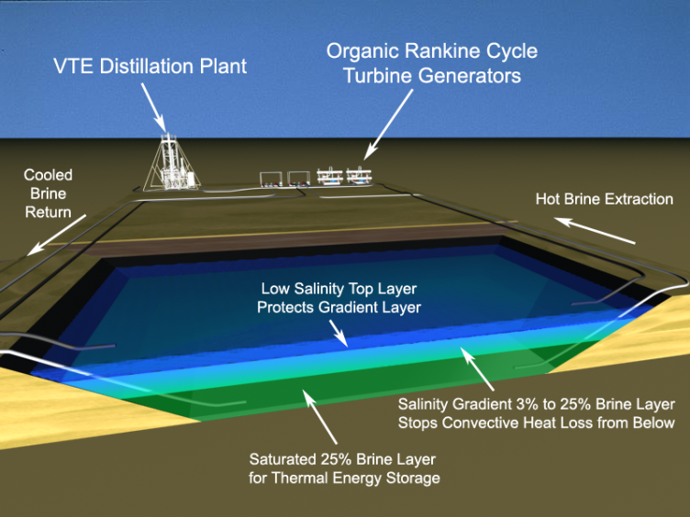
Figure 14. Cutaway view of a small ¼ acre salinity gradient solar pond

A salinity gradient solar pond allows sunlight to pass through the clear upper layers, capturing the solar energy as heat in a layer of hot, clear, saturated brine several feet deep at the bottom of a lined pond, see Figure 15. This hot bottom layer is referred to as the lower convective zone because water can circulate within the layer, mix salts and distribute temperature by convection. Operating temperatures can range from 150°F to 200°F in the lower convective zone, while the top surface of the pond is close to ambient temperature.
An optically clear salinity gradient layer two to three feet deep is created on top of the lower convective zone by controlled blending of saturated brine and low salinity water. This gradient layer is referred to as the non-convective zone because vertical convection does not occur in a smooth salinity gradient. The salinity ranges from 25% TDS at the bottom to 3% or less (seawater to freshwater salinity) at the top of the gradient.
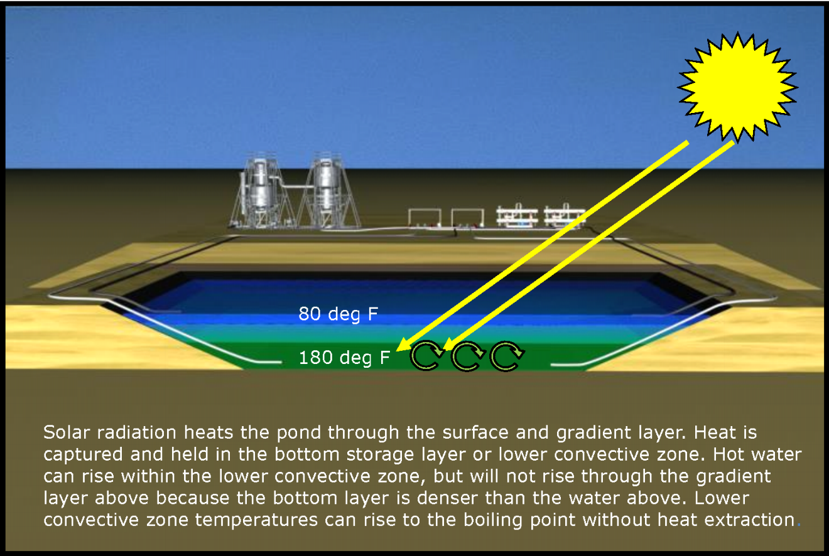
Figure 15. Solar heating of lower convective zone in a salinity gradient solar pond

The gradient traps the heat because dense brine in the lower convective zone is unable to rise through the less dense gradient layer above. Rapid heat loss by convection to the surface and evaporation is blocked leaving only gradual heat loss by conduction to the pond surface or to the ground. Water is a thermal insulator so conductive heat loss is comparatively slow. Water is opaque to infrared so heat loss by radiation from the lower convective zone at the bottom of the pond is also blocked by the water above.
A clear low salinity layer on the top of the pond prevents disturbance of the gradient by wind. This top layer is referred to as the upper convective zone because it exchanges heat with the atmosphere by convection, radiation, and evaporation and remains close to ambient temperature.
Heat energy can be extracted for electric generation by Organic Rankine Cycle turbine generating units (Figure 16) operating in a low temperature range, or for thermal desalination by flashing hot brine into steam in a vacuum. Heat must be extracted to prevent the lower convective zone from reaching boiling temperature, otherwise vapor bubbles from the bottom of the pond would rise and damage the gradient.

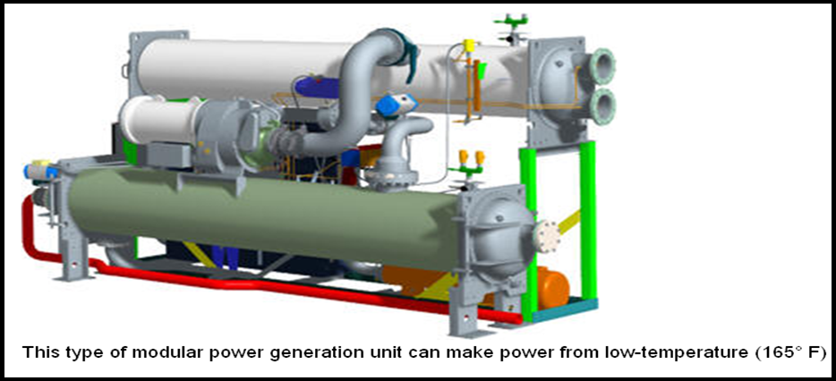
Figure 16. ORC turbine generator by Pratt & Whitney

Heat extraction is typically accomplished by pumping hot brine from the lower convective zone to a heat exchanger, then returning cooler brine to the lower convective zone, Figure 17. With controlled heat extraction, temperatures from 150°F to 200°F can be sustained for weeks in the bottom layer of the pond. The lower convective zone temperature of a pond in the Salton Sea region is expected to vary seasonally from 165°F in winter to 205°F in summer with a constant heat extraction of 47.6 Watts per square meter of pond surface.
ORC engine cooling has been done by circulating water from the upper convective zone. This provides a very low cost evaporative cooling solution, but may limit performance when summer ambient temperatures reach 115°F. Pond surface cooling also increases evaporative losses, increasing the amount of surface water make-up required. Geo-cooling may be an option, but efficacy and cost in the Salton Sea playa is unknown. Cooling with Salton Sea water is possible, but could have adverse impacts on wildlife.

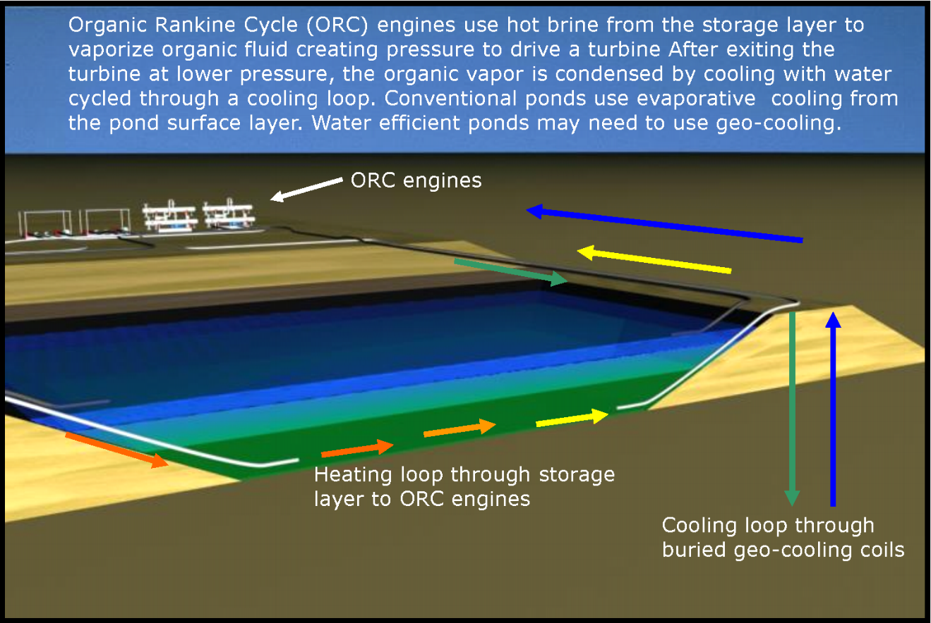
Figure 17. Heat extraction to ORC turbine generators in a salinity gradient solar pond with geo-cooling

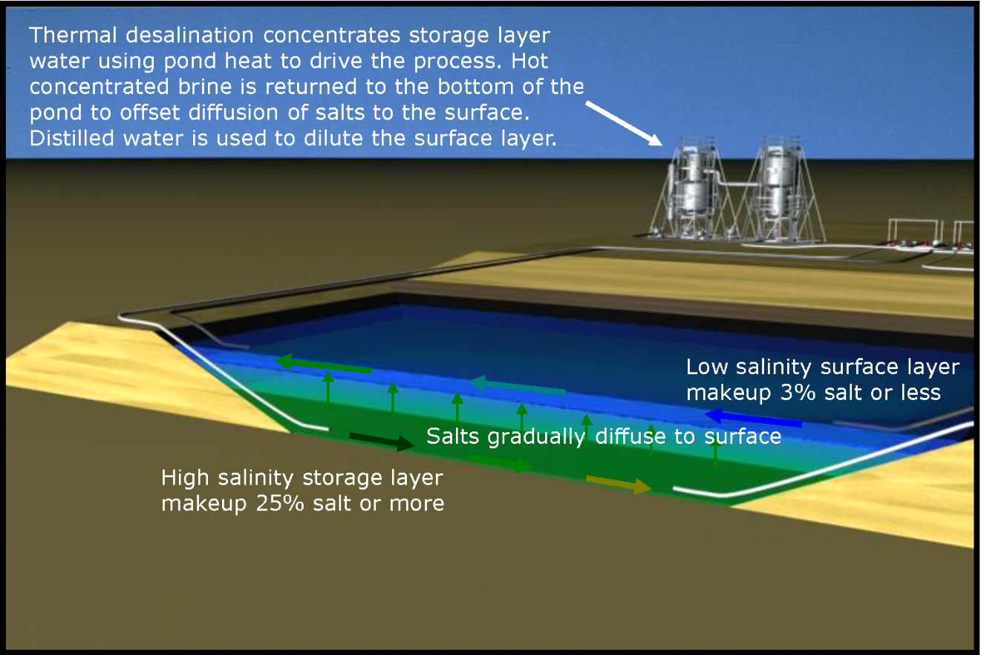
Figure 18. Gradient maintenance in a salinity gradient solar pond using distillation of hot pond brine

Salts diffuse very slowly (about 2mm/day) from the high salinity lower convective zone to the upper convective zone. As shown in figure 18, the salinity of each layer and the gradient can be maintained by circulating brine from the lower convective zone, concentrating it by flashing off some vapor and returning brine at slightly higher concentration to the lower convective zone. Vapor flashed from the hot brine can be recovered in a thermal desalination unit and delivered to the upper convective zone to dilute diffused salts. Upper convective zone water can be concentrated in a second thermal desalination effect and returned to the lower convective zone. Salts are fully conserved in this cycle. Additional low to moderate salinity make-up water will be required to offset surface evaporation.

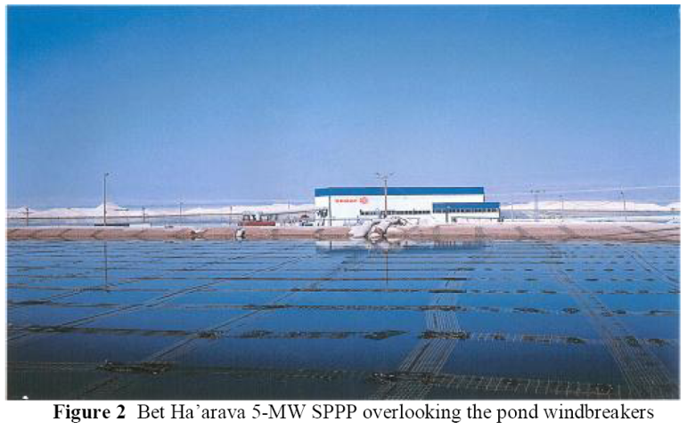
Figure 19. Salinity Gradient Solar Pond and 5MW plant at the Dead Sea, Israel

Salinity gradient solar ponds have been researched since the 1950’s. Pilot scale studies using salinity gradient solar ponds to drive thermal desalination have been carried out in other regions. Generating plants built in Israel in the 1970’s and 1980’s lead up to the 5MW Ormat plant in Figure 19 at Beit Ha’arava on the Dead Sea using 250,000 square meters of salinity gradient solar pond. The floating nets in the photo are wave arrestors to prevent wind damage to the gradient.

Research in the U.S. began in 1974 at Ohio State University. The largest and longest running salinity gradient solar pond project in the U.S. was a 0.8 acre pond at Bruce Foods Corporation in El Paso, seen in Figure 20. The project was carried out by the University of Texas at El Paso and funded by Reclamation.

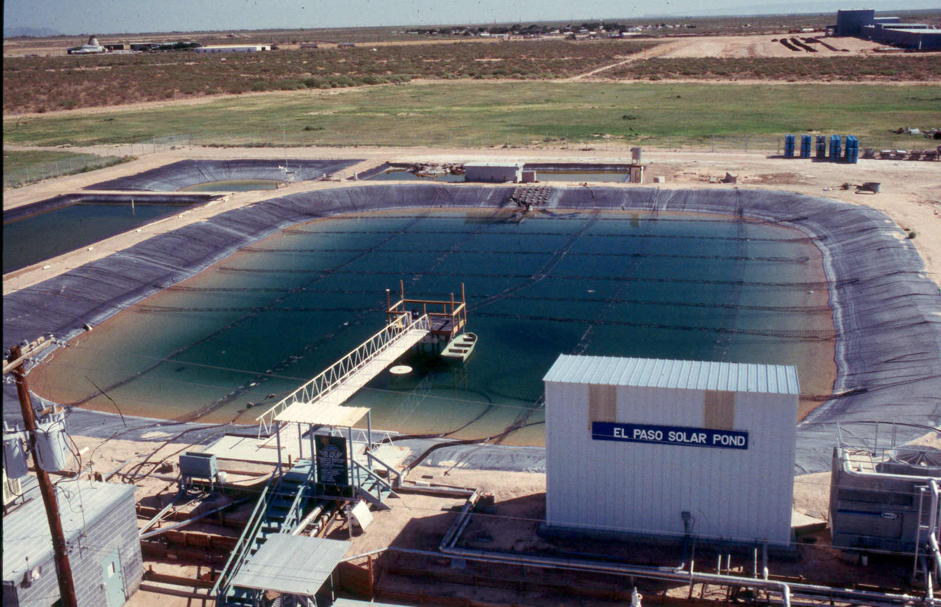
Figure 20. El Paso Solar Pond Project

Thermal desalination was tested for pond maintenance and distilled water production. An organic rankine cycle engine from Ormat Turbines was tested for electrical production. Key personnel from the El Paso Solar Pond Project, Dr. Huanmin Lu and Herbert Hein were also key participants in the VTE project development at the Salton Sea in 2004 and 2005.

Sephton Water Technology installed the flash steam generator and VTE shown in Figure 21 at the California DWR salinity gradient solar pond test site at Los Banos in 1988 (Kovac, Hayes, and Sephton, 1990).

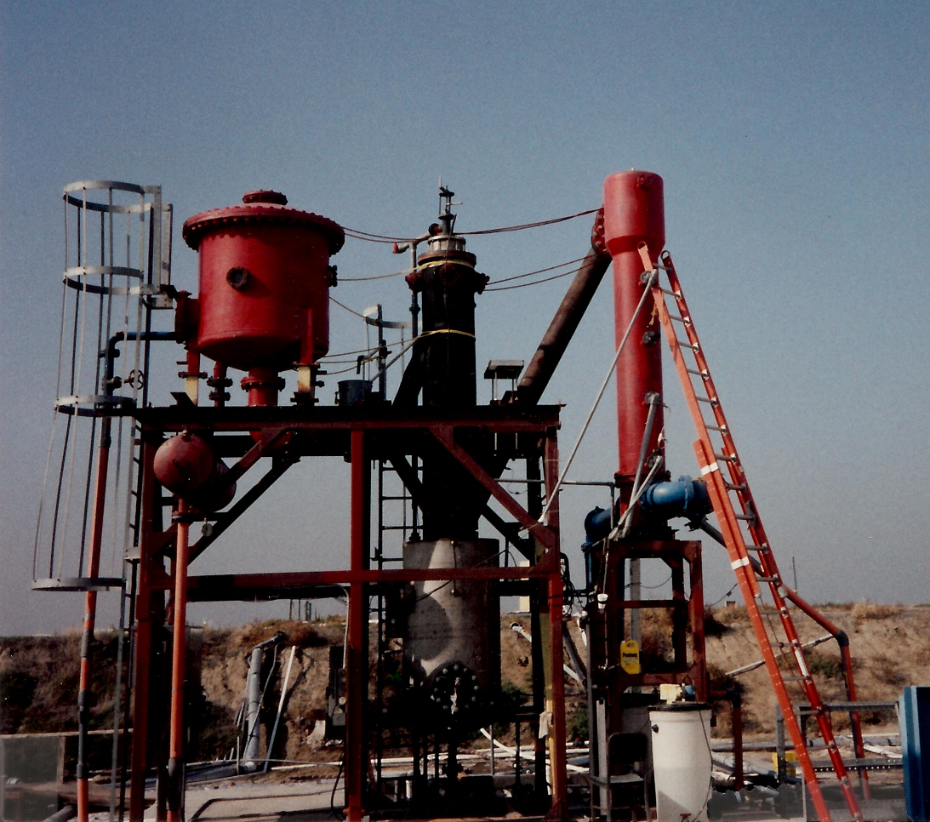
Figure 21. Flash steam generator, VTE, and condenser at Los Banos Solar Pond Project

The system was operated for about a year on solar pond heat to collect data for the test project, help maintain the salinity gradient, and desalt agricultural wastewater.

NASA-JPL published a feasibility study in 1982 with a follow-up lab study in 1984 on a concept to build large salinity gradient solar ponds on submerged land in the shallow south end of the Salton Sea with a total generating capacity of 600MW at full build out. The concept was envisioned to be a salt sink to reduce the salinity of the Salton Sea in addition to generating electricity. Ormat Turbines and Westec were contributors to the study. Ormat estimated capital costs at $1,830/kW of gross output in 1981 dollars. Several local factors were analyzed in the follow up lab study including the use of seabed clay soil as liner. Questions of water use efficiency, water treatment plant design, and a more efficient method of preparing brine for the ponds than evaporation ponds were not resolved. These issues are directly addressed in this proposal.

Salinity gradient solar pond technology has been demonstrated but not commercialized in the U.S. because it was not seen as cost competitive with fossil fuels for electricity generation alone. New renewable portfolio laws in California have created a demand for renewable generation at a price point that makes salinity gradient solar pond generation feasible. Salinity gradient solar ponds at the Salton Sea provide critical ancillary benefits by mitigating public health and environmental risks from PM10 dust and rising salinity in the Sea.

Salinity Gradient Solar Pond Implementation and Costs
The salinity gradient solar pond is a relatively low cost solar energy collection and storage technology. Unlike most solar energy technologies, a salinity gradient solar pond combines collection and storage in one unit by storing solar energy as heat in millions of gallons of hot brine in the lower layer of the pond. This enables a properly sized salinity gradient solar pond facility to drive either a thermal desalination process or a base-load electrical generator 24/7 with year round availability and minimal impact from short term weather variations.

Both thermal and electrical capacity will vary with seasonal temperatures and solar irradiation. Power output also depends on the difference between pond heat and cooling fluid temperatures. Cooling fluid temperatures usually vary seasonally and tend to offset the seasonal variation in both electrical power output and thermal desalination. These costs are based on seasonal averages.

One well qualified literature source (Broniki, 2002) gives a typical value for solar energy captured and continuously extractable as heat in the lower convective zone of a salinity gradient solar pond as about 400 kWh/m²/year based on average insolation of 750 W/m² in eight sunlit hours daily in the Middle East with typical 18% thermal efficiency converting sunlight to heat in the pond.

(750 W/m²)(8 hours)(365 days)/(1,000)(18% efficiency) = 394.2 kWh/m²/year
(394.2 kWh/m²/year)/((365 days)(24 hours))(1,000) = 45.0 W/m²

For a ten acre pond unit that gives:
(45.0 W/m²)(10acres)(4046.86 m²/acre)/1,000 = 1,821 kW or 6.2 million Btu/hr

Insolation data for the Salton Sea calculated according to a Nasa/JPL study (Peelgren, 1982) gives a figure of 261.7 W/m² at the pond surface averaged over 24 hours and 12 months. Heat captured and extractable from the lower convective zone is:

(261.7 W/m²)(24 hours)(365 days)/(1,000)(18% eff.) = 412.6 kWh/m²/year
(412.6 kWh/m²/year)/((365 days)(24 hours))(1,000) = 47.1 W/m²

For a ten acre solar pond unit the Salton Sea estimate gives:

(47.1 W/m²)(10acres)(4046.86 m²/acre)/1,000 = 1,906 kW or 6.5 million Btu/hr

ORC Turbine Generators marketed by Infinity Turbine for low temperature waste heat operation have a thermal to electrical energy conversion of 8-11% or conservatively 40,000 Btu/kWe. The average annual electrical output from a ten acre solar pond would be about (6.5 million Btu/hr)/(40,000 Btu/kWe) = 163 kWe

Figure 22 shows cost estimates for one section (640 acres) of Salton Sea playa. This can support 10MW of 24 hour base-load generation if solar energy input and thermal losses are averaged over an annual cycle. The high temperature polypropylene liner needed to contain brine in the ponds is a major capital cost. The capital and operating cost of water management and treatment is also high due to the high evaporative losses from the ponds in a hot desert climate. The estimated cost of power fixed over a 30 year plant life is 9.73¢ per kWh or 14.0¢ per kWh including payments on public bond construction financing at 4.5% interest over 30 years.

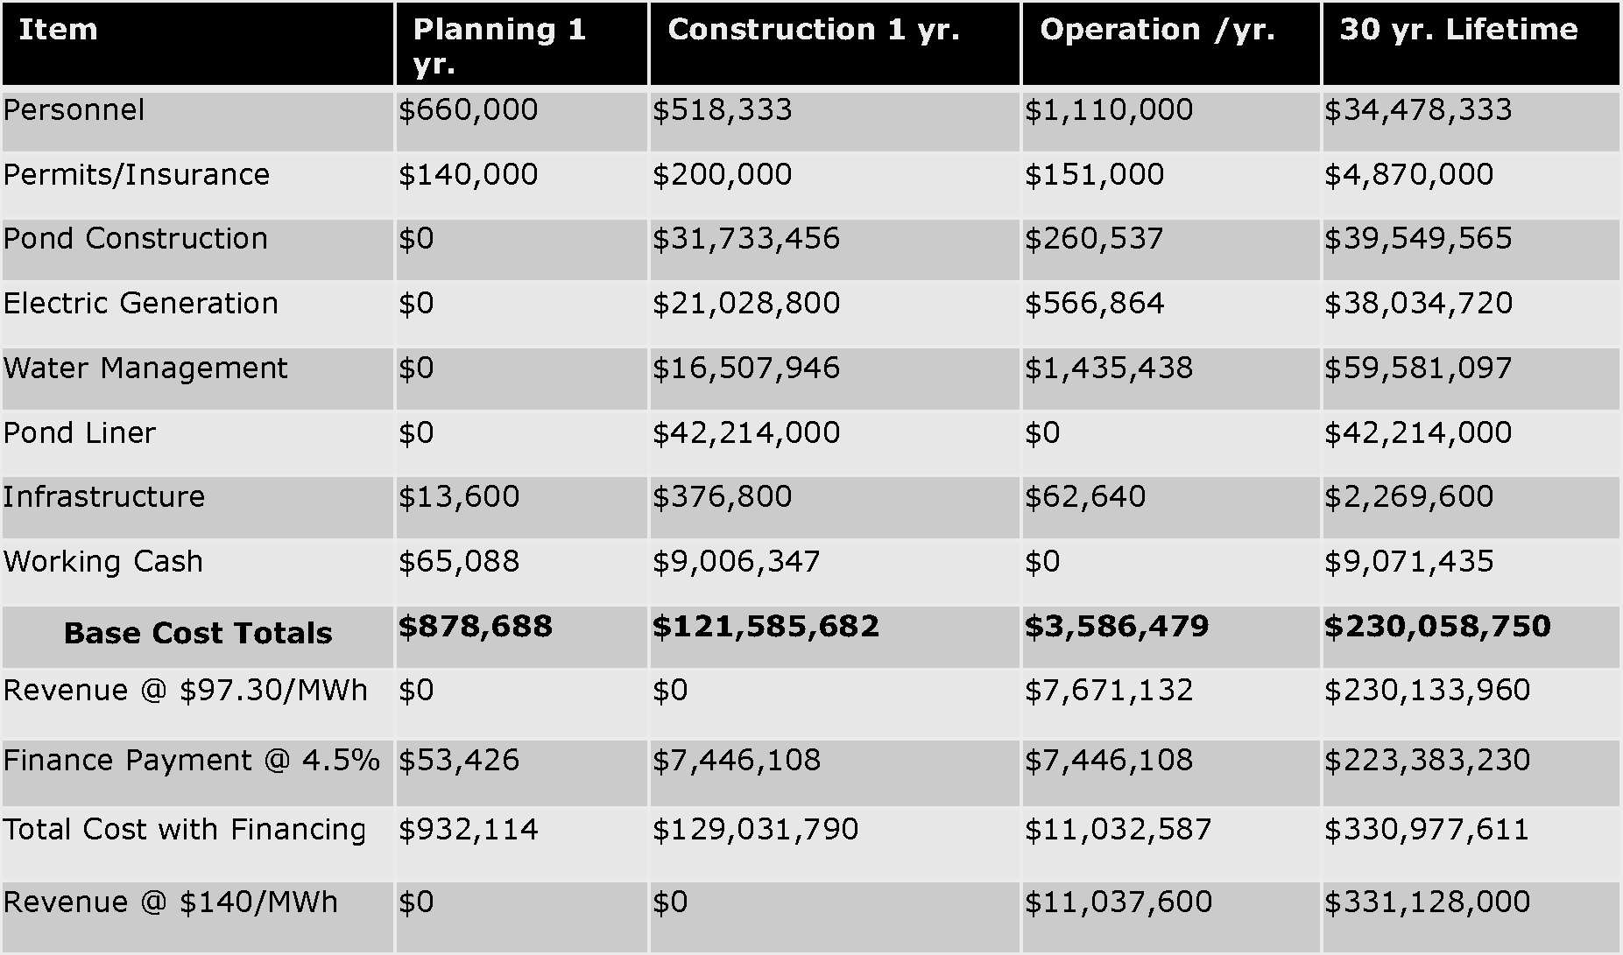
Figure 22. Salinity gradient solar pond cost estimate: base-load 10MW annual avg. high evaporation loss

Absent an effective evaporation retardant, water supply and management would add significantly to the capital and operating costs, and to parasitic load, to offset losses from surface evaporation. A variety of evaporation retardant films or chemicals are available for use on bodies of water ranging in size from swimming pools to large reservoirs. Test data for the Salton Sea locality are not yet available, but published data for chemical additives that act on the water surface show evaporative retardation in the range of 40% to 70% (Hightower and Brown).

Figure 23 shows estimated costs of one section of salinity gradient solar ponds assuming a 50% reduction of surface evaporation. The capital and maintenance cost of water treatment equipment and the cost of make-up water supplies is cut in half. The estimated cost of power fixed over a 30 year plant life is 8.55¢ per kWh equity financed or 12.5¢ per kWh including payments on public bond construction financing at 4.5% interest over 30 years.

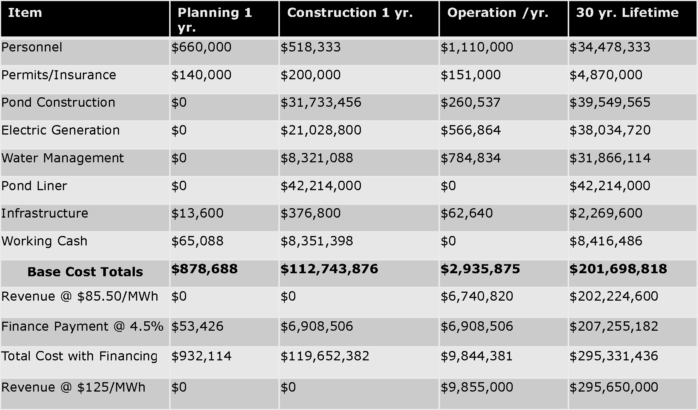
Figure 23. Salinity gradient solar pond cost estimate: base-load 10 MW annual avg. evaporation retardant

By installing more or larger ORC turbine generating units, the pond’s thermal storage capacity can easily be delivered as electricity countercyclical to photovoltaic or wind generation. Because salinity gradient solar ponds are capable of long term thermal storage, heat energy can be extracted from the pond at night or in cloudy or low wind conditions. This may be beneficial locally as large photovoltaic and wind generation plants have been installed in the region in the last couple of years that will supply variable generation to newly installed transmission lines to the Southern California coast.

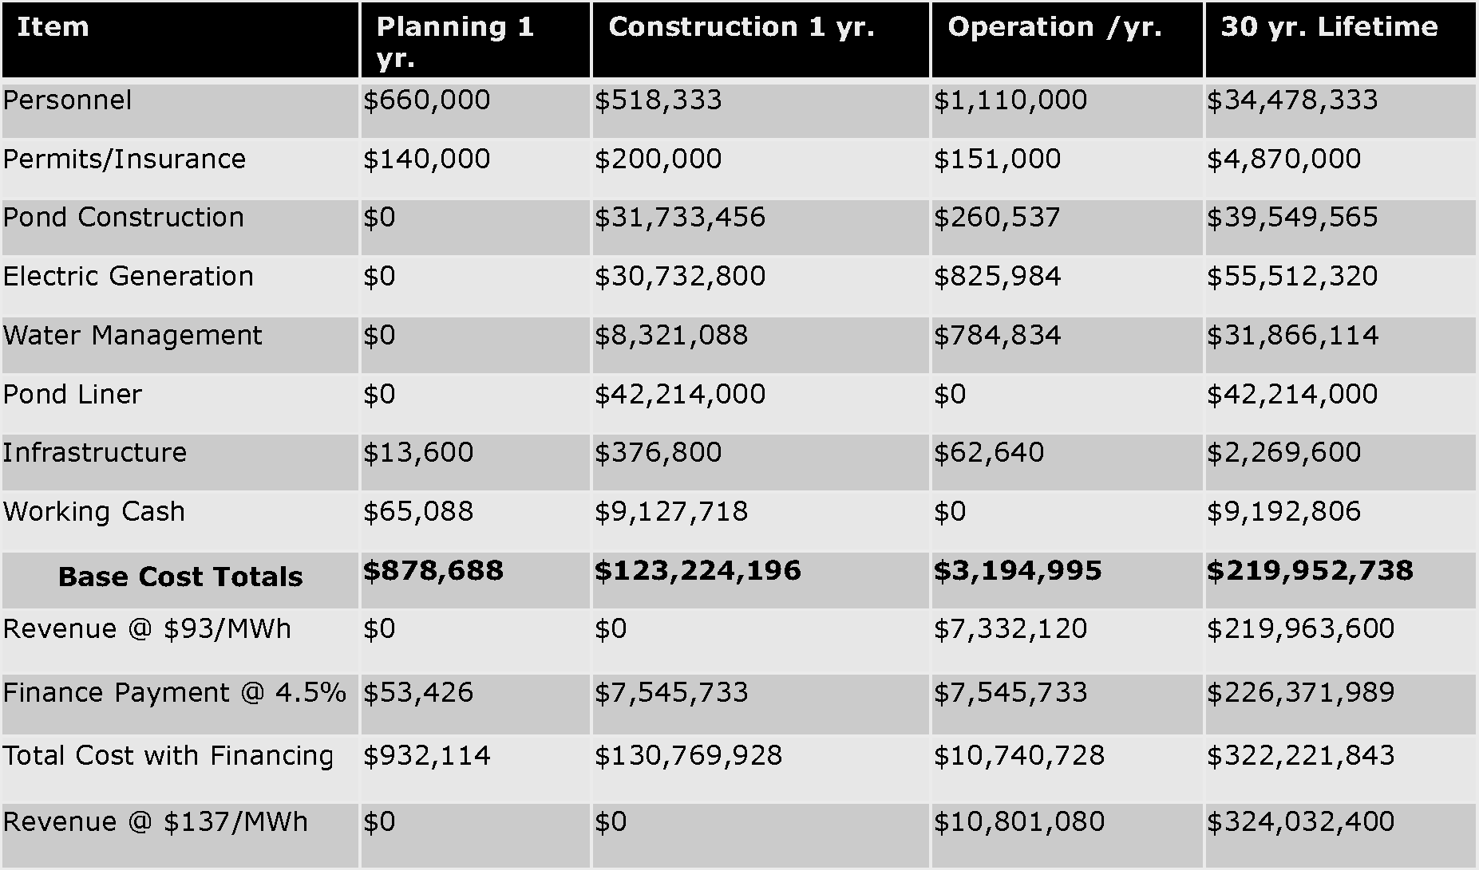
Figure 24. Salinity gradient solar pond cost estimates:16hr peaking 15 MW annual avg. evaporation retardant

Figure 24 shows estimated costs for a 640 acre salinity gradient solar pond system designed to supply the grid with power when photovoltaic plants go offline in the evening and operate through the night until morning. Solar energy collected by the ponds is the same as base-load, but heat extraction and generation runs in a 16 hour duty cycle.

The number of ORC turbine generators is increased by 50% with a similar increase in the capital and maintenance cost for delivery of 15 MW to the grid 16 hours a day or at any time on demand with an average utilization of 66.7%. Any excess pond heat can be used for desalination when full capacity generation is not required because the distilled water and concentrated salt products can be used or stored locally. The cost of power increases to 9.3¢ per kWh with equity financing or 13.7¢ per kWh including payments on public bond construction financing at 4.5% interest, however this countercyclical power may be easier to sell into a southern California renewable energy market now saturated with intermittent solar and wind power.

