Sephton Water Technology, Inc.

Water Import Salt Extraction Revenue
  - Response to Request for Information for Salton Sea Water Importation Projects

Identification of Project Team

Submission Team
For the limited purpose of setting forth the suite of ideas proposed herein, the ‘Project Team’ consists of one person, Tom Sephton, representing a small company Sephton Water Technology, Inc., registered as a California Subchapter C corporation since 2002. For more than a dozen years, Sephton Water Technology has focused exclusively on research and development of a suite of technologies aimed at supporting a restoration of the Salton Sea. From a 2001 proposal to the Salton Sea Authority by Dr. Hugo Sephton and three colleagues expert in the desalination field (all now deceased), to a desalination pilot plant permitted in 2004 and installed at a CalEnergy geothermal power plant next to the Salton Sea in 2005, to a geothermal desalination demonstration plant permitted in 2007 at the same location, to a decade of data collection and operational experience desalinating Salton Sea water with geothermal heat and related work up to the present, Sephton Water Technology is the only entity with recent experience in the unique challenges of reclaiming Salton Sea water and salts. Over $2 million in public grant funds from the Federal and State government and over $1 million in Sephton Water Technology funds, donated effort, and equipment has been invested in the work at the Salton Sea to date.
Some other respondents to this Request for Information (RFI) for Salton Sea Water Importation Projects have thought that this ‘Project Team’ identification requirement implies that a large team backed by one or more deep pocket organizations is required in order to have the information submission considered, however the text of the RFI describes no such requirement. If there is such an unstated requirement, then the reviewer may deposit this submission in ‘File 13’ and move on. If not, thank you for giving this information your time and consideration.

Implementation Team One, private USA
For the much larger purpose of implementation including: securing rights of way, agreements, design, environmental review, permitting, construction, operation, and the eventual decommissioning of plant and infrastructure, a more complex ‘Project Team’ consisting of multiple public and private entities will be required.
Specifically, the organizational structure is divided into three functional entities. One will be a private Subchapter B Public Benefit Corporation to be registered in California with restoration of the Salton Sea as its chartered mission. As a placeholder, this submission will refer to the private entity here described as the Salton Sea Restoration Corporation. This corporation will be free to sell stock, purchase or lease land and equipment as required, write contracts with State and Federal agencies, with other companies, and with foreign entities, and hire employees as required to fulfill its mission. That mission will be to plan and execute a long term restoration project for the Salton Sea including the importation of ocean water from the Sea of Cortez (and any other appropriate sources), the conveyance of that ocean water to the Salton Sea, the extraction of tens of millions of tons of salt from the Salton Sea annually, and the conversion of resources drawn from the Salton Sea, and hence from the imported water, into revenue in the form of renewable energy, purified water, purified salt, and possibly other minerals and/or aquaculture products. Funds from these revenues will be used to pay off construction bonds, purchase ocean water from Mexico, pay for conveyance of that water to the Salton Sea, and construct and operate water treatment and playa covering infrastructure at the Salton Sea to effect a restoration.
The Salton Sea Restoration Corporation will contract with respected engineering and construction firms, technology companies, public and private universities, power producers, power and water utilities, power and water consumers, salt, mineral, and possibly aquaculture, product buyers and distributors to execute its business functions and raise revenue as efficiently as possible. These contracted private and public entities, together with management and employees of the Salton Sea Restoration Corporation will combine to form the first of the three functional entities composing the ‘Project Team’, hired as needed and appropriate for design, permitting, and implementation of each component of the overall project. The core business functions of this first entity will include: The construction and operation of new brine to energy renewable power facilities, the construction and operation of salt purification facilities, the construction and operation of desalination facilities, the marketing and sales of renewable energy, purified salts, purified water, and any other feasible mineral or aquaculture products, the reduction of salinity and management of water quality in the main body of the Salton Sea, and the long term elimination of dust from the Salton Sea playa.

Implementation Team Two, public Mexico
The second functional entity will be a public agency responsible for all operations in Mexico. This ocean water import proposal will require a contract with the Mexican government to design, build, own, and operate the conveyance infrastructure required to collect ocean water from the Sea of Cortez, by regulated tidal flow or by pumped intakes if preferred by engineers there, to deliver that seawater to the border by lined canal and/or pipelines either west or east of Mount Signal with the pumping infrastructure required to get over 300 feet or 200 feet of ridge respectively. The entity in Mexico responsible for the design, construction, and operation of the conveyance infrastructure may be either the National Water Commission (ConAgua) or the Baja State Water Commission. Both have the engineering and operations staff to do the job and both have long experience designing, building, and operating canals and pipelines in Mexico. Either agency can contract with engineering and construction firms in Mexico to dig canals and install pipelines, tidal gates, and pumping infrastructure.
The construction in Mexico will be financed with a public bond funds raised in Mexico and supported by investor funds from either side of the border. The private Salton Sea Restoration Corporation will contract to pay the agency the Mexican government selects for each acre foot of ocean water delivered to the border. The amount paid will be sufficient to pay off the bond funds over a 30 year period, plus reasonable operation and maintenance costs, plus a modest allowance for public benefits, estimated at $60 per acre foot delivered. The pay per acre foot delivered model will provide the Mexican agency with an incentive to complete the conveyance infrastructure on schedule and keep it maintained and efficiently operated. The seawater delivery and purchase contract will run for the duration of the QSA water transfers, with an option to renew.

Implementation Team Three, public USA
Conveyance of ocean water from the border, down to the Salton Sea, will be contracted with a public agency in the USA as the third functional entity of the ‘Project Team”. The appropriate Federal agency is the U.S. Department of the Interior, Bureau of Reclamation. This agency has considerable experience designing, building, and operating canals, dams, and hydro power infrastructure along the Colorado River, in California, and in all the Western States. The appropriate State agency alternative is the California Department of Water Resources, which also has extensive experience designing, building, and operating dams, canals, pipelines, hydro power, and pumping infrastructure in California. Either agency has engineering, management, and operations staff capable of conducting environmental review, securing permits, and designing and operating the conveyance infrastructure from the border to the Salton Sea. Either or both agencies can contract with U.S. engineering and construction contractors to build the lined canals, pipelines, and hydro power stations that will be needed to convey ocean water from the border to the Salton Sea, recover power from 400 to 500 feet of elevation drop, and deliver that power to the Mexican agency for pumping over the high point in Mexico and across the border.
Similar to the implementation in Mexico, the design, permitting, and construction of conveyance and power infrastructure in the U.S. will be financed with a public bond funds raised by the State of California, or other suitable public entity. The Salton Sea Restoration Corporation will contract to pay the agency assigned, State or Federal, for each acre foot of ocean water delivered from the border to the Salton Sea with an agreement that the power derived from the elevation drop will be delivered to the agency in Mexico for pumping. The amount paid will be sufficient to pay off the construction bond over a 30 year period, plus operation and maintenance costs, plus a small allowance for graft and corruption in the Imperial Valley, estimated to total $45 per acre foot of ocean water delivered to the Salton Sea. The pay per acre foot delivered model will also apply to the American water agency as an incentive to complete the conveyance infrastructure on schedule, keep it maintained, and operate it efficiently. The conveyance infrastructure will be owned and operated by the public agency, but paid for over time by the private Salton Sea Restoration Corporation with each acre foot delivered. In essence, the State of California, or the Federal Government, will be paid to help restore the Salton Sea, since neither public entity has shown any commitment to do so on its own dime. This ocean water delivery contract will also run for the duration of the QSA water transfers, with an option to renew.

Narrative Description of Project Concept
This Water Import Salt Extraction Revenue concept will pay to import a large volume of ocean water from the Sea of Cortez to restore elevation in the Salton Sea and eliminate playa dust. To manage salinity in the Salton Sea, a lesser volume of hypersaline Salton Sea water will be extracted and separated into distilled water, purified salt, and mixed salt brine. Some of the distilled water will be sold to outside water agencies to offset costs and reduce the demand for water transfers over and above the QSA. The balance will be given to habitat and recreation projects, or delivered directly to the Sea for dilution. Some purified salt will be shipped for sale to the regional market within the limits of gradually rising demand, while some may be sold to support local salt using industries, such as food processing, leather tanning, and chemical processing. The balance of salt extracted will be concentrated mixed salt in brine useful for brine to energy processes. Initially, salinity gradient solar ponds are an established technology that can provide a safe depository for millions of tons of salt while generating revenue from solar power and process heat and while also covering thousands of acres of dust emitting playa in areas of the shoreline that do not have any fresh or brackish water supply. In time other brine to power technologies currently in lab or pilot development may supplant the solar ponds.
Figure 1. Basic Water Import Salt Extraction Revenue Concept
The concept basics are illustrated in Figure 1. The commercial products from extracting salts from the Salton Sea, renewable power, purified salt, and purified water, will provide the economic engine to pay for the importation of ocean water. The ocean water import will provide a sustained supply of both water and salt over the long term while also sustaining a managed level and water quality in the Salton Sea. An ocean water import canal, with a few sections of pipeline, is envisioned that will collect water from the Sea of Cortez for transport north to the U.S. Mexico border, then downhill to the Salton Sea. There are a few reasonable route options illustrated in Figure 2.
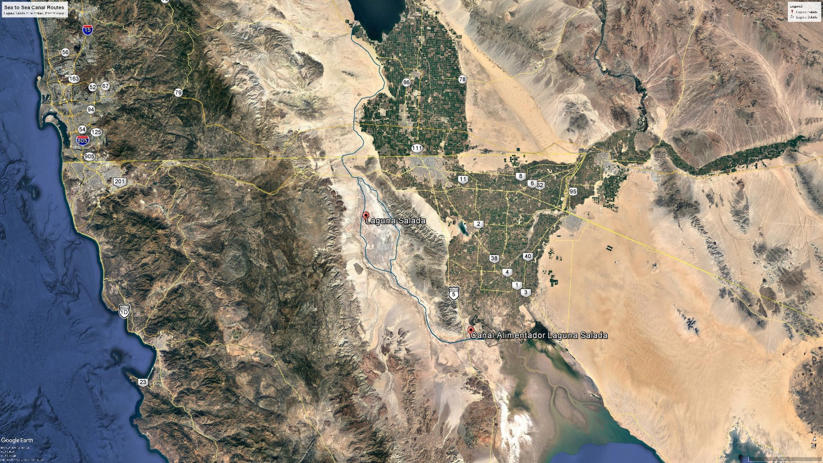
Figure 2. Proposed Route Options for Water Import from the Sea of Cortez
The conveyance design capacity for planning purposes is 900,000 acre-feet per year (AFY), or 900 KAFY delivered to the Salton Sea. The canal will be lined with marine mix concrete along most of its length to conserve water and prevent saltwater intrusion into adjacent groundwater in areas where that is a concern. Siphon pipelines will be used for undercrossing major existing roads and waterways. Sections of pipeline may also be used for pumped conveyance in uphill sections of the route depending on the pump type selected in each location. To the extent feasible, energy for uphill pumping of ocean water will be recovered by hydro-turbines installed in drops on the downhill sections. There will be a net downhill flow between 230 feet and 257 feet depending on time and inflow conditions. Taking pump and turbine efficiencies into account and resistance to flow, some canal alignment options will generate a small net positive power output after pumping on the order of 5 MW, while others will have a modest deficit.
All alignment options considered in this submission are directed at an efficient one way delivery of 900 KAFY of ocean water from the Sea of Cortez to the Salton Sea with no return flow to Mexico. Aside from natural outflows to evaporation and seepage, the only built outflows will be to water and salt treatment facilities that will process the hypersaline Salton Sea water, return some pure water to the Salton Sea or adjacent habitat, and covert the rest to commercial products with both economic and Sea restoration benefits.

Salt Extraction and Water Treatment Process
Salt in the Salton Sea is predominantly, but not exclusively, sodium chloride. The Salton Sea contains much higher sulfate and magnesium levels than ocean water. Unlike sea salts from the ocean, Salton Sea water cannot be simply crystallized in evaporation ponds and sold as a product. The Salton Sea is close to 6% total dissolved salts. By the time this restoration concept can be implemented, the salinity of the Salton Sea will be much higher. In a way, the high salinity is an advantage for salt extraction, as the volume of water to be separated from salt is much less per ton of salt extracted. The salt extraction process planned is capable of purifying slightly over half of the salt content in Salton Sea water to the two higher commercial grades of sodium chloride (vacuum pan salt and solar salt) and put them out for sale on the regional market to offset the capital, operation, and energy costs of the salt extraction and distillation process.
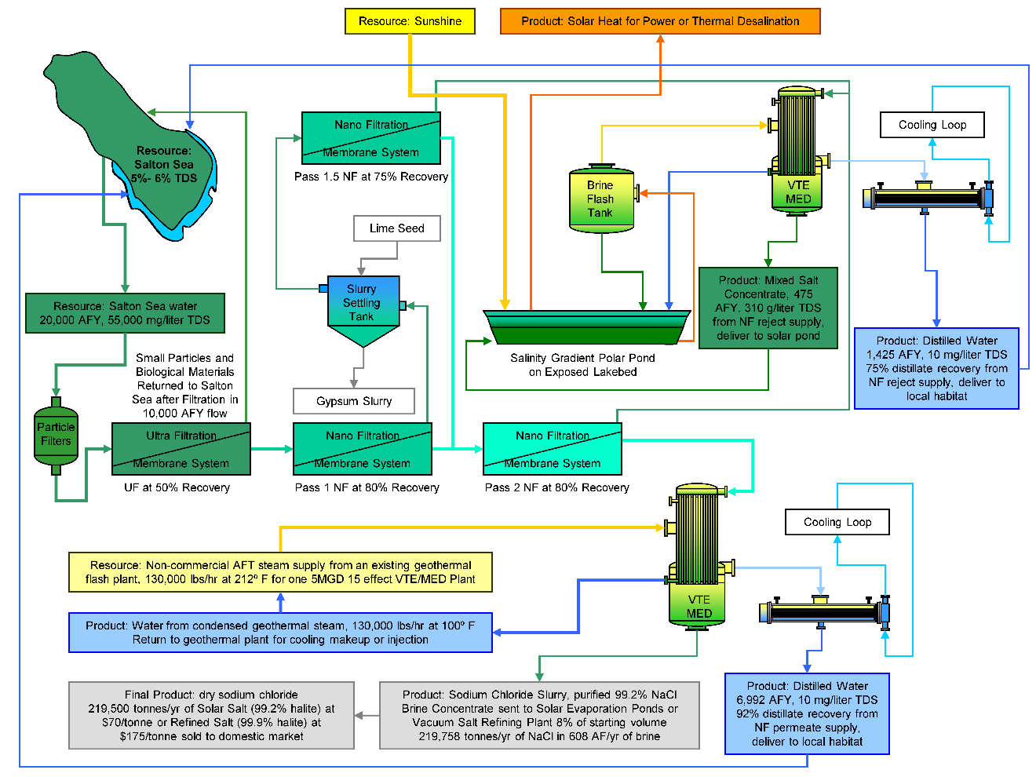
Figure 3. Salt Extraction and Purification Process Developed at the Salton Sea
The basics of the salt extraction and water treatment process are illustrated in Figure 3 on a small commercial scale. This process was developed in testing done at the Salton Sea in 2009-2010, under a grant from the U.S. Bureau of Reclamation to Sephton Water Technology. Salton Sea water will be filtered to remove particles down to 100 microns. Ultra-Filtration (UF) will be employed to remove bacteria and all suspended solids down to 0.1 micron in order to prevent scaling of the Nano-Filtration membranes (NF) membranes by eliminating anything that could seed precipitation. The UF step will be run between 50% and 90% recovery with the small particle and organic enriched return flow delivered to the Sea after settling and algal digestion of the nutrients. To prevent formation of calcite scale, the water will be de-carbonated by adjusting the pH from the typical pH 8 in the Salton Sea to 6.5 prior to Ultrafiltration. Clear, de-carbonated, particle free Salton Sea water at pH 6.5 will be fed to NF membranes shown in tests to reject more than 99.8% of sulfate and magnesium. Two passes of NF was shown to reduce all ions but sodium and chloride to very low concentrations.
The UF/NF process shown in Figure 3 will provide a net recovery from both NF passes of 95%. The first NF pass is driven to 80% recovery. Reject from that pass is seeded with particles to force precipitation of the 5 fold supersaturated gypsum. After a settling, the clear supernatant is filtered with an NF element at 75% recovery. 80% permeate plus 75% of the 20% reject recovered as permeate yields 95% recovery of purified sodium chloride from Salton Sea water.
Permeate from 2 passes of Nano-Filtration will have TDS slightly over half that of the Salton Sea source water with 99% of the dry weight consisting of sodium chloride. The permeate will be concentrated in a VTE-MED plant to the saturation point of sodium chloride, then further evaporated and crystallized to sodium chloride slurry. The slurry can be sun dried to yield commercial grade Solar Salt, or dewatered by centrifugation and fluid bed drying. Further refinement by standard vacuum pan evaporation methods will yield a food grade or high purity industrial product. About 92% of the water in the NF permeate was recovered as distilled water in the 2010 tests.
Reject from the 2 passes of Nano-Filtration will have a TDS higher than the Salton Sea source water with a mix of salts including elevated concentrations of sulfate and magnesium compared to the Salton Sea. The NF reject will be concentrated in a VTE-MED process to saturation. Scale will be controlled in the NF reject concentration process by the Dispersed Seeded Slurry Evaporation (DSSE) method that has been effective in evaporating Salton Sea brine to high concentrations in testing. About 75% of the water in the NF reject was recovered as distilled water in a 2010 test. After removing the suspended solids, the concentrated NF reject brine will be well suited for use in the bottom layer of a salinity gradient solar pond to directly collect and store solar heat for use as needed generating electricity or driving a thermal desalination process.
The mixed non-marketable Salton Sea salts rejected as concentrated brine after the salt separation and distillation process will be delivered to salinity gradient solar ponds built on exposed playa similar to the Ormat plant at the Dead Sea shown in Figure 4. The brine will be contained in plastic pond liners with transparent floating covers to reduce evaporation loss and sequester the various low level contaminants in concentrated Salton Sea water from the environment. Built out incrementally over the life of the QSA water transfer agreements (up to 60 years remaining), these salinity gradient solar ponds will indefinitely cover thousands of acres of exposed playa and can be located anywhere that windblown dust is critical. They will not depend on a freshwater supply. Only access to water from the Salton Sea is needed.
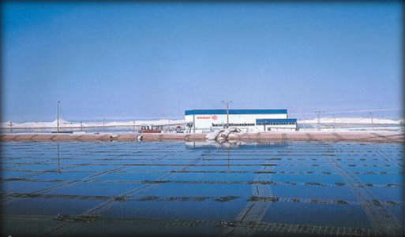
Figure 4. Ormat Salinity Gradient Solar Pond at the Dead Sea
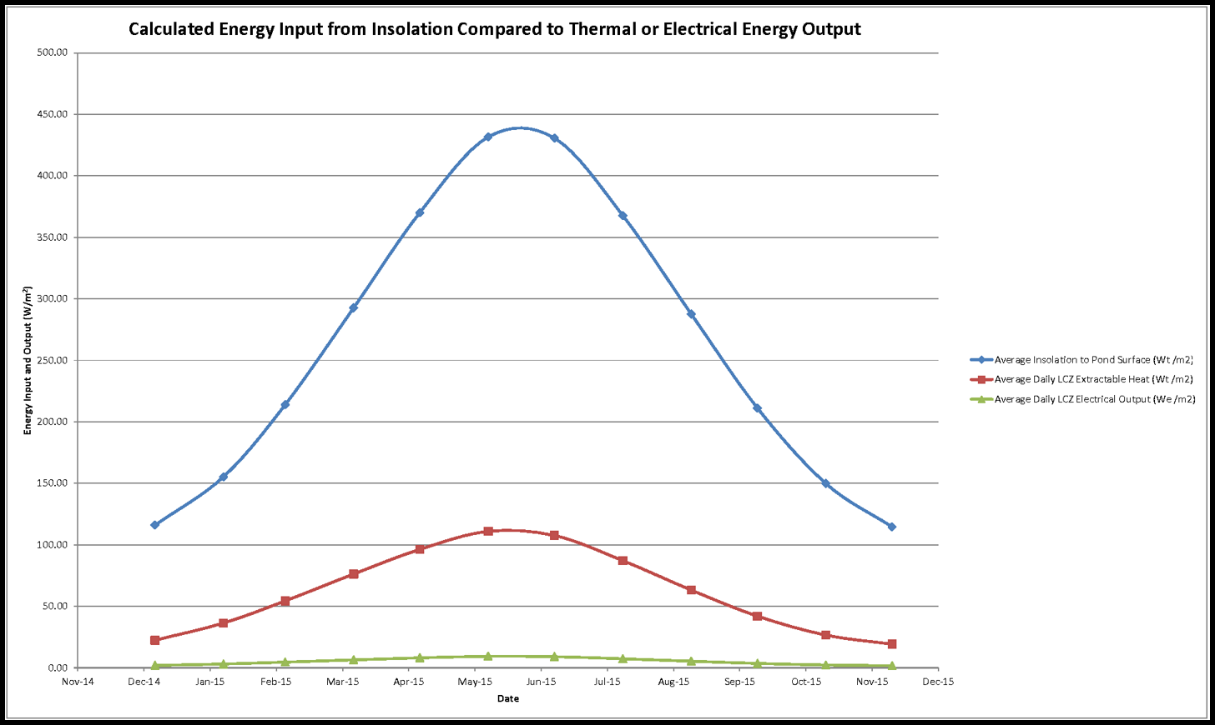
Figure 5. Monthly Salinity Gradient Solar Pond Input and Outputs Calculated for the Salton Sea
The salinity gradient solar ponds will capture and store heat from the sun that can be converted to electricity at any time of day or night, or used directly as heat to drive a distillation process. The solar ponds proposed will operate on average 75% for electrical generation and 25% as heat for distillation, to provide their own sustained supply of water and salt from the Salton Sea, plus additional purified salt for the regional market. These ratios will be adjusted seasonally to meet variations in solar availability and power and water demand.
Electrical generation from the solar ponds can initially be supplied for project use, separating salts and pumping water. As more solar ponds are built out, excess power will be sold through the grid to California utilities seeking to meet any renewable portfolio standards beyond the 50% by 2030 requirement. With continued growth in both markets, production of electricity and purified salt by the salinity gradient solar ponds will fully offset their capital and operating costs.

Implementation of Water and Salt Treatment Facilities
The concept is designed to be implemented by installing five types of water and salt treatment facilities incrementally as modular plants and solar ponds that work together to provide the four fold benefits of clean water for habitat and potable use, dust coverage on playa, Salton Sea salinity management, and renewable energy development to boost the local economy. The five types of water and salt treatment facilities are:
Facility Type 1. Vertical Tube Evaporator (VTE) Multi-Effect Distillation (MED) Plants will be driven by geothermal heat purchased as steam at up to 200°C (394°F) to separate pure water from all other contaminants in the Salton Sea by distillation. The VTE-MED Plants will be built in 20 MGD modules composed of twelve cylindrical vacuum vessels containing five effects each in a vertical stack for a total of 60 effects enabling very high thermal efficiency from purchased geothermal steam. The recent availability of novel high temperature polymer composite evaporator tubes with thermal conductivity similar to metal tubes, but with a very high resistance to scaling, fouling, and corrosion make this performance improvement possible. These evaporator tubes have been developed by Technoform Kunststoffprofile GmbH in Germany. Up to 15 VTE-MED plants will be built at a pace of one per year adjacent to new geothermal power plants that will supply both heat from geothermal steam and power for pumping. Contracts to buy all the heat and power from the new geothermal plants over a 30 year plant life will enable the Salton Sea geothermal industry to expand to meet this new demand.
Facility Type 2. Filtration and Salt Separation Plants using particle filters and ultrafiltration (UF) membranes to remove particles and biological materials, followed by nano-filtration (NF) membranes to separate larger more highly charged ions from sodium and chloride ions. The Salt Separation Plants will be built in 6 million gallon per day (MGD) modules and in 1 MGD satellite modules. These Plants will be similar in construction to a Reverse Osmosis (RO) desalination plant with stacks of membrane housings, pumps, and other filtration equipment in a building or container. However the NF membranes used have a pore size ten-fold larger than RO membranes making it feasible to treat hypersaline water from the Salton Sea. They will placed on the Southern shore of the Salton Sea adjacent to other Project facilities. Eight of the 6 MGD plants will be built, one per year, adjacent to the first two 20 MGD VTE-MED plants to feed their 99% pure sodium chloride permeate product to the VTE-MED process for concentration and distilled water recovery.
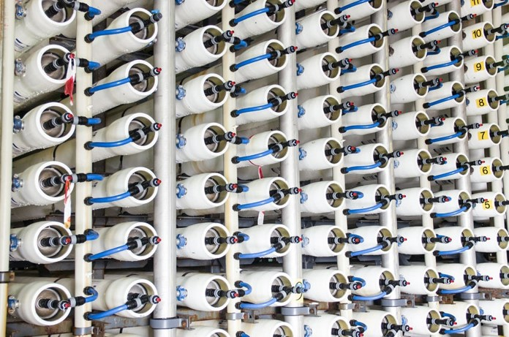
Figure 6. Array of Pressure Vessels Typical for NF Plant, Facility type 2
Facility Type 3. Solar Salt Evaporation Ponds take 99% purified sodium chloride brine concentrated to near saturation in the VTE-MED plants and crystallize the salt in shallow ponds built on exposed Salton Sea playa. The crystallized salt will be harvested, washed, dried, and sorted by traditional methods. Similar ponds are in use in coastal areas all over the world, including at the Sea of Cortez. These evaporation ponds will be built out gradually as needed eventually covering up to 1,500 acres of exposed playa as the QSA water transfers sunset.
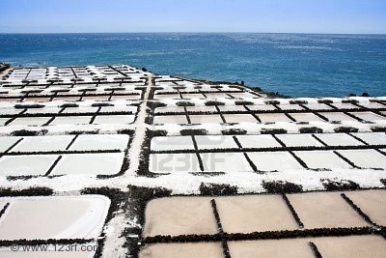
Figure 7. Solar Salt Evaporation Ponds, Facility type 3
Facility Type 4. Vacuum Salt Refining Plants will take 99% purified sodium chloride brine concentrated to saturation in the large 20 MGD VTE-MED plants and crystallize the salt in small VTE-MED evaporators driven by low temperature geothermal steam, removing remaining impurities by precipitation and drawing off the liquor, to achieve the 99.9% purity of refined salt used for food processing and a range of chemical process industries The refined salt crystals will be dewatered by centrifugation and fluid bed hot air drying, then milled and sorted for sale. Eight of these plants will be built in 250 metric ton per day production units and located near VTE-MED plants that supply the concentrated brine and near geothermal plants that will supply geothermal steam to heat the vacuum evaporation process and electric power. Additional salt refining plants will be built adjacent to groups of salinity gradient solar ponds to use heat and purified, concentrated feed stock supplied by the solar ponds.
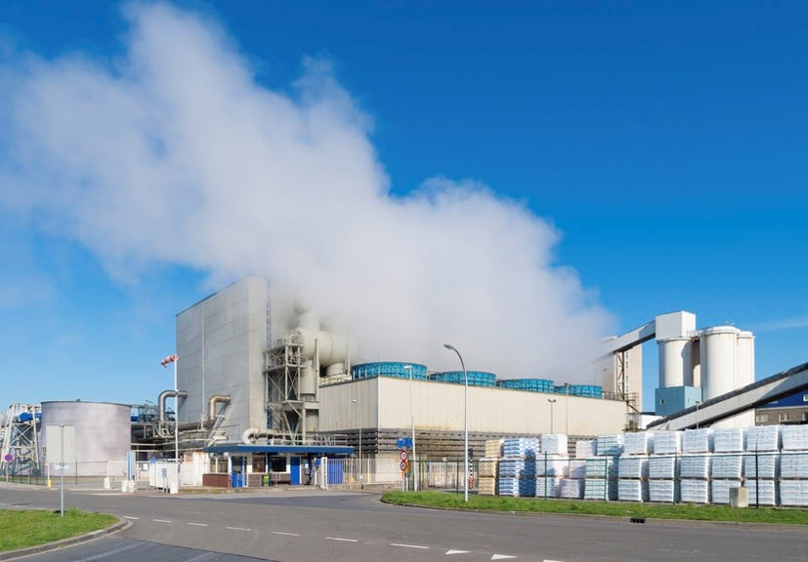
Figure 8. Vacuum Salt Refining Plant, Facility type 4
Facility Type 5. Salinity Gradient Solar Ponds will be built out gradually on exposed Salton Sea playa to cover dust in emissive areas. The solar ponds will take non-marketable mixed salts in brine concentrated to saturation by the 20 MGD VTE-MED Plants and by other solar ponds. A salinity gradient layer created above the concentrated brine will trap heat from the sun in the dense brine layer at the bottom of the solar pond. This heat will be used to drive turbine-generators to make power for use within the project powering a 1 MGD salt separation unit at each solar pond complex and to drive a small low temperature VTE-MED distillation process to maintain the salinity gradient and to make more salt for sale. Power in excess of local project needs will be delivered to the grid for sale to customers. The electrical power capacity is on the order of 9.3 MW per section of land and varies seasonally, but can be extracted at any time of day or night as salinity gradient solar ponds store the heat of the sun for weeks. Before the end of the QSA water transfer agreements 60 years hence, power produced by the salinity gradient solar ponds will be sufficient to replace all that lost by the decommissioning of the San Onofre nuclear power plant. Generation from the San Onofre plant is being replaced by fossil fuel natural gas plants now. As those plants are retired after a typical 30 year life, 24/7 baseload generation from the salinity gradient solar ponds will become available to replace that with renewable power.
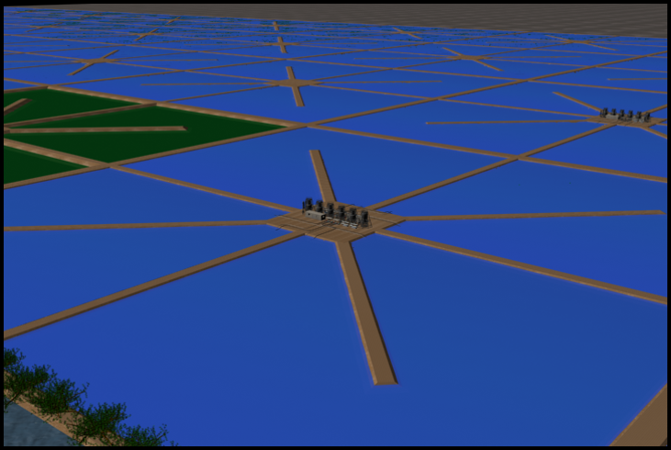
Figure 9. 40 Acre Salinity Gradient Solar Pond Unit Designed for the Salton Sea, Facility type 5
Combined with the level rise from ocean water import, the build out of salinity gradient solar pond acreage will be sufficient to cover all remaining exposed playa by 2034 in a best case water supply scenario and to cover all exposed playa by 2041 in a worst case water supply scenario. With transparent floating evaporation reduction covers, the salinity gradient solar ponds will be 75% more water efficient than aquatic habitat or shallow flooding dust mitigation strategies and equally effective. While not directly useful as habitat, the solar ponds will supply a modest amount of pure selenium free distilled water to any nearby habitat ponds for selenium dilution and, with pond water heat exchangers installed, they can be used to keep habitat ponds above the fish mortality temperature on the cold winter nights where that threat may be imminent.

Benefit to the Lake 1: Elevation Management
The reduction of inflows to the Salton Sea from QSA water transfers, related on farm water efficiencies, reduction in cross border flows, increased IID storage, and other factors has been causing a substantial reduction in surface elevation at the Salton Sea since the 2003 QSA agreement went into effect. The level decline will accelerate now that QSA mandated mitigation flows to the Salton Sea have stopped. This has caused both the exposure of potentially dust emissive playa and the retreat of the shoreline from areas of human and wildlife use. On the human side there is the loss of use of community shorelines, boat docks and ramps, fishing piers, beaches, and shoreline parks. Key impacts on wildlife include the cutoff of access by the dominant fish, Mozambique tilapia, to protected harbors and inlets used for spawning, the exposure of critical nesting habitat such as Mullet Island and nesting trees along the shoreline to ground predators, and the dramatic change of river estuaries.
The import of up to 900 KAFY of ocean water to the Salton Sea will raise the elevation of the Salton Sea dramatically over just a few years because it will exceed the loss of inflows attributable to the water transfers significantly.
Figure 10. Impacts of QSA and Water Import on the Surface Elevation of the Salton Sea
The chart of past and predicted reductions to Salton Sea surface elevation in Figure 10 compares a gradual loss of inflow to the Salton Sea from non-QSA changes in farming practices, climate change, cross border flow changes, and possibly other factors estimated by the dark blue plot with the loss of level when QSA water transfers and some recent storage measures are included, shown in the dark red plot, partly hidden by the blue line. The elevation declined substantially from 2010 to 2018 and will decline at a faster rate from 2018 to 2030 as QSA transfers ramp up after being held steady for the past few years, and mitigation water no longer offsets some of the inflow loss. The loss of level slows out to around 2050 as the Sea’s surface area shrinks reducing the evaporation rate. Figure 11 shows a plot of the Salton Sea surface area under QSA water transfers in dark red behind light blue. The curve shape is similar as the change in surface area acts on the elevation and vice versa because the largest factor influencing the elevation change after inflows is evaporation loss, which is directly related to surface area. Both surface area and elevation increase slightly after 2048 because the QSA water transfer to the Coachella Valley Water District (CVWD) is scheduled to be cut by half from that year forward.
Figure 11. Impacts of QSA and Water Import on the Surface Area of the Salton Sea
These predictions are based on water and salt balance equations explained in some detail in Appendix A and calculated in annual increments in spreadsheets included as Appendix B. Since the official Salton Sea hydrology report and data has not been released to the public, it was necessary to create an alternative water and salt balance model to analyze the impacts and potential benefits of ocean water import and salinity management at the Salton Sea. This is not a Monte Carlo simulation or other range of uncertainty model, but rather a simple result of water volume balance and salt mass balance equations applied to the available data on historic and predicted inflows to the Salton Sea, Salton Sea evaporation losses based on the Alex M. Sturrock, Jr. 1969 study (U.S. Geological Survey Water-Supply Paper 2053) supplemented with data for higher salinity in the Sea now, and volume to elevation to surface area relationships calculated from bathymetry data in the Paul Weghorst 2000 Salton Sea Accounting Model study for the U.S. Bureau of Reclamation. These are perhaps a few of the many studies that residents at the Salton Sea complain about, but they are a necessary reference to figure out the impacts of a water import based restoration proposal.
Figures 10 and 11 show the impact of a modest 450 KAFY ocean water inflow direct to the Salton Sea in the light green plot. This amount is roughly equal to the fully implemented QSA water transfers with the preexisting 105 KAFY transfer to the Metropolitan Water District of Southern California (MWD) included. An arbitrary assumption is made that it will take ten years of International negotiations, right of way acquisition, environmental review, and permitting, plus two years of construction to have imported water infrastructure ready to go in 2030, so ocean water import starts then. By 2030, the Salton Sea elevation will be reduced by ten feet, from -235 feet below mean sea level now to -245 feet then. The increase in level and surface area from the added ocean water will be rapid and dramatic, quickly reversing the decline starting in 2030 and rising at a gradually declining rate in the following years. By the end of the agreed QSA transfers after 2077, the Salton Sea elevation will have risen by 45 ½ feet to -220 feet below mean sea level. This would rise above existing berms and historic shoreline elevations flooding nearby farms and communities. Either the rate of ocean water import would have to be reduced, wasting some of the built infrastructure capacity, or a scheme to remove excess water (and salt) would have to be put in place. The latter scenario is illustrated in the light blue plot in Figures 10 and 11.
An even larger ocean water import of 900 KAFY commences in 2030 with a salt (and saltwater) extraction scheme sufficient to slow and stop the rise in elevation by 2055 at -230 feet below mean sea level, close to where the elevation was when the QSA was implemented and at a level that would restore human access to now stranded shoreline recreational facilities and restore access by fish to spawning inlets. This Salton Sea elevation would make Mullet Island an island again, but by that time a geothermal plant may be in operation there, so that area would have to be protected by berms of 5 to 6 feet and may never again be a nesting habitat for double crested cormorants. However, other rocky outcrops near Obsidian Butte will become islands again and likely may be re-colonized by birds.

Benefit to the Lake 2: Air Quality Improvement by Playa Coverage
Playa coverage benefits will be obtained by three mechanisms. The mechanism with the largest and most immediate effect will be the one shown in Figure 10. Raising the lake surface elevation, or level, by importing 900 KAFY of ocean water starting in 2030 will cover thousands of acres of exposed playa very rapidly as shown in Figure 12.
The second mechanism is by creating sea salt evaporation ponds on playa where saturated brine sourced from the hypersaline Salton Sea and purified to 99% sodium chloride will be evaporated by the sun to precipitate salt, then harvested, leaving a few inches of solid salt crust. A normal sea salt works would refill and reuse these ponds, but playa coverage can be accelerated while urgent by leaving the salt crust dry and creating a new evaporation pond downslope to accept more purified saturated brine. Revenue from the sea salt harvested will pay for the evaporation pond construction, and for the salt purification and concentration.
The third mechanism for playa coverage is to deliver the non-purified mixed salt brine, rejected from the NF salt separation process and concentrated to saturation in a VTE-MED system, to salinity gradient solar ponds built on the playa and lined with high temperature plastic or compacted clay. The solar ponds will cover playa, permanently store non-marketable salts removed from the Salton Sea, and pay their own construction and operation cost by capturing and storing the heat of the sun to generate electricity and distill Salton Sea water.
Figure 12. Impacts of QSA and Water Import on Exposed Playa at the Salton Sea
The dark red plot behind the blue and green lines in Figure 12 shows the amount of playa exposed year by year with QSA water transfers compared to a no QSA transfer scenario with the dark blue line. Playa exposure will exceed 60,000 acres by 2035 then level out and decline a bit after 2048 if diversions to the CVWD are reduced on schedule. If 450 KAFY of ocean water import started in 2030 the exposure of playa would quickly reverse. Playa would be re-covered reaching a pre QSA zero point in 2054 by the first mechanism only. However that trend would continue, flooding land above the pre QSA elevation unless water import were cut back. The Water Import Salt Extraction scheme proposed manages this more effectively by importing a larger 900 KAFY flow starting in 2030 and using all three mechanisms for playa coverage to reduce exposed playa to zero in four years as shown in the light blue plot. The playa coverage is then managed by reusing solar salt evaporation ponds and by taking build out of any new salinity gradient solar ponds off the playa to open ground on the sparsely developed east side of the lake north of Bombay Beach or by switching to a less land intensive brine to energy technology if one is developed to a reliable and cost effective level of maturity by 2034.

Benefit to the Lake 3: Salinity Management
The reduced brackish water inflows to the Salton Sea resulting from the QSA water transfers will reduce the volume of the Salton Sea rapidly now that mitigation water has stopped. This will cause a concentrating effect that will push salinity up more rapidly than would have occurred without the QSA water transfers. This is illustrated by the dark red plot behind the blue and green lines in Figure 13. Salinity under the QSA water transfers will reach 125 g/liter well above the salinity tolerance of the endangered desert pupfish or any other fish species in the lake.
Figure 13. Impacts of QSA and Water Import on Salinity in the Salton Sea
Ocean water import of 450 KAFY starting in 2030 will have an immediate dilution effect as shown in the green plot in figure 13. But, the dilution effect will reverse within six years as the higher salt loading from ocean water accumulates in the lake, causing the salinity to rise again. By implementing the Water Import Salt Extraction Revenue scheme proposed with a higher 900 KAFY ocean water import rate, salinity can be effectively managed in the Salton Sea. The salinity rise will be curtailed in the years just ahead of 2030 as salt and water treatment plants are built out as shown in the light blue plot. Salinity will be rapidly reduced in the years right after 2030, declining to current levels within six years, then declining slowly and steadily thereafter allowing fish to repopulate the Salton Sea over time with a reasonable hope of eventually reestablishing the fish and bird ecosystem in the Salton Sea.

Business Plan
The Salton Sea’s Water Import Salt Extraction Revenue project will be owned and operated by three functional entities:

Private Business Entity
The business entity responsible for raising private capital to push the project forward will be the Salton Sea Restoration Corporation. This will be a private California registered Subchapter B Public Benefit Corporation. Restoration of the Salton Sea will be its chartered mission. The expression of that mission will be to plan and execute a long term restoration project for the Salton Sea including the importation of ocean water from the Sea of Cortez, the conveyance of that ocean water to the Salton Sea, the extraction of tens of millions of tons of salt from the Salton Sea annually, and the conversion of saltwater resources drawn from the Salton Sea, into revenue in the form of renewable energy, purified water, and purified salt. If technically and financially feasible, and environmentally sound, other minerals and/or aquaculture products from the Salton Sea may also be used as revenue sources.
The core business functions of the Salton Sea Restoration Corporation will include: construction and operation of new brine to energy renewable power facilities, the construction and operation of salt purification facilities, the construction and operation of desalination facilities, the marketing and sales of renewable energy, purified salts, purified water, and any other feasible mineral or aquaculture products, the reduction of salinity and management of water quality in the main body of the Salton Sea, and the long term elimination of dust from the Salton Sea playa by covering it with water or water based infrastructure.
The Salton Sea Restoration Corporation will sell stock to raise funds for project planning. The more costly design, permitting, and construction work, and early operations will be funded with loans from banks and other financial institutions and/or from private investors. Revenues from the sale of power, salt, water, and any other products will be used to pay off the loans and construction bonds needed to design, permit, construct and operate the salt extraction, salt purification, water treatment, brine to energy, and playa covering infrastructure at the Salton Sea. These borrowed funds plus revenues will also be used to purchase ocean water from Mexico on a per acre foot delivered basis and to pay for the conveyance of that water to the Salton Sea to complete a restoration.

Mexican Government Entity
One or more government agencies in Mexico will own and operate the conveyance infrastructure there and be responsible for the design, permitting, and construction of that infrastructure and for all operations in Mexico. The Mexican Government agency, or agencies, will be contracted to deliver ocean water to the border by lined canal and/or pipelines either west or east of Mount Signal. Either ConAgua (the Mexican National Water Commission) or the Baja State Water Commission are the logical agencies with staff and resources capable of doing the job. The Mexican Government will select the agency, or agencies, responsible.
The construction in Mexico will be financed with public bonds, or other instruments, raised in Mexico and sold to investors from either side of the border or internationally. The Salton Sea Restoration Corporation will contract to pay the selected agency in Mexico for each acre foot of ocean water delivered to the border. The amount is estimated at $60 per acre foot delivered. The ocean water purchase contract will run for the duration of the QSA water transfers, with an option to renew.

U.S. Government Entity
Conveyance of ocean water from the border to the Salton Sea, will be contracted with a government agency. The U.S. Department of the Interior, Bureau of Reclamation is the appropriate Federal agency. The appropriate State agency is the California Department of Water Resources. Either agency has the engineering, management, and operations staff capable of conducting environmental review, securing permits, and designing and operating the conveyance infrastructure from the border to the Salton Sea and either can contract with U.S. engineering and construction contractors to build the lined canals, pipelines, and hydro power infrastructure needed.
The design, permitting, and construction of conveyance and power infrastructure in the U.S. will be financed with public bond funds raised by the State of California, or other suitable entity. The Salton Sea Restoration Corporation will contract to pay the State or Federal agency for each acre foot of ocean water delivered from the border to the Salton Sea. The State or Federal agency will responsible for delivering power derived from the elevation drops to the selected agency in Mexico for pumping. The amount paid to the State or Federal agency is estimated at $45 per acre foot of ocean water delivered to the Salton Sea. The conveyance infrastructure in the U.S. will be owned and operated by the public agency in the U.S. This ocean water conveyance contract will run for the duration of the QSA water transfers, with an option to renew.

Revenue Basis: Marketable Products from the Concept
This Water Import Salt Extraction Revenue proposal is conceived as a public benefit business enterprise supporting public health and the environment, but also able to benefit private investors making it possible to raise equity capital to get the work started. The Project will implement energy and cost efficient processes to desalinate high salinity water resources from the Salton Sea while converting the concentrated salts to useful products. The products from implementation of the Water Import Salt Extraction Revenue concept will be pure distilled water, purified sodium chloride sold as solar salt (99.0% purity) and as refined salt (99.9% purity), and solar power. Initially, the solar power produced will be used internally by this Salton Sea restoration project or other projects in need of 24/7 renewable power for pumping. When these power needs are exceeded by production, the additional power will be delivered to the regional grid for sale to utilities in California seeking to expand their renewable portfolio.
The pure water and salt produced will be sourced from the Salton Sea. The solar energy will be captured and stored in the non-purified mixed salt brine that would otherwise be a waste product. After ocean water import starts, some of the pure distilled water product will sold as drinking water (with a little salt added back in) and will be available for human uses in a regional water emergency. Figure 14 shows the production rate of both water for sale in blue and water for environmental uses in green. At this time, despite the critical need, there is no dollar value for pure water supplied to wildlife habitat, but dilution water will be available to either support habitat or help manage salinity in the Salton Sea available early on from the 20 MGD VTE-MED plants and later from excess distilled water production by the salinity gradient solar ponds.
Figure 14. Distilled Water Production over Time for Potable Use (blue) or Environmental Use (green)
The 15 VTE-MED plants at 20 MGD each will produce as much potable water as the 2003 QSA water transfer agreements provide to San Diego and to the Coachella Valley. This will be available for sale to regional water agencies at $600 per acre foot to reduce demands on Colorado River supplies. The import of 900 KAFY of ocean water will easily sustain the 319 KAFY of potable water produced for sale from hypersaline Salton Sea water. The decline in water for sale in the later years toward the end of the QSA water transfer agreements anticipates the stepwise decommissioning of the 20 MGD VTE-MED plants after 30 years of operation. If there is a continued need for regional water supply past the termination of the current QSA water transfer agreements, then these plants could be re-tubed and refurbished, or newer desalination technology could be installed sustained by a continued supply of ocean water.
The Salt Extraction Revenue aspect of the concept will produce a gradually rising quantity of solar salt for sale, initially sourced from purified brine concentrated in the 20 MGD VTE-MED plants, then later from purified brine produced by the salinity gradient solar ponds, all dried and crystallized in dust elimination ponds at the periphery of the Salton Sea. The rate of solar salt production is shown in Figure 15 by the dark grey plot. The 99% purity solar salt product had a market value of $90 per metric ton FOB in the 2017 U.S. domestic market according to USGS mineral market data (Appendix C) with a gradually rising demand over the last three decades.
Vacuum process refined salt will be produced for sale at the required 99.9% purity by vacuum crystallization of 99.0% purified brine concentrate sourced from the salt separation and VTE-MED process using Salton Sea water as feed. The rate of vacuum refined salt production is shown in Figure 15 by the light grey plot. The vacuum refined salt product had a market value of $190 per metric ton FOB in the 2017 U.S. domestic market according to USGS data (Appendix C). Production projections are limited to 30% of the gradually rising market demand trend-line to avoid flooding the regional salt market. To the extent feasible, the Salton Sea Restoration Corporation will work to build partnerships with local and regional industries that can use purified salt in manufacturing to reduce the price impact on the domestic market and boost the regional economy. Examples of partnerships may include food processing, leather tanning, and the chloralkali chemical process, as well as other industrial processes.
Figure 15. Solar Salt (dark grey) and Refined Salt (light grey) Production for Sale over Time

Target Market, Salt
The Project will serve the bulk solar salt and refined salt market in the Western United States. This market is mature but has grown in the last few years due to high demand and supply shortages in other parts of the Nation.
As shown in Figure 16, domestic production reported by the USGS of all salt grades rose from 35 to 43 million metric tons from 1991 to 2017 with apparent domestic consumption rising from 40 to 50 million metric tons over the same time period, the difference being made up by salt imports. The U.S. has consistently been a net salt importer from 1991 through the present, with imports at 23% in the most recent USGS report covering 2017. Salt exports have been consistently low throughout that time frame.
Market volatility in recent years has been caused by unusually cold winters in the Eastern U.S. depleting supplies of road de-icing salt that are typically supplied by mined rock with reduced demand in subsequent warmer winters. Municipalities typically purchase road salt with long term contracts to stabilize prices, but unusual weather has destabilized that market recently. Higher grades of salt may be purchased by municipalities when road salt supplies are depleted.

Figure 16. Comparison of Domestic Salt Consumption, Production, Imports, and Exports 1991-2017
Solar salt and vacuum pan refined salt have made up 7% to 11% each of the total salt used domestically from 1991 to 2017 according to USGS data. The solar salt and vacuum pan refined salt are used in a wide range of industries from food processing, to water softening, to chemical manufacturing. Figure 17 compares domestic consumption of solar salt and vacuum pan refined salt to overall domestic salt consumption. The domestic demand volatility of these two higher grade salt products is less than the overall salt market with a modest impact on the higher grade consumption from overall salt market demand fluctuations and only a slight rising trend in domestic demand for solar salt and refined salt from 1991 to the present.
Figure 18 compares the prices of rock salt, vacuum pan refined salt, and solar salt from 1991 to 2017 based on USGS domestic salt market data. At recent market pricing, only the two higher grades of salt are economic to produce and ship using the desalination and extraction process proposed at the Salton Sea. The price of all three salt grades shown has a rising trend in spite of price fluctuation over one or more years. The price rise trend is faster for the higher priced salt grades. The rising price of refined salt exceeds the average rate of inflation.
The trend line price rise of $3.33 per year with a 2017 trend line starting price of $190 is used in the project revenue estimates for sales of vacuum pan refined salt calculated in the Appendix D spreadsheets. For solar salt, the trend line price rise of $2.10 per year with a 2017 trend line starting price of $90 is used in the Project revenue estimates in Appendix D.
Figure 17. Comparison of Refined and Solar Salt to the Overall Domestic Salt Market 1991-2017
After limited sales to the local agricultural and water softening market, the Project will ship the majority of the two salt products to regional markets over an existing Southern Pacific rail link connecting the production area to Los Angeles and Phoenix and on to the Nation. Rail loading facilities exist within ten miles of the proposed plants, but one or more dedicated rail spurs may be more cost effective if large quantities of dry salt are produced in a centralized location near a large geothermal plant.

Marketing and Sales, Salt
Higher grade refined salt and solar salt are marketed to consumers and industry for a very wide range of uses. Sea salt from various sources and other specialty salts are successfully marketed at premium prices, often disconnected from the actual production cost and quality. An example is Himalayan Sea Salt, a relatively impure mined product sold for food and bathing at a premium price with a pink color and a good story. While the Salton Sea Restoration Company’s product purity will be high and the environmental story is a good one, the marketing effort to consumers will have to be carefully crafted as the Salton Sea has a negative reputation as a polluted body of water among the small percentage of people in Southern California who even know it exists. Due to that “ick” factor, the products will not be marketed to consumers for food use in Southern California. In the first years when the scale of production is limited, the products will be marketed to U.S. consumers and small business for non-food uses such as water softening, animal feed, and de-icing with an environmental protection story and brand naming such as ‘Envirosalt’ or ‘Sustainable Solar Salt’.
Figure 18. Comparison of Refined and Solar Salt to the Overall Domestic Salt Market 1991-2017
As production increases, the focus of sales and marketing will have to shift to the larger industrial market serving a wide range of uses including chemical production, pulp and paper production, leather tanning, textile treatment and dye processes, and drilling fluids for oil, gas, and geothermal exploitation. The Salton Sea Restoration Company can competitively sell some industrial products locally for use in agriculture and geothermal drilling fluids. Selling large amounts of product into the broader U.S. industrial market would put the Salton Sea Restoration Company in direct competition with the major domestic salt producers Morton (now owned by K&S), Cargill, and Compass Minerals. A strategic alliance can be sought to supply product to one of those competitors at a price sufficient to sustain profitability and growth. Such an alliance would leverage the extensive marketing, branding, and distribution networks already established by each company. While Cargill, Morton, and Compass Minerals have extensive domestic production capability, none has a production operation in Southern California. The one significant salt manufacturer in Sothern California, South Bay Salt Works, competes directly with Morton’s branded products in consumer solar salt sales for water softening by substantially undercutting the price. Regional price competition is an option if neither Cargill nor Morton will form an alliance, but it is a problematic strategy.
An alternate sales strategy is to bring a major salt using industry to the Imperial Valley where land, labor, and energy are relatively cheap by U.S. standards. Existing rail and highway routes provide access to the Southwestern U.S. and to industry in Northwestern Mexico. Such industries could include leather tanning, food processing and packing, or chemical production. Several of the other raw materials are locally produced and shipped out. With such industries as local customers, the Salton Sea Restoration Company would be well positioned as the lowest cost supplier of salt products.

The Competition, Salt
Three large vertically integrated companies dominate the salt production industry in the U.S. Morton Salt (now owned by the German firm K&S) is an established brand that owns salt mines, evaporation ponds, and salt refining operations and controls product distribution to industries and store shelves. Cargill owns the Diamond Crystal and several other brands and purchased the well known Leslie Salt in 1978. Cargill operates the largest California salt production facilities in San Francisco Bay producing 500,000 tons of salt annually from 12,000 acres of evaporation ponds. Cargill also operates salt mining and production facilities around the country. Compass Minerals operates salt evaporation ponds at the Great Salt Lake, mines salt, and operates vacuum refining plants in Canada, the Midwest and the Great Lakes. United Salt Corporation operates salt mining, refining, and evaporation plants in Texas, New Mexico, and Virginia. The South Bay Salt Works near Chula Vista, California is the geographically closest competitor. This small operation has existed since the late 1800’s and produces a steady 75,000 tons of salt annually from 1,000 acres of land designated as a historic site. Several small U.S. producers compete in niche markets including Real Salt in Utah.
The largest salt production competitor is Exportadora de Sal, owned 51/49 by the Mexican Government and Mitsubishi. This seawater evaporation facility is in Mexico’s Baja State at Guerrero Negro about 375 miles to the south on the Pacific coast. It is the world’s largest salt works, producing several grades of salt totaling nearly 7.5 million tons annually for export around the world and for sale in Mexico and to the United States. The production site is environmentally sensitive for grey whales and birds. Expansion plans in the late 1990’s were halted by environmental opposition in Mexico. This provides a regional market opportunity for environmentally beneficial salt production at the Salton Sea.

Competitive Advantage, salt
Traditional solar salt production by evaporating ocean water requires large areas of flat land. Coastal land in Southern California is in very high demand and is extremely costly making expanded coastal solar salt production uneconomic in the region. All major existing California salt operations are in environmentally sensitive areas also restricting expansion. The three fold environmental benefits of the concept, suppression of a the public health risk from Salton Sea lakebed dust, clean water for habitat, and salinity management of the Salton Sea ecosystem, may serve to grant access to an expanding publicly owned land resource as the Sea recedes at very low cost.

Production, Solar Power
The Salton Sea Restoration Company will produce a steadily rising output of solar power from the salinity gradient solar ponds shown in Figure 19. By 2070 this will exceed the 2,000 MW capacity of the San Onofre Nuclear Power plant forced to shut down a few years ago.
Figure 19. Baseload Solar Power Production for Local Use or Sale over Time
Because they store solar heat for weeks and even months, power from the salinity gradient solar ponds can be dispatched on an on-demand basis or generated 24/7 similar to baseload electricity supplies. The heat available for power production does vary seasonally being significantly higher in the summer months (see Figure 5) when demand is also high. The pricing model within this concept is based on renewable geothermal rates quoted in the region at $85 per MWh over a long term contract. Actual prices will vary and only be locked in at the time a Power Purchase Agreement is signed.

Target Market, Solar Power
As salinity gradient solar ponds come online and exceed local needs, the Salton Sea Restoration Company will sell renewable solar energy to customers on the Southern California grid. Power is normally sold under long term Power Purchase Agreements (“PPA’s”) typically ranging from 15 to 25 years. Potential customers include Southern California Edison, San Diego Gas and Electric, and the Imperial Irrigation District (IID).
The California State Legislature has acted on a plan to convert the State to 50% renewable energy use by 2030 with active discussion of going to 100% renewables in time. If this goal continues to hold political support, the demand for renewable energy in California will rise substantially as happened during the last round of Renewable Portfolio Standards implemented in the State. Other solar providers will face a challenge because the intermittent availability of most solar technologies cause problems managing supply and demand on the grid. The salinity gradient solar pond technology is uniquely capable of inherent capture and storage of solar energy as heat that can be converted to power and sold to the grid on demand at any time needed, day or night without the cost and losses of battery storage.

The Competition, Renewable Power
A large number of small to large companies compete in the renewable energy and particularly in the solar energy market. In the Imperial Valley region, Silver Ridge Solar (formerly AES solar), First Solar, Tenaska Solar Ventures, Imperial Valley Solar Project 2, Centinela Solar Energy LLC, Regenerate Power LLC, and 8 Minute Energy have built, or are building, utility scale Photovoltaic (“PV”) solar plants on leased or purchased farmland in the last several years. Power from these PV plants is sold to San Diego Gas and Electric and other regional utilities. These PV solar plants have the key disadvantage that they can only generate during daytime hours when the sun is shining. The salinity gradient solar ponds planned under this concept can fill the high demand niche in the early evening when the sun sets, but when households and some business are still at peak power use.
Three geothermal companies currently exploit the regional geothermal resource, CalEnergy Generation, Ormat, and Energy Source. All three supply baseload renewable power to California and Arizona markets. A fourth, Controlled Thermal Resources, has leased a large area of land at Mullet Island from IID and is drilling exploratory wells for a large new geothermal plant. These companies are seen as key suppliers and possibly partners rather than as competitors. Sephton Water Technology has partnered with CalEnergy Generation as a steam and facility provider for the last decade to develop the water/salt/power co-generation process proposed here.

Competitive Advantages, solar power
The Salton Sea region is a prime location for solar energy as year round sunshine is typical. The locality also has one of the world’s largest geothermal resources with proven reserves over 75% larger than the currently exploited capacity. The geothermal resource supports the solar resource by supplying the initial heat required to concentrate Salton Sea water to the saturated brine needed in the salinity gradient solar ponds and possibly for other future brine to energy technologies. The unique integrated process developed by Sephton Water Technology for this concept makes efficient use of the available land, water, solar, and geothermal resources while protecting the environment and enabling cost competitive production of salt, on demand solar power, and clean water.

Marketing and Sales
Power produced by the salinity gradient solar ponds may initially be supplied to the Salton Sea Restoration Company’s internal salt and water production operations. As enough solar ponds come on line to justify external power sales, PPA’s will be sought with regional public utilities including San Diego Gas and Electric and the Los Angeles Department of Water and Power, and possibly with the local utility IID. PPA’s will also be sought with California investor owned utilities such as Southern California Edison and Pacific Gas and Electric. All of these utilities are likely to face rising requirements to purchase renewable power and each would benefit from renewable solar power that can be supplied whenever needed, not only when the sun shines. Pricing will be based on market rates for renewable power at the time the PPA’s are negotiated with a premium for on demand delivery. If the recently legislated 50% renewable standard for California utilities is the law at the time, renewable power prices are likely to rise from current levels. Ideally phased in PPA’s will be sought to sell annually increasing amounts of generating capacity in step with the steady build out of solar ponds as concentrated brine and dry lakebed land become available. While a phased in PPA is not the standard model, IID has negotiated such an agreement to support a new technology geothermal Project.

Business Cost and Revenue Estimates and Private Funding Plan for Salton Sea Restoration
The concept will be funded by construction loans sought on the private capital market. An interest rate of 8% per annum on bank loans and private loan capital is assumed for this analysis. Revenues will come from sales of purified salt initially, potable water when ocean water import supply becomes available to supply it, and from the eventual sale of baseload solar power as the salinity gradient solar ponds are built out over time.
Figure 20. Capital Costs, Operating Costs, Revenue, Profit/Loss, and Loan Repayment
Figure 20 shows the capital and operating costs, construction loan repayment, revenue, and profit/loss yearly throughout the life of the Project. The derivation of these estimates is detailed in Appendix D. The Salton Sea Restoration Company will operate at a loss for the first seven years through a long and complex planning, contracting, design, and permitting process. Profitability is estimated to start in year eight when salt production begins to come online. The Salton Sea Restoration Company is estimated to earn a steadily rising profit for the duration of the QSA water transfers to reward early investors. Profitable operation is likely thereafter, but predicting conditions 60 years hence at the close of the QSA contracts is uncertain at best.

Planning and Design Process of Project

Project Engineering Feasibility

Water Import Canal
The proposed ocean Water Import canal will be similar in dimensions and capacity to the lined section of the Coachella Canal completed in 2006, but will use a marine mix concrete for lining.
Coachella Canal 2006 Lined Section
(basis of cost estimation for Ocean Water Import canal)
Length of 2006 concrete lined section | 35 | miles
Water Depth first 16.1 miles | 10.4 | feet
Water Depth second 32.2 miles | 12 | feet
Bottom width | 16 | feet
Top width | 150 | feet
Slope of sides | 1.5 | to 1
concrete lining thickness | 3 | inches
Lined channel capacity | 1,300 | CFS
Annual flow capacity | 941,157 | AFY
Prior annual seepage | 32,350 | AFY
Cost to build | $119,700,000.00
Cost per mile | $3,420,000.00
inflation rate 2006 to 2018 | 1.25
Cost per mile 2018 | $4,275,000.00

Please see Appendix F for specifications and calculations for the Archimedes screw pumps and hydro-turbines suggested for the Water Import canal. These are recommendations at this point, as the water agencies on the U.S. and Mexican side of the border that will own and operate each section of the canal will make equipment selections and design decisions according to their standards and preferences.

Salt Evaporation Ponds
Salt evaporation ponds have been used for thousands of years to convert seawater into dry salt. The use of successive evaporation pond cells also has a long history and very wide use. The proposed application differs only in that brine will be delivered to the evaporation ponds at eight fold higher concentration than seawater and pre-purified by membrane filtration. This eliminates several of the initial evaporation steps, reducing cost, and conserves most of the water. Sea salt pond management and salt harvesting is done on an industrial scale in Baja California. Similar methods can be used on a smaller scale at the Salton Sea.

Vacuum Salt Refining
Salt refining to food and chemical industry grade by precipitation of contaminants and controlled crystallizing evaporation is also well established and practiced at an industrial scale around the world. Established salt refining methods will be applied to a 99% pure sodium chloride brine separated and concentrated from Salton Sea water, similar to the feedstock for other salt refining operations.

Salinity Gradient Solar Ponds
Salinity gradient solar ponds are a natural thermal phenomenon in a few brine lakes around the world. They have been developed as a controlled solar thermal technology since the 1950’s. The largest commercial application was a 5 MW plant built by Ormat at the Dead Sea in Israel. While there is a long research and development history, there have been very few commercial facilities because the cost of electricity produced by solar ponds has not been competitive with electricity produced from fossil fuels. The cost per megawatt is in line with locally produced renewables that have 24/7 availability, a key featured shared by salinity gradient solar ponds, and the benefits from playa dust coverage and long term safe storage of thousands of tons of salts and other contaminants discharged from the Salton Sea make this old technology well suited to local needs. Please see Appendix I for more information on the technology.

VTE-MED Distillation
Vertical Tube Evaporators (VTE) are well established technology for concentration of juices, brine, and other solutions. Use of multi-effect vertical tube evaporators VTE-MED for efficient seawater distillation was well known technology by the 1960s. See Appendix A for a more in depth discussion. The application of geothermal steam as heat source to distill hypersaline Salton Sea water is a unique application of the VTE-MED technology that has been demonstrated at a pilot scale on the South shore of the Salton Sea starting in 2006.
The VTE-MED technology proposed for this Water Import Salt Extraction Revenue concept is high temperature, high performance, Multi-Effect Distillation (MED) using Vertical Tube Evaporators (VTE) with a novel scale control method. A system capable of low to zero net liquid discharge to the environment is targeted. Stacking of vertical effects within practical limits is also proposed to reduce capital and pumping costs.
MED is an established thermal desalination technology wherein heat from any available source is introduced to effect 1, typically in the form of heating steam. The heating steam condenses on a heat transfer surface, typically the outside or inside of evaporator tubes, transferring its heat of condensation to saline water on the other side of the heat transfer surface. The saline water evaporates to steam in a mass quantity near equal to the heating steam that condensed in effect 1. To recover heat energy from effect 1, the steam evaporated there is introduced to effect 2, where it condenses on a second heat transfer surface, typically 2°C or more cooler than the steam from effect 1, evaporating a near equal mass of saline water to that evaporated in effect 1. This heat energy recovery process can be repeated in effect 3, 4, etc., adding a mass of evaporated water near equal to that condensed in effect 1 with each successive effect. The temperature of the evaporated water will reduce with each successive effect by about 2°C or more until a minimum temperature is reached sufficiently above the temperature of available cooling water to condense steam from the last effect. The thermal performance is limited by system losses and by the number of effects, which in turn is limited by the temperature range between the heating steam to effect 1 and the cooling water temperature.
By using an effect 1 temperature of 200°C or higher an MED system can employ 60 or more effects with a performance ratio of up to 56 kg of distillate per kg of heating steam or up to 56 lbs of distillate per 1,000 BTU. This very high number of effects has not been employed in any commercial MED system, mostly because high temperatures increase the rate of mineral scaling when evaporating seawater, or many other naturally occurring saline waters, to unacceptable levels.
Vertical Tube Evaporators (VTE) have been in use for decades for brine concentration and for the concentration of liquids for beverage and industrial applications. VTE systems differ from the Horizontal Tube Evaporators (HTE) typically used for MED systems not only in the vertical versus horizontal orientation of the tubes, but also in that steam is condensed on the outside surfaces of an evaporator tube bundle while saline water is evaporated in the inside. This makes physical cleaning of the saline water contact surfaces inside the tubes practical with hydro-blasting, brushes, or other methods. Mineral scale bridging between adjacent tubes in a bundle is not a problem as it is with HTE systems. Efficient evaporation is accomplished by causing the saline water to flow in a thin annular layer on the inside surface of the evaporator tubes.
The VTE system proposed is a multi-effect falling film evaporator with as many as 60 effects in a forward feed configuration where saline source water is preheated and fed to effect 1 at just under 200°C, getting progressively cooler and more concentrated with each effect down to about 50°C at the last effect. Steam from the last effect (number 60 or higher) is condensed with saline source water at ambient temperature in a standard shell and tube condenser. A concentration factor of 12 or higher is proposed for a distillate recovery of 92% of saline source water from reduced salinity Salton Sea water. A lower concentration factor will be used while the Salton Sea is extremely hypersaline. Please see Appendix H for peer reviewed data on VTE distillation work at the Salton Sea.
A capital cost estimate at just under $50 million for the proposed commercial 60 effect VTE-MED plant with a production capacity of 20 MGD is based on a 4 fold scale up of a plant design and cost estimate made a few years ago for a 15 effect 5 MGD capacity commercial plant designed to use non-commercial geothermal steam at 100°C in the first effect. The 60 effect design uses 12 evaporator stacks in 80ft high cylindrical vacuum/pressure vessels with 5 effects in each stack having multiple bundles of 3” evaporator tubes 10ft long with brine/vapor separation spaces between. The vertical stacked configuration reduces costs for vessels, piping, and brine recycle pumps within reasonable height limits for similar industrial structures. Vessels and interconnecting structures are steel with an inner cladding on 316 stainless steel. Aluminum and copper alloy evaporator and condenser tubes are used for costing.
The 60 effect VTE-MED plant is estimated to have a performance ratio of 56 lbs of distillate per 1,000 BTU of heat from steam supplied at 200°C. This is based on performance data from pilot testing of an existing VTE plant with geothermal steam supplied at 100°C in a 15 effect configuration that yielded a performance ratio of 14.0 lbs/1,000 BTU [1]. The heating steam required for effect 1 was estimated at 120,000 lbs/hr for the 15 effect 5 MGD plant. The thermal requirement to effect 1 for 60 similarly sized effects will be the same, equivalent to 29,327 KW_{t} at 200°C. For 20 MGD of production that gives a thermal requirement of 9.3 KWh_{t}/m³.
Amortizing the capital cost over 30 years at 8.3% interest gives a capital cost of 17 cents per m³ of distillate. Estimating the cost of electricity for pumping at an $85/MWh wholesale rate from local geothermal plants, the cost of solar thermal heat at $0.01/KWh_{t}, and the cost of crew, anti-scalants, and supplies gives $7,865,000 in annual O&M costs. Amortized capital cost plus O&M costs over a 20 MGD production at 95% plant availability gives a cost of distilled water of $0.47 per m³.
Any conventional MED system distilling seawater, or most other naturally occurring high salinity source waters, at temperatures close to 200°C or at concentration factors approaching 12 fold would be rapidly impacted by mineral scaling on the heat transfer surfaces. Substantial scale formation would severely reduce net heat transfer across the evaporator tubes causing a major degradation of the MED plant’s thermal efficiency and distillate output capacity.
The planned scale control method is made possible by the very recent availability of novel polymer composite evaporator tubes with thermal conductivity similar to metal tubes, but with a very high resistance to scaling, fouling, and corrosion. These evaporator tubes have been developed by Technoform Kunststoffprofile GmbH in Germany. They use a thermally conductive filler of graphite particles and fibers oriented in a special extrusion process to preferentially transfer heat across the tube wall. Heat transfer characteristics of these polymer composite evaporator tubes are similar to stainless steel and titanium, however corrosion resistance is superior and tests show more than 13 fold improvement in resistance to scaling by calcium salts and a 6 fold reduction in scaling by magnesium salts. Recently the company has created polymer composite evaporator tubes rated for use with seawater brine up to 200°C. Installation of these tubes in a VTE-MED system will enable evaporation of seawater and similar brines at first effect temperatures of 200°C for high thermal performance and brine concentration much higher than typical for seawater MED systems enabling distillate recovery to be increased from the typical 50% to 90% or higher with a major reduction in brine discharge.

Salt Separation Process
The salt separation process used to extract 99% pure sodium chloride from the mix of salts and organic materials in the Salton Sea is novel, but it uses ultrafiltration (UF) and nanofiltration (NF) technology and equipment that has been in commercial use for two decades or more. The salt separation process was developed at the Salton Sea in 2009 and 2010 on a pilot scale. See Appendix J Project Feasibility for a discussion of both the VTE-MED and the salt separation process development at the Salton Sea.

Water Source Identification
The water source is the Sea of Cortez either at its northern terminus at the tidal estuary that connects to the Rio Hardy and the Rio Colorado channels or on the northwestern shore just north of San Felipe. These are coastal waters of the nation of Mexico. The Mexican Federal government holds and enforces complete rights to regulate the use of this water for commercial fishing, recreation, environmental protection, and any other uses. Nations all over the world hold an inherent right to draw ocean water on their coastline for desalination plants, salt evaporation ponds, marine aquaculture, and other uses, and to grant permission for private entities to use that ocean water under whatever regulatory scheme the nation wishes to impose on its coastal waters.
There is nothing in International law that can prevent the Mexican Government from drawing water from the Sea of Cortez. The Mexican Government will, of course, have to comply with or modify its own laws if there is any impediment within Mexican law.
Neither Sephton Water Technology, Inc. as the concept creator nor the proposed public benefit Salton Sea Restoration Corporation as the implementer would expect or need to obtain a water right to the Sea of Cortez. Instead, the Salton Sea Restoration Corporation will purchase ocean water from the Mexican Government on a per acre foot basis delivered at the border with payment to fully compensate all costs and impacts incurred by the Mexican Government and/or Baja State Government in delivering that water and mitigating any impacts as the nation of Mexico sees fit.
The delivery of ocean water across the border with the U.S. will require a minute amendment to the 1945 Mexico-U.S. water treaty, but that does not involve conveying a water right, just conveying water.

Project Canal Route Alignment and Land Use Status
The shortest canal route option from the Sea of Cortez to Laguna Salada would take advantage of the existing Coyote Canal. Built between September 1973 and February 1974 to protect Mexicali Valley agriculture from flooding due to excess flows sent down the Colorado River from the U.S. in the 1970’s. The Coyote Canal was widened starting in May 1974 to support a maximum flow of 60 m³/second, equivalent to 2,119 cfs or about 1.5 million AFY of annual continuous flow. It has fallen into disrepair in recent decades after flood flows on the Colorado River stopped.
The Coyote Canal could be repaired to intake a mix of tidal and river flow from the point where the Coyote Canal meets the Rio Hardy and connects to several irrigation drains and to the Sea of Cortez, about 5 miles east of the Mexicali to San Felipe Highway (Mexican Federal Highway 5). This intake option already has saltwater flow from the Rio Hardy junction downhill into Laguna Salada, but the canal is not maintained and the flow is not sufficient. To increase the flow into the Coyote Canal at high tide, the tidal estuary and lower Rio Hardy and irrigation drain channels connecting it to the Sea of Cortez would have to be made several feet deeper in some areas by dredging. The 5 mile section of the Coyote Canal from the junction with the Rio Hardy in the east to Highway 5 in the west is in extreme disrepair. This section of canal is on the edge of the property line of a single ejido. It would have to be dug deeper at the bottom and the side berms would have to be rebuilt in many sections to make the capacity sufficient to carry the required flow using the 10ft to 20ft above sea level high tides twice a day alone as the driving force. This would require roughly a doubling of the original canal design capacity to 120 m³/second. Redundant tidal gates would have to be constructed in the rebuilt Coyote Canal to regulate flow in and out of the canal and protect the elevated Highway 5 from flooding during extreme tides of 25ft above sea level that sometimes occur in the area.
The regulated tidal flow in a rebuilt Coyote Canal would pass under Highway 5 through existing channels under existing bridges. A series of flow regulating reservoirs would be needed west of Highway 5 with tidal gates to convert the intermittent tidal flow to a sustained flow through the western section of the Coyote Canal and down into Laguna Salada. The section of the Coyote Canal from a half mile west of Highway 5 into the south end of Laguna Salada is in fair condition and is of sufficient capacity to carry the required continuous flow. It will need to be cleared of vegetation at the bottom and may need to be lined if salt water intrusion into the already salt laden ground or seepage loss is considered to be of concern.
The five miles of Coyote Canal from the Rio Hardy to the Mexican Federal Highway 5 is within the Alto Golfo de California Biosphere Reserve. Reconstructing damaged sections of the Coyote Canal east of Highway 5 and dredging sections of the tidal channel deeper east and south of the Coyote Canal intake to increase the flow at high tide, would impact the Reserve with construction activity and sediment. This area has no settlement and minimal human activity, but does support some birds and other wildlife. A variety of fish inhabit the tidal estuary. The region is the only habitat for the endangered vaquita porpoise and a spawning area and maturation habitat for the totoaba fish. It is possible that some individuals of either species could swim into a deepened Coyote Canal. The infrastructure proposed would be unlikely to harm them, but any individual of either species arriving at the Salton Sea would not survive the hypersaline conditions there in the first several years of a restoration project. An alternate route that avoids the Biosphere Reserve altogether, would involve pumping ocean water from the Sea of Cortez using beach wells or screened deep water intakes near Playa el Paraiso just north of San Felipe up 160 feet to the west side of Mexican Federal Highway 5, then turning north and following the Highway 5 right of way with pumped pipelines over the 200 feet above sea level rises and lined canals on the level sections to join the Coyote Canal on the west side of where it crosses Highway 5, a total of 64 miles. This would add substantial cost to the conveyance infrastructure in Mexico, but would avoid reliance on regulating tidal inflows, eliminate the need for tidal gates and regulating reservoirs, prevent the endangered totoaba fish and the endangered vaquita porpoise from entering the canals, and eliminate all direct impacts on the Biosphere Preserve.
Whether the ocean water is brought to the main section of the Coyote Canal west of Highway 5 by tidal flows through a repaired eastern section, or brought by pumped pipelines and canals from the San Felipe area outside the Biosphere Reserve will be a decision for the Mexican Federal and Baja State governments to make with advice from environmental groups in Mexico. Ocean water from either source chosen will flow through a refurbished Coyote Canal by gravity west and then north into Laguna Salada.
The large central section of Laguna Salada is below sea level and extends to 5 ½ miles south of the Mexico-U.S. border. Decades ago it was filled with seawater from occasional extreme high tides until an elevated section of Highway 5 was built across the south end connection with the Sea of Cortez. Barnacle shells are still visible on the rocks of the eastern edge at sea level. It has periodically flooded with fresh, brackish, and saline water since then from flood diversions, some tidal flows, and rain from the surrounding mountains. Currently, central Laguna Salada is a dry playa, mostly flat, with very little vegetation and little or no human habitation. The western side, above sea level, has a military base, an abandoned olive plantation, and several ejidos that engage in farming and sheep ranching supplied by a few sweet water wells on the east side. There is a rustic hot spring resort in the mountains on the west side fed by a moderate temperature geothermal resource that extends across Laguna Salada from the Sierra de Juarez on the west to the Sierra de los Cucapah on the deserted east side. The eastern half of Laguna Salada is owned by the Native American Cucapah Community based at El Major on the Rio Hardy. The land was deeded by the Mexican Government in compensation for more developed lands taken in the past. The Cucapah are fishermen by tradition and previously fished their Laguna Salada territory when it was wet, but have no economic activity or residents there now that it is dry.
The lowest cost way to convey ocean water from south to north through Laguna Salada would be to simply flood the ephemeral lake from the Coyote Canal at the south and pick up the saltwater at the north to pump across the border. This would have the benefit of creating a large saline water habitat that could replace a substantial portion of the fish and migratory bird habitat value now being lost at the Salton Sea and could provide recreational lake benefits to the million plus residents in the nearby city of Mexicali. This approach was welcomed by some local officials and residents in Mexico, but was opposed in a meeting with officials at ConAgua, who see the several decades of brackish groundwater collected under Laguna Salada as a potential future water resource. To get around this issue, a concrete lined canal is proposed along the sea level contour at either the eastern or western edge of Laguna Salada with enough drop toward the below sea level center to ensure sufficient flow. The canal route distance along the eastern edge is 26 miles and is all on undeveloped Cucapah land up to the northern terminus. A canal route on the western edge crosses undeveloped land owned by several ejidos with a similar route length.
Either the proposed eastern or western Laguna Salada bypass canals would terminate at the same point on Mexican Federal land just south of Mexican Federal Highway 2D that runs from the outskirts of Mexicali to Tijuana about 5 ½ miles south of the border with the U.S. It will be up to officials in Mexico to choose the conveyance route that best meets the interests the Federal and State governments and the local landowners consisting of half a dozen ejidos, possibly the Cucapah Community, and the Mexican Federal Government itself. With either Laguna Salada bypass canal option, a flow regulating reservoir will be needed at the north end of Laguna Salada before the ocean water is pumped over a ridge, then down to the border. Depending on the size and construction, this reservoir could provide some marine habitat and recreational benefits near Highway 2 within a half hour drive from Mexicali.
From the flow regulating reservoir at the north end of Laguna Salada, or perhaps from a fully flooded lake, ocean water will need to be pumped over either a 305 foot above sea level rise in the saddle west of signal mountain or over a 195 foot above sea level pass in the ridge just south of the pass that carries Mexican Federal Highway 2D to the southeast of Signal Mountain. It will be up to a public water agency in Mexico to choose the route, select the equipment, and execute the design, construction, and operation of the pumping and conveyance infrastructure in Mexico.
The route to the border west of Signal Mountain is a long gentle upward slope through 6 ½ miles of mostly sandy soils from sea level up to the apex of the saddle at 305 feet above sea level, then down 1 ¼ miles to the Mexico-U.S. border in the Yuha Desert at 262 feet above sea level. The conveyance will have to cross under Mexican Federal Highway 2 with a siphon and under or over the buried freshwater pipeline supplying water from Mexicali to Tijuana. A series of Archimedes screw pumps at 25 rises of 12 to 14 foot each with graded canal connections between are recommended and estimated based on good 85% mechanical efficiency, low maintenance, long pump life of 20-40 years, and documented minimal impact on fish for the Archimedes screws and support infrastructure. These pumps are well suited to the gentle upward slope. A similar scheme can be used on the downward slope to the border with three Archimedes screw turbines and lined canals between each drop to recover some of the pumping energy on the Mexican side of the border.
The alternate route southeast of Signal Mountain is 2.6 miles from the northeast end of Laguna Salada from sea level up to an apex 185 feet above sea level through a rocky pass with a dirt road, then down 1.4 miles past a Pemex facility to Mexican Federal Highway 2D in the Mexicali Valley at 90 feet above sea level. There the conveyance will have to cross under Highway 2D with a siphon, then turn north 1.6 miles to cross under the route to central Mexicali, Mexican Federal Highway 2, at 45 feet above sea level, then directly north and slightly west on the eastern flank of Signal Mountain along a high voltage power transmission right of way to the Mexico-U.S. border another 3.4 miles down to an elevation 7 feet above sea level. The total southeastern route from Laguna Salada to the border is 6.4 miles over a 185 foot pass. The pumping energy required is less for this route. There was no objection from the Baja State Water Commission to using this route on an ocean water canal route tour they hosted with Imperial County officials and an Imperial Irrigation District (IID) board member. However, in a separate meeting, an official representing Mexicali Valley agriculture and the Economic Development Minister for the Mexicali region did object to the idea of bringing seawater close to irrigated agriculture or through a busy highway corridor slated as an economic development zone. They preferred the route west of Signal Mountain from Laguna Salada to the Yuha Desert. These issues need to be decided between the various Federal and State agencies in Mexico. A profitable payment for each acre foot of ocean water delivered to the border will provide an incentive for these agencies to come to a resolution, with intervention from the Mexican Federal Government if needed.
Some individuals have proposed that either the rocky 185 foot pass southeast of Signal Mountain be blasted down to sea level, or that the 304 foot saddle west of Signal Mountain be excavated down close to sea level. Both plans would significantly reduce operating costs by eliminating the need to maintain and eventually replace pumps and hydro-turbines. The roughly $300 million savings in capital costs for the pumps and turbines may be largely spent on the blasting and/or excavation costs. The drawback of these plans is that they would virtually eliminate a natural physical barrier that has protected the Imperial and Northern Mexicali Valleys from periodic flooding in Laguna Salada, supplanting it with man-made gates or control structures. Even in a major earthquake or other emergency, pumps can be shut off by cutting power, gates or valves may fail.
The canal route on the U.S. side of the border will pick up on either the east or west side of Signal Mountain depending on what route is acceptable to Mexican authorities. From there either route will descend into the Yuha Desert and converge south of Interstate Route 8 east of Plaster City. The canal will have to under-cross State Route 98 and Interstate Route 8 with siphons. From there it will flow north and east staying west of the IID’s West Main Canal by a wide margin to avoid the risk of any spillover. The canal will flow generally north until it nears the Salton Sea near Kane Spring. Nearly all of this route is BLM managed land. The canal will undercrosss State Route 86 at an existing dry wash and flow next to that channel between private farmland into the Salton Sea. Some of the flow may or may not be diverted from there to support the New River West saline habitat complex with gravity fed saltwater in place of extremely hypersaline water pumped up from the Salton Sea.

Environmental Impact
The Water Import Salt Extraction Revenue project will avoid impacts to existing surface waters other than the Salton Sea by using a lined canal, or piped sections, that does not discharge to any surface waters until reaching the Salton Sea. The impact on the Salton Sea will of course be very significant, but beneficial to wildlife and humans by driving down salinity and raising the level.
The use of a lined canal for virtually the full route will largely eliminate impacts on groundwater basins. There could be temporary leaks in the event of major earthquakes, but flow can be cut off until the damage is repaired.
Birds can be expected to alight in the canal. Fencing will be used to keep large terrestrial animals out. Shallow slope diagonal escape ramps can help animals or humans that do fall in to exit. In sensitive areas like the Yuha Desert, sections of the canal can be covered and graded with natural materials as bridges to prevent terrestrial animal populations from being cut off. Depending on the intake type, fish may colonize the canal. If so, the use of Archimedes screw pumps and turbines with soft leading edges will prevent injury to fish. The one way screws will also block non-native Salton Sea species from swimming up the canals to the Sea of Cortez.
In keeping with the discussion in the prior section, if impacts to the vaquita porpoise and or the totoaba fish cannot be adequately excluded with screens and/or other impacts to the Alto Golfo de California Biosphere Preserve are deemed by Mexican authorities and environmental groups to be significant and not readily mitigated, then the alternate intake near San Felipe south of the Biosphere preserve can be adopted.

Salton Sea Salinity
The Water Import Salt Extraction Revenue project will remove the salts carried in by ocean water import by drawing hypersaline water from the Salton Sea. An inflow of 900 KAFY of water from the Sea of Cortez at a high side estimate 3.58% TDS by weight and a specific gravity of 1.025 at 20°C will carry an annual salt load of:
$$\left(900,000 AFY\right)x \left(0.0358\right)x\left(1.025\right)x\left(1233.48185531999{m^{3}}/{AF}\right)= 40,736,355 metric tons$$

Clearly, that’s a lot of salt. How that impacts the actual salinity in the Salton Sea is influenced by several factors including other salt bearing inflows and changes in volume from the water inflow and evaporation balance. These factors are described in the water & salt balance equations in Appendix A and calculated in the spreadsheets in Appendix B.

Figure X1. Annual Extraction of Salt from the Salton Sea
The strategy to manage salinity in the Salton Sea involves initial dilution of the hypersaline Salton Sea of 2030 with ocean water combined with phased installation of a suite of five types of facilities engaged in salt extraction, purification, and storage as described in the Concept Narrative in Section 2. The annual salt extraction is shown in Figure X1. The effect of this schedule of salt extraction is illustrated in Figure 13. The salinity of the Salton Sea is driven down by the salt extraction for revenue facilities, returning to a level where desert pupfish can thrive by about 2035 and to a level where tilapia can thrive by about 2050 assuming ocean water import can start in 2030.

All salts extracted go either to salt purification for shipment and sale, or to storage and use in salinity gradient solar ponds on the exposed playa and/or nearby barren upland areas. There is zero brine discharge to the environment from the process proposed. The VTE-MED technology used is capable of very high distilled water recovery rates with very low brine volume compared to other desalination technologies. The salinity gradient solar ponds, and possibly other future brine to energy technologies, benefit from the relatively small volume of brine at near saturated concentration, making brine a valued product, not a waste product.

Water Use
The water balance impacts of the Water Import Salt Extraction Revenue concept on the Salton Sea are illustrated in Figure X2. Ocean water import is shown in the light green plot starting in 2030 and continuing at 900 KAFY throughout the QSA water transfer time period to 2077. Consumptive use by all Salt Extraction Revenue facilities combined is shown in the light blue plot. Evaporation loss from the Salton Sea as a whole is shown in red. The net positive or negative impact on the volume of the Salton Sea is shown in the yellow plot. The start of water import has a dramatic effect on the Salton Sea’s volume, but this is moderated year by year by rising consumptive use until a rough balance is achieved around 2045. Moderate fluctuations continue. Evaporation loss remains the main outflow from the Salton Sea.
Figure X2. Salton Sea Water Balance with Import and Salt Extraction, Best Case for Inflows
There is a serious risk of further reductions to brackish inflows to the Salton Sea over and above those predicted by full implementation of the QSA water transfers. One likely cause will be the possible implementation of the Drought Contingency Plan (DCP) currently being negotiated, under which IID may hold back as much as 300,000 AFY from use in the Imperial Valley to build elevation in Lake Mead. The amount of these elevation building hold backs and the schedule under which they may or may not be implemented is completely unpredictable at this point. Absent Water Import, these measures could have a dramatic impact on the Salton Sea.
Since the amount of inflow reduction due to the IID’s possible DCP participation is unpredictable, it’s useful to look at the impacts of a best case versus worst case implementation of the DCP in the Imperial Valley. The best case will be scheduled QSA water transfer reductions with no new inflow reductions, the scenario shown in Figures 10-13 in Section 2. The worst case scenario will assume that IID holds back a full 300,000 AFY in storage in Lake Mead every year from 2020 forward through the end of the QSA water transfers in 2077.
Figure X3 shows the impact of the worst case scenario on the elevation of the Salton Sea surface in the chart on the right, compared with the best case in the chart on the left. The impact on elevation with no Water Import is shown in the red plot on the left chart best case and in the orange plot on the right chart worst case. The Salton Sea goes 13 feet lower by 2045 than in the best case plot. Ocean Water Import, shown in the green plots, can dring the elevation up well above the current level in either scenario. The chart on the right shows 900 KAFY Water Import versus 450 KAFY on the left, so they are not comparable. Adding in Salt Extraction Revenue draw out of Salton Sea water stabilizes the elevation in either scenario. But the level stabilized is 13 feet lower in the worst case scenario if there are no adjustments to the rate of Water Import and draw out by Salt Extraction. Both the Import and Extraction flow rates could be adjusted to maintain a target elevation for the Salton Sea surface.
Figure X4 shows the impact of full DCP implementation on playa exposure. In the best case scenario, with no Water Import, playa exposure goes to 65,000 acres by 2050, but in the worst case DCP scenario playa exposure goes to 110,000 acres. The Water Import Salt Extraction Revenue concept is still able to eliminate playa exposure under the worst case scenario, but it takes six years longer to get to full playa coverage.
Figure X5 shows the impact of maximum DCP implementation on Salton Sea salinity. In the worst case scenario, the Salton Sea is driven to saturation, where massive amounts of sodium chloride precipitate out on the bottom as illustrated by the orange plot on the right chart. The Water Import Salt Extraction Revenue concept is able to drive down salinity in either case. When extracting salt from an extremely hypersaline lake, much more salt is removed per acre foot of saltwater drawn out, so the extraction efficiency increases.
Figure X6 compares the water use and water balance between the best and worst scenario DCP implementation conditions. The Water Import Salt Extraction Revenue concept is able to stabilize the volume of the Salton Sea in either scenario after an initial spike when Water Import starts.

Figure X3. Salton Sea Elevation, Best Case for Inflows on Left, Worst Case 300 KAFY DCP on Right
Figure X4. Salton Sea Playa Exposure, Best Case on Left, Worst Case 300 KAFY DCP on Right

Figure X5. Salton Sea Salinity, Best Case for Inflows on Left, Worst Case 300 KAFY DCP on Right

Figure X6. Salton Sea Water Balance, Best Case on Left, Worst Case 300 KAFY DCP on Right

Cross Border Governmental Coordination and Permitting

Cross Border Negotiations Needed
At the high level, the Water Import aspects of the proposed concept will require approval from the President of Mexico to move ahead with negotiations, designs, and cross border contracts. On the U.S. side that will involve, at a minimum, involvement from the Department of State will be needed to set up a negotiation of the basic concept of bringing seawater across the border between the executive branches of government in Mexico and the U.S. If general, non-specific agreement can be achieved at the Federal executive level, the details of a new Minute, or amendment, to the 1945 Mexico-U.S. treaty controlling border water issues would be negotiated between the U.S. Section and the Mexican Section of the International Boundary and Water Commission to allow ocean water across the border. There was a precedent for this set originally in Minute 319 to allow desalinated water from Mexico into the U.S. There was a subsequent agreement negotiated for a Mexican desalination plant to sell water to the City of Chula Vista. Raw ocean water is not desalinated ocean water, but the precedent is relevant, water sourced from the coast of Mexico can be sold across the border to a U.S. entity under the amended treaty.
When the ocean water import concept can be allowed in a new Minute to the 1945 Treaty, then specific negotiations with the Government of Baja State and the City of Mexicali about specific route options can get underway to balance the concerns of various land owners and interests locally. It will be up to the Mexican Federal Government to determine what agency in Mexico will take primary responsibility for the project development there, probably either ConAgua or the Baja State Water Commission. Once that selection is made, then the Salton Sea Restoration Company can engage in specific price and canal route negotiations with the selected agency in Mexico.
A similar determination will need to be made whether the State of California through the Department of Water Resources or the U.S. Federal Government through the Bureau of Reclamation will take responsibility for the design, permitting, build, and operation of the conveyance infrastructure from the border to the Salton Sea. Once that selection is made, the Salton Sea Restoration Company can start specific price and canal route negotiations with the selected agency in the U.S. The water agency selected in the U.S. will need to negotiate directly with the agency in Mexico over details of the physical border crossing infrastructure and access. The U.S. Department of Homeland Security will undoubtedly require oversite of the border crossing planning. This may be physically more complicated if a siphon needs to be built under the Great Wall of Trump, should that be in place by 2025 or thereabouts.

Mexico Side Permits and Rights of Way
It will be the responsibility of the selected government agency in Mexico to negotiate right of way agreements with affected landowners. Some of the landowners that may need to be negotiated with include the Cucapah Community in El Major if the east side of Laguna Salada is impacted plus at least two ejidos. If the west of Laguna Salada is impacted, then there are half a dozen ejidos to negotiate with. At least two Federal highways, 2D and 5, will be crossed and at least one Baja State pipeline right of way.
The required permits in Mexico will be the responsibility of the chosen managing agency in Mexico to obtain.

U.S. Side Permits Required
Conveyance impacts will be handled by environmental documents drafted by the U.S. side water agency and permits applied for by that agency.
The Salton Sea Restoration Corporation will be responsible for obtaining permits for the Salt Extraction and Revenue plants and infrastructure and playa coverage ponds. The company will have to work through a Federal agency for NEPA and through a State agency for CEQA.
The environmental documentation required in the USA is expected to include:
- CEQA Environmental Impact Report, preferably to cover the whole Project, not separate plant by plant reports. The State, the Salton Sea Authority, Imperial County, or IID are possible lead agencies.
- NEPA Environmental Impact Statement, preferably to cover the whole Project. The Bureau of Reclamation would be a logical agency to file.
The required permits on the U.S. side of the border are expected to include:
- California Department of Fish and Wildlife and Colorado River Basin Regional Water Quality Control Board (RWQCB) permits for seawater intakes incorporating fish screens and minimum depth restrictions to avoid take of desert pupfish, if any survive in the Salton Sea by then.
- Discharge of waste water to any public waterway is not expected to occur, but an NPDES permit may be required.
- California Department of Fish and Game Section 1602 notification and permit for any ponds or facilities on the playa.
- Army Corps of Engineers Section 404 permit for any ponds or facilities on the playa.
- RWQCB Section 401 permit for any ponds or facilities on the playa.
- Imperial County Conditional Use Permit for any construction in the County jurisdiction.
- Imperial County Building Permit for any construction in the County jurisdiction.
- Imperial County Grading Permit for any dirt construction in the County jurisdiction.
- Imperial County Air Pollution Control District permits for dust control and diesel equipment during construction.
- Imperial County Public Works Department Encroachment Permit for any pipeline or cables that cross a County road.
- Imperial Irrigation District (IID) Encroachment Permit for any pipeline or cables that cross an IID canal, power line, or other right of way.
- Permit with CalTrans to cross under Highways 98 and 86.
- Federal permit to cross under Interstate 8.

Project Development Schedule
The project development schedule is included in the Annual Cost & Revenue tab of the spreadsheet in Appendix D from 2020 through 2030.

Project Operation Schedule
The project operation schedule is included in the Annual Cost & Revenue tab of the spreadsheet in Appendix D from 2020 through 2077.

Cost Projection
The total annual capital and operating costs are summarized in Figure 20. The detailed cost projection is in the spreadsheets of Appendix D with annual capital and operating cost amounts for each facility type and in total in the Annual Cost & Revenue tab and supporting documents in the later tabs.
The construction of the canal and pipeline conveyance and hydro-turbine infrastructure is expected be under the design and contracting control of either the U.S. Bureau of Reclamation or the California Department of Water Resources on the U.S. side of the border. All design, procurement, and contracting will be under agency control so a detailed line item cost projection cannot be made by Sephton Water Technology. The cost can be realistically estimated by using actual cost on a very similar project executed by that agency.
As a basis for estimating the cost of constructing the water import conveyance infrastructure, the 2006 construction of the lined section of the Coachella Canal. This was a 35 mile section of a concrete lined canal constructed in a very similar, and close by, desert environment. The design capacity of that section of the Coachella Canal was 1,300 CFS equivalent to 941,157 AFY, slightly higher than the 900,000 AFY specified for this proposed Water Import concept after allowing for evaporation losses along the 150 mile length of the canal. This section of the Coachella Canal includes 25 siphons under wide dry washes similar to and greater in number than the six to eight siphon under-crossings needed by this project. The 2006 Coachella canal lining project was a public agency cooperation between the U.S. Bureau of Reclamation and the Coachella Valley Water District with funding support from the San Diego County Water Authority. It was completed on time at a cost of about $119.7 million. Dividing by the length and adjusting for inflation from 2006 to 2018 that gives a current per mile construction cost of $4.3 million per mile. Applying this cost per mile for a lined canal of similar capacity and through similar terrain to each section of the Water Import canals proposed under this concept gives a reasonable basis to estimate the cost of construction in the U.S. The canal construction estimate in the U.S. for this concept comes to $178 million for a 41.6 mile canal.
The construction of the canal and pipeline conveyance and pumping infrastructure is expected be under the design and contracting control of a Mexican Government entity in Mexico, either ConAgua or the Baja State Water Commission, so costing will be under their control. Labor costs in Mexico should be cheaper. The cost of equipment, fuel, and supplies should be similar. Parts of the canal construction sites in Mexico are more remote than in the U.S. and will have mud in places. The per mile canal construction costs are assumed to be about the same on both sides of the border for the purpose of arriving at an estimate of what to offer Mexico per acre foot of water delivered. The canal construction estimate in Mexico comes to $385 million.
See Appendix E for the derivation of costs by each section of lined canal from the Sea of Cortez to the Salton Sea. The Coachella Canal is all gravity driven, so these costs do not include pumping and hydro-turbine infrastructure specified under this Water Import concept. A derivation of costs for the pumping and hydro-turbine infrastructure is included in Appendix F along with calculations of the power requirement for pumping over the high points either west or southeast of Signal Mountain and calculations of the maximum power that can be recovered from the drop down to the Salton Sea for each route option. The estimated capital cost for pumps, hydro-turbine generators, transmission, and support infrastructure came to $270 million. That gives a total construction cost estimate on both side of the border of $833 million.
The basis for a $60 per acre foot delivered water purchase price estimate for the managing agency in Mexico and for a $45 per acre foot conveyed payment to the managing agency in the U.S. is shown in Appendix E after adding a rough estimate of operation and maintenance costs and an estimate of the cost to finance the capital with 30 year public bonds divided by the annual delivery of 900 KAFY.

Plan for Funding of Proposed Project
The early planning phase of the project will be funded by equity investment in the Salton Sea Restoration Corporation. Late planning and engineering design phases of the project will be funded from loans raised for the design, permitting, construction, and early operation phases.
The Salton Sea Restoration Corporation will be responsible for the operation and maintenance of all plant and equipment, pipes, pumps, electrical generation, buildings, vehicles, tools, and personnel directly related to salt and saltwater extraction from the Salton Sea, salt purification, distillation, salt evaporation ponds, salinity gradient solar ponds, and related infrastructure that deals with water and salt drawn from the Salton Sea. The O&M budget varies substantially from year to year as water and salt treatment facilities are commissioned or decommissioned. The project O&M costs by facility type and in total are included in the Annual Cost & Revenue tab of the spreadsheet in Appendix D from 2020 through 2077.
The Mexican Government will select a government entity responsible for the operation and maintenance of the intake, canal, pipeline, pumping, flow regulating, power transmission, and supporting infrastructure needed for all project related ocean water intake and conveyance infrastructure in Mexico. ConAgua and/or the Baja State Water Commission are the likely entities to be selected. The annual O&M cost is estimated at $21,800,000 with all, or nearly all of the power requirements for pumping across the border be supplied at no cost from hydro-turbine generation on the U.S. side of the conveyance system.
Either the U.S. Bureau of Reclamation or the California Department of Water Resources will be responsible for the operation and maintenance of the canal, pipeline, flow regulating, hydro-turbine generation, power transmission, outfall, and supporting infrastructure needed for all project related ocean water conveyance infrastructure between the Mexico-U.S. border and the Salton Sea. The annual O&M cost is estimated at $21,800,000.

Cost Basis of Water and Salt Treatment Facilities
Estimates of the production capacity, capital costs, operating costs, and revenues for each type of water and salt treatment facility planned for the Project are included in Figures 5-10.
Figure 5. Cost Basis for Salt Separation Plants, 6 MGD unit basis scaled to 1 MGD and 30 MGD
Figure 7. Cost Basis of 10 acre Solar Salt Evaporation Pond
Figure 8. Cost Basis of 250 tonne/day Vacuum Salt Refinery
Figure 9. Cost Basis of 640 acres of Salinity Gradient Solar Pond
Figure 10. Cost Basis per Square Mile based on 640 acres of Salinity Gradient Solar Pond

